

New Zealand Tourism Forecasting

Academic Handover Report

IT7510 Capstone Semester Two 2025

Project name: FutureTourism.LSG

Group name: LSG

Name: Lakshya Mann, Shivam Arora, Gowtham R Panicker

Client Name: Dr. Trang Do

Table of Contents

What the Project Is 12

Milestones Completed / State of the Main Deliverables 13

Key Project Milestones: 13

State of Deliverables 13

Any Major Milestone or Deliverable Changes 14

What Caused the Changes 14

How the Changes Were Negotiated and Recorded 14

Impact of those Changes 14

Methodology 15

Methodology Changes 15

Reflection on Methodology 15

Testing 16

How Testing Was Done 16

When and Who 16

Evidence of Testing 16

Reflection On Testing 16

Team Reflection: Skills at Start vs Skills Gained 17

Initial Skills 17

Skills Developed During the Project 17

Conclusion 18

Appendix A 19

Project Objective 23

Background to the client and problem they want solved 23

The Problem 23

Deliverables 23

Project Scope 25

Project Plan 26

Methodology 26

Agile Methodology 26

Project Management Integration 27

Agile Implementation to the Project Deliverables 27

Alternative Methodology: Waterfall Methodology 29

Technologies 30

Project Budget 32

Project Personnel 33

Client 33

Group Members 33

Project Advisor 34

RACI Assessment Matrix 35

Discussion of Appendix C requirements. 35

Discussion of Appendix D requirements. 36

Project Timeline and Milestones 36

Project Risk Analysis 37

Risk Assessment Matrix 38

References: 42

Appendices: 43

Appendix A: Gantt Chart (Period One) 43

Appendix B: Gantt Chart (Period Two) 44

Appendix C: Client Contract 45

*IT7510 Project Client Contract* 45

Appendix D: Intellectual Property Rights 48

Appendix E: Statement 49

Appendix B 50

Executive Summary 53

Project Overview 54

Methodology 55

ARIMA Model Approach 55

ARIMA Advantages for Tourism Forecasting 55

Model Architecture 56

ARIMA Configuration 56

Model Parameters Explanation 56

Model Settings 57

Technologies and Libraries 58

Core Technologies 58

Key Libraries and Modules 59

Development Environment 59

Data Import and Preparation 59

Time Series Construction Process 60

Aggregation Helper Function 60

Model Implementation 61

Training Framework 61

Data Splitting Strategy 61

Model Fitting Process 61

Forecasting Process 62

Multi-step Ahead Prediction 63

.Forecast Index Construction 63

Results and Analysis 63

Domestic Tourism Forecasting Performance 63

International Tourism Forecasting Performance 64

Historical Pattern Analysis 64

Domestic Tourism Forecasts 65

International Tourism Forecasts 65

Performance Evaluation 65

Model Accuracy Metrics 65

Conclusion 66

Appendix C 67

Executive Summary 70

Project Overview 70

Methodology 71

Model Architecture 71

Random Forest Configuration 71

Technologies and Libraries 72

.Key Libraries and Modules 72

Data Processing Pipeline 74

Data Import and Preparation 74

Data Transformation and Feature Engineering 74

Time Series Construction Process 75

Feature Matrix Generation Process 75

Model Implementation 76

Training Framework 76

Data Splitting Strategy 76

Pipeline Construction Process 77

Recursive Forecasting Process 77

Multi-step Ahead Prediction Methodology 77

Results and Analysis 79

Model Performance Summary 79

Domestic Tourism Forecasting Performance 79

International Tourism Forecasting Performance 79

Historical Pattern Analysis 80

Domestic Tourism Spending Evolution 80

Forecast Interpretation 80

Performance Evaluation 81

Model Accuracy Metrics 81

Recommendations 81

Immediate Implementation 81

Conclusion 82

Appendix D 83

Executive Summary 86

Project Overview 87

Methodology 87

SARIMAX Model Architecture 87

Model Configuration 87

Parameters Explanation: 87

Model Settings: 87

Technologies and Libraries 88

Core Technologies 88

Key Libraries 88

Data Source 88

Data Processing Pipeline 88

Data Import and Preparation 88

Data Transformation 88

Model Implementation 88

Model Training 89

Forecasting Process 90

Results and Analysis 91

Historical Pattern Analysis 91

Forecast Results 91

Model Performance Indicators 92

Recommendations 92

Conclusion 93

Appendix E 94

Executive Summary 97

Project Overview 98

Methodology 99

Model Configuration 100

Technologies and Libraries 100

Data Processing Pipeline 101

Import and Preparation 101

Transformation 101

Forecasting and Evaluation 101

Results and Analysis 103

Forecast Visualization 103

Model Performance Indicators 104

Recommendations 105

Conclusion 106

Appendix F 107

Executive Summary 110

Project Overview 111

Methodology 112

ARIMA Approach 112

Transformation Strategy 112

Model Architecture 113

ARIMA Configuration 113

Order Specification 113

Technologies Used 113

Configuration: 113

Data Processing Pipeline 114

Data Import and Preparation 114

Time Series Construction 114

Data Transformation 115

Forward Transformation 115

Inverse Transformation 115

Model Implementation 116

Training Framework 116

Forecasting with Confidence Intervals 116

Holdout Validation 117

Full Model Training and Forecasting 118

Results and Analysis 119

Model Performance Summary 119

Performance Interpretation 120

Domestic Guest Nights 120

International Guest Nights 120

Total Guest Nights 120

Historical Pattern Analysis 121

Recommendations 122

Conclusion 123

Appendix G 124

Executive Summary 127

Project Overview 128

Methodology 129

Random Forest Ensemble Approach 129

Model Architecture 130

Data Loading and Preparation 130

Data Transformation 131

Feature Engineering 132

Model Fitting 133

Holdout Evaluation 133

Full-Fit Forecasting 135

Results and Analysis 137

Model Evaluation 138

Recommendations 139

Conclusion 140

Appendix H 141

Executive Summary 144

Project Overview 145

Methodology 146

SARIMAX Model Architecture 146

Model Configuration 147

Technologies and Libraries 147

Data Processing Pipeline 148

Import and Preparation 148

Transformation 150

Forecasting and Evaluation 151

Forecast Horizon 152

Prediction Outputs 152

Performance Metrics 153

Results and Analysis 154

Recommendations 155

Conclusion 156

Appendix I 157

Executive Summary 160

Project Overview 161

Data Source 161

Methodology 162

VAR Model Architecture 162

Model Configuration 162

Key Components: 162

Technologies and Libraries 163

Core Technologies 163

Libraries 163

Additional Modules 163

Advanced Data Processing Pipeline 164

Data Import and Preprocessing 164

Data Transformation and Standardization 165

Model-Ready Dataset Preparation 167

Advanced Model Implementation 167

Model Training and Validation 167

Automatic Model Selection 167

Model Fitting Process 167

Performance Metrics Suite 168

Forecasting Architecture 170

Results and Analysis 171

Historical Pattern Analysis 171

Forecast Results 171

Key Forecasting Insights 171

Model Performance Indicators 171

Recommendations 172

Conclusion 172

Appendix J 173

Executive Summary 176

Project Overview 177

Methodology 178

ARIMA Framework 178

Data Transformation Strategy 178

Tools and Technologies 178

Model Architecture 181

ARIMA Implementation Process 181

Results and Analysis 183

Performance Evaluation 183

Forecast Trend Analysis 184

Recommendations 185

Conclusion 186

Appendix K 187

Executive Summary 190

Project Overview 191

Methodology 192

Random Forest Ensemble Approach 192

Model Architecture 193

Data Loading and Preparation 193

Data Transformation 194

Feature Engineering 194

Model Fitting 195

Holdout Evaluation 195

Full-Fit Forecasting 196

Results and Analysis 197

Model Evaluation 197

Recommendations 197

Conclusion 198

Appendix L 199

Executive Summary 202

Project Overview 203

Methodology 204

VAR Model Architecture 204

Model Configuration 205

Technologies and Libraries 206

Data Processing Pipeline 207

Import and Preparation 207

Transformation 208

Forecasting and Evaluation 208

Results and Analysis 209

Recommendations 210

Immediate Implementation 210

Model Enhancement 210

Long-Term Development 210

Strategic Value 210

Conclusion 210

Appendix M 211

Executive Summary 214

Project Overview 215

Methodology 216

SARIMAX Model Architecture 216

Model Configuration 217

Data Processing Pipeline 218

Import and Preparation 218

Transformation 218

Forecasting and Evaluation 218

Forecast Horizon 218

Prediction Outputs 219

Results and Analysis 219

Forecast Visualization 219

**Interpretation** 220

Performance Discussion 220

Recommendations 220

1. Immediate Implementation 220

2. Model Enhancement 221

3. Long-Term Development 221

4. Strategic Value 221

Conclusion 221

Appendix N 222

Model TCS: 225

Analysis 226

Model ADP: 226

Analysis 227

Model Visitors Arrival: 228

Analysis 228

Appendix O 228

Introduction 232

Objectives 232

Test environment 232

Test cases 233

Test Screenshots 235

Conclusion 242

Appendix P 243

Creation of Dashboard 246

Summary Page 248

Accommodation Dataset 250

Domestic and International spend Datasets 251

Visitor Arrival Dataset 252

# What the Project Is

FutureTourism.LSG is a data driven project that focuses on developing a New Zealand Tourism Forecasting System that provides accurate, accessible, and evidence-based based predictions for the tourism sector. The project aimed to create a fore casting framework that is capable of predicting tourist arrivals, guest night and seasonal variations using historical data derived from Ministry of Business, Innovations & Employment (MBIE).

The project has data preprocessing, time series forecasting models and Power BI dashboards to help support the decision making for tourism boards and investors. The project’s main objectives were achieved through the following key deliverables:

* Forecasting Model Development: Implemented and compared statistical and econometric models such as ARIMA, SARIMAX, FOREST and VAR.
* Data Cleaning and Preparation: Created processes for data collection, transformation and validation.
* Power BI Dashboards: Designed visualised forecasts, trends and insights.
* Detailed Documentation: Provided a final documentation of the project.

# Milestones Completed / State of the Main Deliverables

All the projects and deliverables were successfully completed by Week 15.

## Key Project Milestones:

* Week 1-3 : Project Bid and Initial Planning
* Week 5: Proposal Submission
* Week 8-10: Machine Learning Models and Power BI Dashboards
* Week 12: Mid Project Client Review
* Week 13: Self-Management Review
* Week 14-15: Final Integration, Final Project Documentation, Client Handover, Academic Handover and Final Client Presentation

## State of Deliverables

* Forecasting Model Development: COMPLETED. Implemented ARIMA, SARIMAX, FOREST and VAR models for time series forecasting historical data.
* Data Cleaning and Preprocessing: COMPLETED. Processes for data validation, transformation and handling.
* Power BI Dashboard: COMPLETED. Bulit dashboards to visualise forecasts and historical trends.
* Detailed Documentation: COMPLETED. Delivered detailed documentations with methodology, evidence and analysis.

# Any Major Milestone or Deliverable Changes

The only significant change to the milestone was related to the Mid Project Client Meeting, where the team was unable to get in contact with the client to conduct the presentation.

As a result, we had to present our Mid Project Presentation to our project advisor, Anjali de Silva, during Week 12 instead.

No other milestones or deliverables changed occurred and all the remaining project objectives were completed as planned.

## What Caused the Changes

The changes were primarily due to the client unavailability during mid project presentation. Despite multiple communication attempts, the client was unable to attend so the team was advised to present to our project advisor to maintain the project progress and meet the academic requirements.

## How the Changes Were Negotiated and Recorded

The team notified both the client and advisor about the issues. The advisor approved conducting the mid project presentation to her. The situation and outcome were recorded in the meeting minutes and individual logs of week 12.

## Impact of those Changes

Presenting to the advisor instead of the client did not significantly impact the project scope or timeline. The feedback from advisor was highly valuable in refining the forecast models and improving the dashboard.

# Methodology

The project initially developed the Agile Methodology as outline in the proposal. Agile was chosen for its flexibility and iterative nature, which was essential for data driven projects which requires regualer feedback. However, due to limited client engagement, the team relied primarily on the weekly meetings with the project advisor for progress review. These meeting with the advisor acted as the checkpoints for evaluation deliverables and resolving technical challenges. This adjustment maintained the collaborative nature of Agile but replaced client sprints with advisor feedback.

## Methodology Changes

There were no changes made to the methodology except, instead of getting feedback from the client each sprint, the team received feedback from the advisor.

## Reflection on Methodology

Overall, this methodology is proven to be very efficient as the iterative feedback process helped refine models and improve dashboard clarity while also maintaining strong documentation. In reflection, this methodology was well suited for the technical and academic demands of the project.

# Testing

## How Testing Was Done

Testing covered data validation, model performance, and dashboard functionality, carried out progressively throughout the project.

1. Model Testing:

* Accuracy metrics like MAE, RMSE, MAPE to compare ARIMA, SARIMAX, and VAR models.
* Evaluated seasonality trend accuracy for forecast reliability.

1. Data Testing:

* Validated dataset consistency, handled missing values, and removed outliers through Python scripts.

1. Dashboard Testing:

* Forecast visual updates, and verified filters

## When and Who

Testing was conducted between Weeks 6 and 14.

Gowtham R Panicker: Led model performance testing and statistical evaluation.

Shivam Arora: Focused on dashboard verification and validation of data accuracy.

Lakshya Mann: Helped Shivam and Gowtham in both tasks.

## Evidence of Testing

Scripts, Model Comparison, dashboard screenshots and deliverable documentation provided in the Appendices of this document.

## Reflection On Testing

Testing confirmed that all the models produced reliable and interpretable forecasts. The dashboards performed seamlessly as well. Overall testing validated the project’s reliability and scalability while enhancing the team’s understanding of predictive analytics and time series validation.

# Team Reflection: Skills at Start vs Skills Gained

## Initial Skills

At the project’s start, the team had:

* Basic knowledge of Python.
* Introductory understanding of Power BI dashboards.
* Limited Exposure to real world forecasting and large data handling.

## Skills Developed During the Project

Over the course of this project, the team has developed:

* Strong technical skills in ARIMA, SARIMAX, FOREST and VAR modelling
* Data processing, cleaning and transformation using Python.
* Dashboard Design and data validation in Power BI.
* Improved collaboration and communication through team and advisor.
* Improved analytical thinking and project documentation aligned with academic standards.

The project allowed the team to connect theoretical knowledge with practical implementation, enhancing the readiness of the team for potential future professional data analysis and forecasting roles.

# Conclusion

The FutureTourism.LSG project successfully achieved its objectives by delivering a complete, functional and accurate forecast system for New Zealand tourism data.

Despite the limited client interaction, consistent advisor support ensured the team with strong academic and technical progress.

The final outcome represents a detailed integration of data science, forecasting models and decision-making dashboards , demonstrating the team’s growth, collaboration and adaptability throughout the Capstone experience.

# Appendix A



New Zealand Tourism Forecasting

Project Proposal

IT7510 Capstone Semester Two 2025

Project name: FutureTourism.LSG

Group name: LSG

Name: Lakshya Mann, Shivam Arora, Gowtham R Panicker

Client Name: Dr. Trang Do

Table of Contents

What the Project Is 3

Milestones Completed / State of the Main Deliverables 4

Main Deliverables Completed 4

Project Milestones Achieved 4

Deliverables Agreed to Be Done After Week 16 5

How the Project Will Be Maintained After Week 17 5

Key Technologies Involved in the Project 6

Project Installation Instructions 6

Project Hosting Information 7

User Manual Summary 7

Additional Material Provided to the Client 7

Conclusion 8

Appendix A 9

Project Objective 12

Background to the client and problem they want solved 12

The Problem 13

Deliverables 13

Project Scope 14

Project Plan 15

Methodology 15

Agile Methodology 15

Project Management Integration 16

Agile Implementation to the Project Deliverables 16

Alternative Methodology: Waterfall Methodology 18

Technologies 20

Project Budget 22

Project Personnel 23

Client 23

Group Members 23

Project Advisor 24

RACI Assessment Matrix 25

Discussion of Appendix C requirements. 25

Discussion of Appendix D requirements. 26

Project Timeline and Milestones 26

Project Risk Analysis 27

Risk Assessment Matrix 28

References: 32

Appendices: 33

Appendix A: Gantt Chart (Period One) 33

Appendix B: Gantt Chart (Period Two) 34

Appendix C: Client Contract 36

*IT7510 Project Client Contract* 36

Appendix D: Intellectual Property Rights 39

Appendix E: Statement 40

## Project Objective

Tourism in New Zealand is one of the country’s main export industries. It plays an important role in the national economy and contributes significantly to the country’s GDP. However, instability and unpredictability in tourism patterns driven by factors such as geopolitical events, financial transitions, and global disruptions make forecasting a critical task.

The objective of this project is to create an accessible and easy-to-use tourism forecasting system for New Zealand. The system should be reliable, enabling investors, organisations, tourism boards, and travel-related industries to gain trustworthy insights into future tourism trends. The client has requested a solution that provides consistent predictions on tourist arrivals, expenditure patterns, and seasonal tendencies using the data they supply (Tourism New Zealand, n.d.).

## Background to the client and problem they want solved

The Client for this project is **Dr.Trang Do** has been assigned to us by **Dr. Roberts.** Dr Do will help the team in defining expectations, validating outcomes throughout the progress of the project.The clientprovided us with the requirements that are needed, data that is to be used throughout the project and will give feedback to questions as well as the submitted documents.

## The Problem

The problem that are required to be solved is inaccuracy and inefficiency of old forecasting techniques as they are outmoded, cannot provide insightful visual outputs that are easy to understand for the decision makers. Many of the present models are not able to forecast the insightful visualizations and are not able to acclimate with real-time data inputs. Tourism organizations and businesses suffer from uncertainty in need of forecasting which affects a lot of aspects from marketing works to budgeting and planning. The problem of real- time adaptability with deep-rooted data analysis lead to missing opportunities and makes the decisions weak without solid predictive support.

## Deliverables

To solve these issues, the main deliverables will be:

1. **An analytical and predictive forecasting model using** numerical and statistical machine learning methods that will help in analysing previous data to make solid future predictions.
2. **An interactive and user- friendly dashboard** that helps the user to visualize trends, data, forecasts as well as similarities or differences in an apparent and accessible way.
3. **An industrial report** that outlines the methodologies used for forecasting, model execution, findings, commendations, along with recommendations for future implementation and scalability.
4. **A reliable secure system** that helps organize, clean, provide a structured foundation for both modelling as well as visualization tasks to prepare data so it is ready to use and easy to understand.

The deliverables will provide the client with accurate forecasts and predictions on tourism seasonal behaviours, enabling insights that will improve the understanding, support more effective planning, while also enhancing decision making in the tourism sector.

## Project Scope

In Scope:

* **Collecting data**

Collecting tourism datasets provided by the client, combining any additional data required for better forecasting accuracy.

* **Data analysis and filtering**

Executing exploratory data analysis, recognizing tendencies, seasonal models, and planning the data for modelling.

* **Development of dashboard**

Developing an interactive and easy to use dashboard to demonstrate forecasts and trends.

* **Forecasting model implementation**

Executing and validating machine learning model to produce reliable forecasts.

* **Technical report and documentation**

A full project report detailing model structure, control, explanation of outputs and execution instructions.

Out of scope

* **Developing real-time web application**
* **Post - project support and maintenance**
* **Integration of the tourism platform**

# 

## Project Plan

## Methodology

This project will employ the Agile Methodology as the primary approach for developing the New Zealand Tourism Forecasting system. Agile is ideal for this project as it provides flexibility, adaptability and frequent client feedback which is essential in data centric projects involving analysis, dashboard creation as well as evolving deliverables.

### Agile Methodology

Agile Methodology represents collaborative approach to project management that focuses on iterative development, continuous client feedback and adaptive planning strategies. According to Schwaber and Sutherland (2020), Scrum provides a lightweight framework that has adaptive solutions for complex challenges while maintaining flexibility in the project.

This methodology centres around delivering requirements progressively while maintaining the capability to respond effectively to changing requirements based on the client’s needs. As Agile provides a structured and flexible framework which balances the technical requirements with project objectives, making it particularly well suited for developing data science systems like the tourism forecasting platform (Saltz, J. and Shamshurin, I., 2018). The methodology focuses on the evidence-based development strategies a continuous improvement, aligning well with the project requirements of iterative testing, data validation and ongoing client’s collaboration throughout the forecasting system development lifecycle.

Agile has five key stages (Behrens A., Ofori M., Noteboom C., and Bishop D., 2021):

1. Requirements Analysis: This initial phase focuses on identifying project goals, defining the overall scope, and justifying the use of Agile practices.

2. Iteration Planning: Here, specific criteria and success measures are established for each development cycle.

3. Sprint Development: This involves crafting user stories, setting sprint schedules, and carrying out the necessary development tasks.

4. Continuous Quality Assurance: Ongoing testing is performed throughout each sprint to ensure the work aligns with the set requirements.

5. Review and Communication: At the end of each sprint, outcomes are assessed, progress is compared to project goals, and regular updates are shared with stakeholders through planned meetings.

### Project Management Integration

To effectively implement the Agile Framework within the academic and client requirements, the project will require a comprehensive management structured that will synchronises with the development across the all the sprints. The project manager, Lakshya Mann, will be coordinating resource allocations, sprint planning tasks, deliverable tracking, and impediment resolution while maintaining the alignment with both the client’s requirements and academic requirements. He will also work on data cleaning and dashboard development. Gowtham R Panicker will lead data sourcing and cleaning. Shivam Arora will focus on modelling responsibilities and dashboard developments. Regular sprints reviews will be conducted to ensure that all requirements are met.

### Agile Implementation to the Project Deliverables

The implementation of Agile methodology will be addressing the project deliverables in the sprints of two weeks.

Sprint 1: Project Foundation and Data Discovery

* Sprint Goal: Establish project and conduct initial data exploration
* Key Activities:
  + Project start
  + Development environment setup (Python, Git, collaboration tools)
  + Initial tourism dataset acquisition and exploratory analysis
  + Data source identification and access protocol establishment

Team Responsibilities: Lakshya Mann leads project setup, Gowtham R Panicker focuses on data exploration, Shivam Arora sets up development tools.

Sprint 2: Data Integration and Quality Framework

* Sprint Goal: Develop comprehensive data collection and cleaning processes
* Key Activities:
  + ETL pipeline development and data validation libraries
  + Data quality assessment and cleaning protocol implementation
  + Initial data profiling and quality metrics establishment
* Team Responsibilities: Gowtham R Panicker leads ETL development, Shivam Arora supports data validation, Lakshya Mann coordinates quality assurance
* Sprint Review: Demonstrate cleaned datasets with quality metrics to the client.
* Deliverables: Clean, validated tourism datasets ready for modelling

Sprint 3: Initial Forecasting Model Development

* Sprint Goal: Implement basic forecasting models and establish framework
* Key Activities:
  + Model implementation for tourism trend analysis
  + Model development for seasonal pattern recognition
  + Model validation framework establishment with accuracy metrics
  + Initial forecasting results generation and evaluation
* Team Responsibilities: Lakshya Mann, Gowtham R Panicker, Shivam Arora will collaborate on model development, and Lakshya Mann to also coordinate the validation protocols.

Sprint 4: Advanced Model Development and Dashboard Prototyping

* Sprint Goal: Refine forecasting models and create initial dashboard prototypes
* Key Activities:
  + Method implementation combining multiple forecasting approaches
  + Model parameter tuning and cross-validation procedures
  + Dashboard wireframe design and initial Power BI prototype development
* Team Responsibilities: Shivam Arora and Gowtham R Panicker do model development, and Lakshya Mann leads dashboard prototyping.
* Sprint Review: Demonstrate improved models and dashboard concepts

Sprint 5: Dashboard Development and System Integration

* Sprint Goal: Complete dashboard development
* Key Activities:
  + Full-featured dashboard implementation with visualisation capabilities
  + Model-dashboard integration for real-time forecasting display
  + User testing and interface refinement based on client feedback
* Team Responsibilities: Shivam Arora completes dashboard development, Gowtham R Panicker handles model integration and Lakshya Mann coordinates testing protocols
* Sprint Review: Present to the client.

Sprint 6: Final Integration and Project Closure

* Sprint Goal: Preparing detailed documentation for the project deliverables
* Key Activities:
  + Detailed technical documentation compilation and review
  + Final report preparation covering methodology, implementation, and findings
  + Client handover procedures and system deployment guidance
* Team Responsibilities: All team members contribute to documentation
* Sprint Review: Final client close-out presentation

## 

### Alternative Methodology: Waterfall Methodology

As an alternative methodology to Agile, the Waterfall Methodology could be applied to this project. Waterfall Methodology is a traditional, linear project management approach that divides the project into distinct sequential phases: Requirement gathering, System Design, Implementation, Testing, Deployment, and Maintenance (Menzheha, I., 2025).

This methodology is well suited for projects that have cleared requirements and will not change throughout the project lifecycle. For instance, if the data sources, forecasting requirements and dashboards are fixed, Waterfall can facilitate the structured development with clearly defined documents deliverables and timelines.

However, this methodology is not flexible as each phase must be completed before moving on to the next phase. Due to the rigid nature of this methodology, Waterfall is less suited for a data science project which typically requires iterative implementation, regular client feedback, and adaptability (Webb, T., 2025).

Table 1 on the next page provides a side-by-side comparison of Agile and Waterfall, highlighting the differences that make Agile the more suitable approach for this project.

*Table 1 Comparison of Agile Methodology vs Waterfall Methodology*

|  |  |  |
| --- | --- | --- |
| **Aspect** | **Agile** | **Waterfall** |
| **Primary Focus** | Iterative delivery with continuous feedback and adaptation | Structured, phase-based development with defined outcomes |
| **Timeline Structure** | Highly adaptive changes integrated continuously | Inflexible as changes difficult once development starts |
| **Client Involvement** | High involvement through sprint reviews | Limited to requirement gathering and final delivery |
| **Documentation** | Focuses on essential documentation and working deliverables | Emphasizes on detailed documentation at each phase |
| **Risk Management** | Ongoing risk identification and mitigation during sprints | Risks identified primarily during early planning phases |
| **Evaluation Transparency** | Regular sprint reviews which ensure continuous visibility | Evaluation typically occurs after full development is completed |
| **Team Structure** | Collaborative teams with shared responsibilities | Specialised roles aligned with specific phases of the project |
| **Deliverable Focus** | Incremental working features and improvements | Single final product delivered after all phases are completed |

Therefore, while Waterfall may be appropriate for well-defined projects with a static scope, Agile remains a more suitable approach for this project due to its flexibility and responsiveness to evolving requirements.

## Technologies

The project integrates a range of programming languages, data environments, visualisation technologies, and project management tools.

Primary Development Languages

1. Python 3.13: Primary programming language for detailed data analysis, model development and system integration.

2. R 4.3: Secondary programming language for statistical analysis and time series analysis.

3. SQL: Database querying for data manipulation and management of tourism dataset.

Development Environment

1. Visual Studio Code:

IDE supporting multiple languages and extensions. The development will be conducted using Visual Studio Code Version 1.101.

2. GitHub Desktop:

Version control for development and code management. The GitHub Desktop Version 3.5.1 will be used for version control and collaboration.

Visualisation Technologies

1. Power BI:

Power BI is to design interactive dashboards, visual reports and data summaries (Microsoft Power BI, 2024). The version of Power BI that will be used is 2.143.878.0.

Primary Data Sources

1. Statistics New Zealand (Stats NZ): Official tourism statistics and visitor arrival data

Project Management and Communication Tools

Team Collaboration:

1. WhatsApp:

WhatsApp is a platform for communication on text messages, audio or video calls (WhatsApp, n.d). It will be used as the team’s primary communication tool that will allow the team to share quick updates and have discussions of the project.

2. Trello: Visual project management with Kanban boards for sprint tracking

Trello is a visual task management platform using Kanban boards to help organise project sprints, allocate tasks, and monitor progress on the project (Trello, n.d.).

3. GitHub Projects:

Integrated within the GitHub environment, it has collaborative task tracking, milestone planning, and issue management (GitHub, n.d.).

4. OneDrive:

This provides version control of the documentations and document collaboration (Microsoft OneDrive, 2024).

## 

## 

## Project Budget

This Capstone Project is part of the academic program at WelTec, with no expected costs. The client does not need to provide additional financial resources with most tools available through Weltec’s licenses or community versions.

However, it should be noted that once the development is completed and the client assumes ownership of the system, there will be cost for software licences, hosting, cloud storage or any other need that fall outside the scope of the project.

*Table 2 Project Budget*

|  |  |  |  |
| --- | --- | --- | --- |
| **Expense Category** | **Description** | **Estimated Cost** | **Provided by** |
| **Software Licenses** | Microsoft Power BI Pro | $0 NZD | Weltec resources |
| **Cloud Storage** | Additional cloud storage for large datasets and backups | $0 NZD | Weltec resources |
| **Data Access** | Datasets | $0 NZD | Client-provided datasets |
| **Development Tools** | Python, R, Visual Studio Code, Git | $0 NZD | Open Source/Weltec resources |
| **Computing Resources** | Personal computer and Weltec lab access | $0 NZD | Team members and Weltec |
| **Communication Tools** | Team communication and project management platforms | $0 NZD | Free tiers and Weltec resources |

## Project Personnel

## Client

Dr. Trang Do is an industry professional who serves as our client for our project. She will be providing the project requirements, scope and feedback to sure the requirements are meeting the expectations.

## Group Members

Lakshya Mann – Project Manager, Data Analyst, and Developer

Lakshya Mann is the Project Manager for this project. He will be leading the team and ensuring that tasks are completed on time while maintaining clear communication and coordination among team members. He will also contribute as a Data Analyst and Developer, applying his skills in team leadership, data mining, data analysis, and data visualisation using Power BI to extract meaningful insights. He has hands-on experience with ETL processes, SQL (including queries, joins, and subqueries), data cleaning, preprocessing, integration, and transformation to ensure high-quality, structured data throughout the project. Additionally, he brings strong technical abilities in mobile application development, web development, along with a focus on secure data management and secure coding practices. He is proficient in programming languages such as Python, C#, and JavaScript, and is experienced in working with web technologies like HTML, CSS, and ASP.NET. His skills in UI/UX design, combined with his experience in managing secure coding practices, will ensure both the usability and security of the solutions developed by the team.

Shivam Arora – Data Analyst and Developer

Shivam Arora will serve as a developer and data analyst for this project. Throughout the project, he will use his excellent data mining, data analysis, and data visualisation abilities using Power BI to allow informed decisions. In order to efficiently handle and retrieve data, he has written queries, joins, and subqueries using SQL. Shivam is proficient in data cleansing, preparation, integration, and transformation to guarantee data quality and consistency. He also has practical knowledge with ETL procedures. He also contributes knowledge of technology in developing online and mobile applications, emphasising safe coding techniques and data management. He is well-versed in web technologies including HTML, CSS, and ASP.NET and is proficient in Python, C#, and JavaScript. Throughout the project, his safe development methodology as well as UI/UX design skills will contribute to the delivery of secure and user-friendly solutions.

Gowtham R. Panicker –Cloud Infrastructure and Data Analyst

Gowtham R. Panicker's experience in cloud infrastructure, networking, and cybersecurity. He has practical knowledge with security procedures throughout development pipelines and a solid foundation in maintaining DevOps settings. In addition to his expertise in SQL, which involves creating intricate queries, joins, and subqueries for efficient data management, he has experience working in data warehousing and data mining. Gowtham is strong in automating and managing system operations with platforms like PowerShell and Bash. He has expertise with present infrastructure tools including Terraform, Ansible, Kubernetes, and Docker as well as cloud computing.

## Project Advisor

The project advisor of the LSG group is Anjali de Silva. She is a lecturer in data science and is currently completing her PhD.

*Table 3 Communication Plan*

|  |  |
| --- | --- |
| **Name** | **Email Address** |
| Dr Trang Do - Client | trangdtt@gmail.com |
| Anjali de Silva - Advisor | Anjali.DeSilva@weltec.ac.nz |
| Lakshya Mann - Project Manager | lakshyamann2003@gmail.com |
| Shivam Arora - Group Member | shivamarora11221@gmail.com |
| Gowtham R Panicker - Group Member | gowtham.r.panicker@gmail.com |

**A phone number for the client is not available, communication will be conducted via the provide email address.**

**Project Client**

Client meetings will be scheduled for reviews after sprints or whenever necessary. The client will be contacted by email to arrange and confirm meeting times. Meeting agendas will be sent to the client before the meeting, and the meeting minutes will be sent within three days after the meeting for approval.

**Project Advisor**

The meetings with the advisor will be scheduled on weekly on Fridays. The meeting agenda will be sent to the advisor before the meeting through email and meeting minutes will be sent to the advisor within three days after the meeting for approval.

**Project team**

The team will have a weekly one hour meeting every Mondays or Tuesdays via Zoom to get the progress on the previous tasks and get assigned for upcoming tasks.

## RACI Assessment Matrix

RACI Assessment Matrix stands for Responsible, Accountable, Consulted and Informed, each role assign to the team member, advisor and the client. It is very curial in the management of the project as it shows what member is responsible for and helps to understand the roles and responsibilities before and during the project (Gurnov A, 2023).

*Table 4 RACI Assessment Matrix*

|  |  |  |  |  |  |
| --- | --- | --- | --- | --- | --- |
| **Task** | **Lakshya Mann (Project Manager)** | **Gowtham R Panicker (Team Member)** | **Shivan Arora (Team Member)** | **DR: Trang (Client)** | **Anjali de Silva (Advisor)** |
| Project planning & scope | R | A | A | C | C |
| Data sourcing & cleaning | A | R | A | C | I |
| Modelling & forecasting | A | R | A | C | C |
| Dashboard development | A | A | R | C | I |
| Interim presentations | R | A | A | A | I |
| Final report | R | A | A | I | I |

### Discussion of Appendix C requirements.

The Capstone Project Client Contract is included in Appendix C, see page 29. This version is the unsigned for the initial submission of the proposal.

### Discussion of Appendix D requirements.

Appendix D, see page 33. This contains statement that the client confirming about intellectual property rights of this project.

## Project Timeline and Milestones

*Table 4 Project Timeline*

|  |  |
| --- | --- |
| **Requirement** | **Academic week of semester** |
| The Project Bid | Week 1 - week 3 |
| Project Proposal | Week 5 |
| Conflict of interest choice for Proposal | Week 6 |
| Mid-Project Progress Presentation to client | Week 8 - Week 10 |
| Feedback from the mid-progress report | Week 11 - Week 12 |
| The self-management review written document | Week 13 |
| Conducting a concluding review with the client (Video Upload) | Week 15 |
| Client handover report | Week 15 |
| Academic handover report | Week 15 |
| Individual Closeout Review: (video Upload) | Week 15 |
| Poster upload | Week 15 |
| One pager upload | Week 15 |

The Gantt Chart Period One is included in Appendix A, see page 28.

## 

## Project Risk Analysis

Project Risk Analysis is a method that helps to adapt multiple ways of understanding how likely a risk is to occur and how it can be impacted throughout lifecycle of the project. This analysis also helps the project managers to handle possible uncertainties and how it can impact the project’s schedule (Monday, 2025).

*Table 4 Risk Description*

|  |  |
| --- | --- |
| **Risk** | **Mitigation** |
| **R001** Data/File Lost/Corruption | Regular backups in multiple secure locations (e.g., cloud, Drive and local storage). |
| **R002** Team Member Unavailability | Distribute tasks with overlap; maintain shared documentation for continuity. |
| **R003** Delayed Client Feedback | Schedule regular check-ins and buffer time in project timeline. |
| **R004** Incomplete/Noisy Data | Establish clear data validation and cleaning protocols early. |
| **R005** Technical Tool Failure | Choose reliable tools; prepare alternate tools/platforms as backup. |
| **R006** Misalignment with Sponsor (Client or Advisor) | Maintain frequent communication and review checkpoints with sponsor (Client or Advisor). |
| **R007** Requirement changes | Document requirements clearly and review changes with the team and client. |
| **R008** Resource constraints (time, software) | Monitor resource usage; plan tasks realistically and identify alternatives. |
| **R009** Miscommunication within the team | Hold regular meetings, use collaboration platforms, and maintain clear written documentation. |
| **R010** Loss of critical project documentation | Maintain version-controlled repositories (OneDrive, Git) for all project files and documentation and perform regular backups. |

## Risk Assessment Matrix

The team will use the risk management matrix, that will rank the risks based on their likelihood and impact on the project.

Table 5 Risk Assessment Matrix

|  |  |  |  |  |  |
| --- | --- | --- | --- | --- | --- |
|  | **Severity** | | | | |
| **Likelihood** | **1** | **2** | **3** | **4** | **5** |
| **5** |  |  | R008 | R003 | R001 |
| **4** |  |  |  | R007 | R004 |
| **3** |  |  | R006 | R002 | R010 |
| **2** |  |  | R005 |  |  |
| **1** |  |  | R009 |  |  |

**Severity Scale**

This risk severity scale outlines the how worse things can possibly get if a particular risk occurs. It also demonstrates how much damage can happen if that particular risk occurs. If the severity of the risk is high, it means that the risk is serious and requires more attention as well as resources to manage that risk. If the risk’s severity is low, it indicates that the risk does not require too many (Desmar, 2022).

**Risk Impact Scale (Desmar, 2022):**

**1 – Negligible:** The risk is so minor.

**2 – Low:** A small risk, addressed through standard processes.

**3 – Medium:** A noticeable risk that requires more care and mitigation.

**4 – High:** A significant risk that must be addressed promptly.

**5 – Catastrophic:** A critical risk that demands immediate action and resources.

**Likelihood Scale (Aptien, 2025):**

This likelihood scale represents the probability of a risk occurring. Although it is based on estimates rather than exact numbers, it helps assess how likely a risk is:

* **1 – Almost Impossible:** Extremely rare
* **2 – Unlikely:** Very unlikely
* **3 – Moderate:** Occasionally
* **4 – High Likelihood:** Likely to happen
* **5 – Maximum Likelihood:** Certain to happen

*Table 6 Risk Mitigation Plan*

|  |  |  |  |  |
| --- | --- | --- | --- | --- |
| **Risk ID** | **Risk** | **Mitigation Strategy** | **Responsible Member(s)** | **Priority (1–5)** |
| R001 | Data/File Loss or Corruption | Perform regular backups in multiple secure locations and use version-controlled repositories. | Gowtham, Shivam | 5 |
| R002 | Team Member Unavailability | Maintain shared documentation for task continuity. | Shivam, Lakshya | 3 |
| R003 | Delayed Client Feedback | Schedule regular check-ins with client, set time in project plan for responses. | Lakshya, Gowtham | 5 |
| R004 | Incomplete/Noisy Data | Establish clear data validation and cleaning protocols before starting the analysis. | Gowtham, Lakshya | 4 |
| R005 | Technical Tool Failure | Choose reliable tools and have alternative tools ready. | Shivam, Gowtham | 2 |
| R006 | Misalignment with Client | Maintain frequent communication and review checkpoints with sponsor; document decisions. | Lakshya, Shivam | 3 |
| R007 | Requirement Changes | Document requirements clearly, review changes with team and client before implementation. | Lakshya, Shivam | 4 |
| R008 | Resource Constraints (Time, Software) | Monitor resource usage; plan tasks realistically; identify alternative software or approaches early. | Shivam, Lakshya, Gowtham | 5 |
| R009 | Miscommunication within Team | Hold regular meetings; use collaboration platforms; maintain clear written documentation. | Lakshya, Shivam, Gowtham | 1 |
| R010 | Loss of Critical Project Documentation | Use version-controlled repositories (Git, OneDrive); perform regular backups and maintain organized file structure. | Shivam, Gowtham | 3 |

*Table 7 Risk Contingency Plan*

|  |  |  |  |  |
| --- | --- | --- | --- | --- |
| **Risk ID** | **Risk** | **Contingency Plan** | **Members Responsible** | **Priority (1-5)** |
| R001 | Data/File Loss or Corruption | Recover lost data from backups; ensure all progress and files are backed up regularly in multiple secure locations. | Gowtham, Shivam | 5 |
| R002 | Team Member Unavailability | Reassign tasks based on skill set and availability; provide support to ensure deadlines are met. | Shivam, Lakshya, Gowtham | 3 |
| R003 | Delayed Client Feedback | Follow up promptly with client, schedule regular check-ins, and adjust internal planning to accommodate response delays. | Lakshya, Gowtham | 5 |
| R004 | Incomplete/Noisy Data | Implement data cleaning protocols and validate datasets; consult advisor if data quality impacts analysis. | Gowtham, Lakshya | 4 |
| R005 | Technical Tool Failure | Switch to pre-approved alternate tools or techniques if compatibility issues arise; test new tools before full implementation. | Shivam, Lakshya | 2 |
| R006 | Misalignment with Client | Schedule review checkpoints with sponsor to clarify expectations and ensure alignment on project goals. | Lakshya, Shivam | 3 |
| R007 | Requirement Changes | Review requirement updates with team and client; adjust project plan accordingly. | Lakshya, Shivam | 4 |
| R008 | Resource Constraints (Time, Software) | Reassess task priorities and resource allocation; identify alternatives to stay on track. | Shivam, Lakshya, Gowtham | 5 |
| R009 | Miscommunication within Team | Organize in-person or virtual meetings to clarify responsibilities and improve communication practices. | Lakshya, Shivam, Gowtham | 1 |
| R010 | Loss of Critical Project Documentation | Restore documentation from version-controlled repositories and backups; reinforce version control practices. | Shivam, Gowtham | 3 |

## References:

Aptien. (2025, April). Scales for risk assessment: Risk Management. https://aptien.com/en/kb/articles/what-are-risk-assessment-scales

Behrens, A., Ofori, M., Noteboom, C., & Bishop, D. (2021). A systematic literature review: How agile is agile project ... A systematic literature review: how agile is agile project  management?  . https://iacis.org/iis/2021/3_iis_2021_298-316.pdf

Desmar. (2022, July 1). Risk severity: Definition, calculation, and reduction. ECLIPSE Suite. <https://www.eclipsesuite.com/risk-severity/>

Gurnov, A. (2023, April 18). What is a responsibility assignment matrix (RAM)? Wrike. Versatile & Robust Project Management Software. [What Is a Responsibility Assignment Matrix (RAM)? | Wrike](https://www.wrike.com/project-management-guide/faq/what-is-responsibility-assignment-matrix/)

Menzheha, I. (2025, March 27). What is the waterfall methodology? A step-by-step guide with Time Tracking Tips. Atlassian Community.<https://community.atlassian.com/forums/App-Central-articles/What-Is-the-Waterfall-Methodology-A-Step-by-Step-Guide-with-Time/ba-p/2979381>

Microsoft OneDrive. (2024). [Personal Cloud Storage – Microsoft OneDrive](https://www.microsoft.com/en-nz/microsoft-365/onedrive/online-cloud-storage)

Microsoft Power BI. (2024). Data visualization and business intelligence. [https://powerbi.microsoft.com](https://powerbi.microsoft.com/)

Saltz, J., & Shamshurin, I. (2018). Exploring Agile principles in data science projects: Initial results from a study of data science projects. [AIS Electronic Library (AISeL) - AMCIS 2018 Proceedings: Exploring Project Management Methodologies Used Within Data Science Teams](https://aisel.aisnet.org/amcis2018/ITProjMgmt/Presentations/12/)

Schwaber, K., & Sutherland, J. (2020, November). 2020 scrum guide. The Scrum Guide .<https://scrumguides.org/docs/scrumguide/v2020/2020-Scrum-Guide-US.pdf>

Trello. (n.d.). Organize anything with Trello.  [https://trello.com](https://trello.com/)

Webb, T. (2025, June 30). Agile vs. waterfall: Which project management methodology is best for you? Forbes.<https://www.forbes.com/advisor/business/agile-vs-waterfall-methodology/>

GitHub. (n.d.). Why choose github? · GITHUB. https://github.com/why-github

WhatsApp. (n.d.). Simple. Secure. Reliable messaging. https://www.whatsapp.com/about

## 

## Appendices:

## Appendix A: Gantt Chart (Period One)

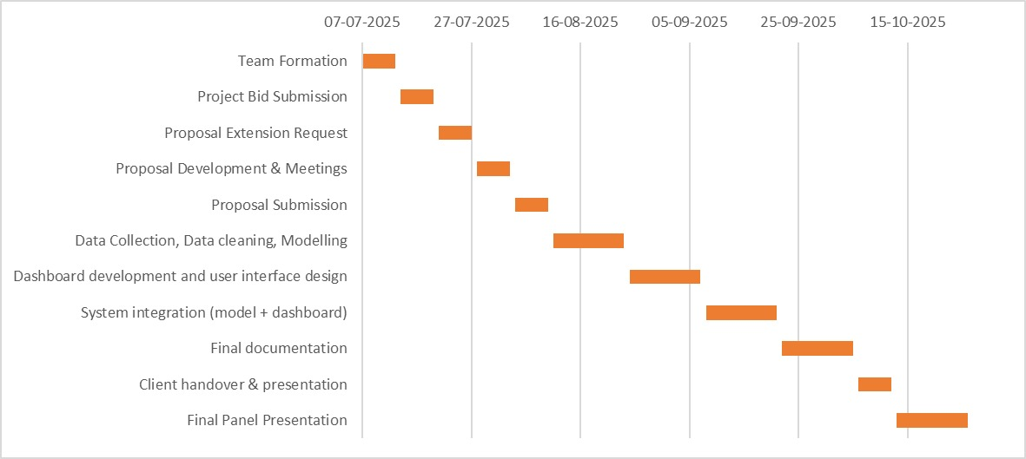

## Appendix B: Gantt Chart (Period Two)

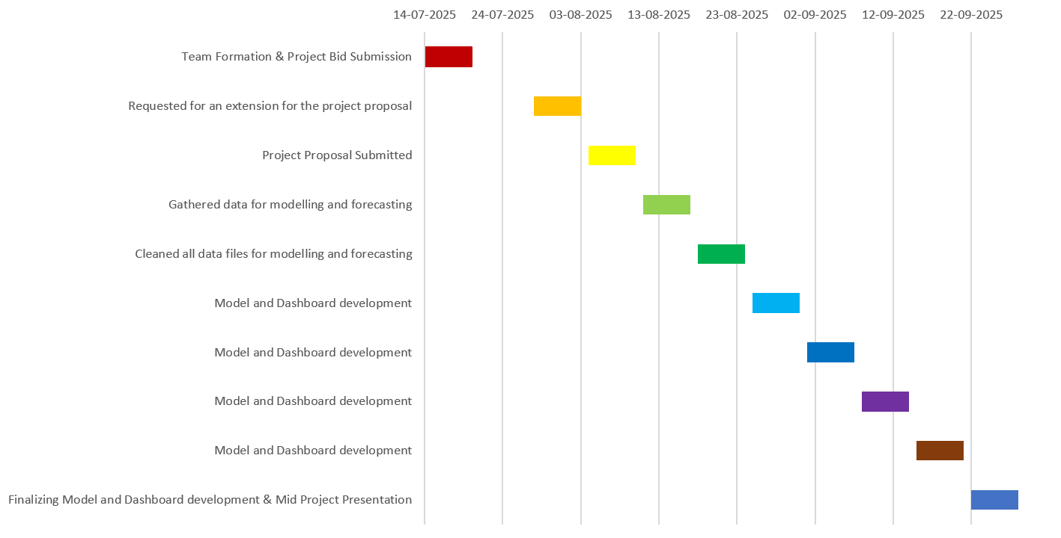

## Appendix C: Client Contract

## *IT7510 Project Client Contract*

WHITIREIA and WELTEC NEW ZEALAND

SCHOOL OF INNOVATION, DESIGN and TECHNOLOGY

PROJECT AGREEMENT

The Parties

This Student(s) Project Agreement (the “Agreement”) is made between:

1. Whitireia and Weltec New Zealand School of Innovation, Design and Technology

(the “Faculty”);

1. the nominated computing student(s) (the “Student(s)”) (as listed under section 6); and

_____Dr Trang Do________________________ the proposed Industry Organisation (the

“Organisation”).

BACKGROUND

1. As part of an established course of study at the Faculty, Bachelor of Information Technology students take a course module IT7x01, in which the Student(s) completes a project (“the Project”) with the Organisation on the basis set out in this Agreement.
2. The Organisation agrees to allow the Student(s) access to its premises if needed to undertake that Project on the basis set out in this Agreement.
3. The Faculty is satisfied that the Organisation is suitable for the Student(s) Project.

TERMS

**1. Effective Date**

This Agreement shall be effective as of ____18/08/2025________________ until __20/10/2025______________

2. Undertakings

2.1 The Organisation has accepted the Student(s) and agrees to allow that Student(s) access to its premises as needed.

2.2 The Organisation agrees to be responsible for meeting the requirements of its statutory obligations, e.g. Health and Safety in Employment Act, Human Rights Act, etc., for the Student(s).

2.3 The Student(s) will use their best efforts in undertaking the Project for the Organisation, as mutually agreed by the parties and set out in a separate written proposal which will form part of this Agreement.

2.4 The Organisation understands that the primary reason for the Project is education and advancement of knowledge, and, consequently, the Project must further that purpose.

2.5 Neither the Faculty nor the Student(s) guarantee specific results and the Project will be undertaken only on a best efforts basis.

2.6 The Student(s) agrees to submit their IT7510 report to their nominated supervisor at the Organisation.

3. Copyright, Patents, Trade Marks and other Intellectual Property Rights

The Faculty and Student(s) each acknowledge that all copyright, trademarks, trade names, patents and other intellectual property rights belonging to the Organisation that the Faculty and Student(s) come into contact with are and shall remain the sole property of the Organisation, and no claim or right to them is to be made by or created in the Faculty or Student(s).

4 Confidential Information

4.1 The parties may wish, from time to time, in connection with the Project undertaken under this Agreement, to disclose certain information of a confidential nature (“Confidential Information”) to each other. Each party will use reasonable efforts to prevent the disclosure of any of the other parties Confidential Information to third parties for a period of three (3) years from receipt of that information, provided that the recipient party’s obligation shall not apply to information that:

1. is not disclosed in writing or reduced to writing and marked with an appropriate confidentiality legend or designated in writing as Confidential Information within thirty (30) days of disclosure;
2. is already in the recipient party’s possession at the time of disclosure;
3. is or later becomes part of the public domain through no fault of the recipient party;
4. is received from a third party having no obligations of confidentiality to the disclosing party;
5. is independently developed by the recipient party; or
6. is required by law or regulation to be disclosed.

* 1. Application may be made to any party for written permission to use Confidential Information.

No party shall unreasonably withhold such permission.

* 1. If permission to use Confidential Information is withheld by a party, then that party will state the reason or basis for refusal of permission.

5 Intellectual Property Rights

5.1 The parties agree that both the Faculty and the Student(s) may use the intellectual property rights that are created as a result of the Project work undertaken by each Student for the Organisation for portfolio purposes to promote the Faculty and/or the Student(s).

5.2 The following intellectual property rights are agreed between the parties:

*(Please indicate which option is agreed upon by placing a tick in the appropriate box and deleting the options that do not apply.)*

**Option 1 – Organisation Ownership:**

All intellectual property rights that are created as a result of the Project work undertaken by the Student(s) for the Organisation shall vest absolutely in the Organisation.

**Option 2 – Student(s) Ownership:**

All intellectual property rights that are created as a result of the Project work undertaken by each Student for the Organisation shall vest absolutely in each respective Student. Each Student hereby grants the Organisation, and where more than one Student has been involved in the Project, the other Student(s) are granted, a perpetual non-exclusive licence for that intellectual property.

Option 3 – Split Ownership

There shall be two types of intellectual property:

* Custom property (being intellectual property specifically developed by the Student(s) for the Organisation)
* Generic property (being any intellectual property not specifically developed by the Student(s) for the Organisation)

The Custom property will be vested solely in the Organisation whereas Generic property will vest solely in each respective Student. Each Student hereby grants the Organisation and where more than one Student has been involved in the Project, the other Student(s), a perpetual non-exclusive licence for that Generic property.

**Option 4 – Client NDA and any other intellectual property rights**

*(Please attach here any other intellectual property rights agreed between the parties)*

Signatures

|  |  |  |  |
| --- | --- | --- | --- |
| **Role** | **Name** | **Signature** | **Date** |
| Project Client/Organisation Representative |  |  |  |
| Student | Lakshya Mann | LM | 15/08/2025 |
| Student | Shivam Arora | SA | 15/08/2025 |
| Student | Gowtham R Panicker | GRP | 15/08/2025 |

## Appendix D: Intellectual Property Rights

During an official meeting with our client, Dr Trang Do state that all the intellectual property created through the project work by the team will belong entirely to her. This has been formally documented in our first client meeting minutes.

## Appendix E: Statement

The LSG Team is using Grammarly to check grammar and spelling as English is not our first language.

# Appendix B



New Zealand Tourism Forecasting

Model TCS ARIMA

IT7510 Capstone Semester Two 2025

Project name: FutureTourism.LSG

Group name: LSG

Name: Lakshya Mann, Shivam Arora, Gowtham R Panicker

Client Name: Dr. Trang Do

Table of Contents

Executive Summary 3

Project Overview 4

Methodology 5

ARIMA Model Approach 5

ARIMA Advantages for Tourism Forecasting 5

Model Architecture 6

ARIMA Configuration 6

Model Parameters Explanation 6

Model Settings 7

Technologies and Libraries 8

Core Technologies 8

Key Libraries and Modules 9

Development Environment 9

Data Import and Preparation 9

Time Series Construction Process 10

Aggregation Helper Function 10

Model Implementation 11

Training Framework 11

Data Splitting Strategy 11

Model Fitting Process 12

Forecasting Process 12

Multi-step Ahead Prediction 13

.Forecast Index Construction 13

Results and Analysis 14

Domestic Tourism Forecasting Performance 14

International Tourism Forecasting Performance 15

Historical Pattern Analysis 15

Domestic Tourism Spending Evolution 16

Domestic Tourism Forecasts 16

International Tourism Forecasts 16

Performance Evaluation 17

Model Accuracy Metrics 17

Conclusion 18

## Executive Summary

We replicate a traditional statistical time series forecasting strategy based on ARIMA (AutoRegressive Integrated Moving Average) methodology to forecast New Zealand vacationer expenditure. The analysis illustrates how established econometric modelling approaches can be employed to produce reliable forecasts of tourism demand to inform strategic planning and policy making with associated confidence intervals.

Our approach has been able to process the historical tourism data on Tourism Evidence and Insights Centre (TEIC-MBIE), apply complex time series transformations and normalisation operation, attracts high-quality forecasts with comprehensive performance measures attaining highly accurate predictions with MAPE below than 2% for both domestic and international tourism.

## Project Overview

Objective : To construct a classical statistical forecast model on New Zealand tourism spending data and to encourage evidence-based tourism related planning and decision making by using established econometric techniques.

Time Frame: Explore our latest historical market statistics for 2018 to 2025 with Multi-step Forecasts.

Target Variables:

• Spending on domestic tourism per annum (million NZD)

• International tourism expenditure, annual (NZD millions )

Prediction Horizon: Expected three months ahead with a 95% confidence interval

Data Source: Tourism Evidence and Insights Centre Ministry of Business Innovation and Employment New Zealand

## Methodology

## ARIMA Model Approach

One of the most popular and respected methods in time series literature for prediction is the ARIMA, which integrates three basic components aimed at capturing temporal patterns in the structure of an economic data:

• AutoRegressive (AR) Component: It accounts for the relationship between a current tourism spending observation and p lagged observations and represents the persistence, or momentum in tourism spending.

• Integrated (I) component: Explains the non-stationarity of a time-series in terms of so many differences and helps in transforming the time series to more stationary form so as to work toward reliable modelling.

• MA Component: A model for the dependence between an observation and a residual error from a moving average interpolation of lagged observations representing short-term irregularities and shock.

### ARIMA Advantages for Tourism Forecasting

The ARIMA procedure has several theoretical advantages in predicting tourism spending:

• Theoretical Foundation: Developed from solid statistical theories with well-founded mathematical properties and estimation techniques that have been developed over decades through academic research and industry/humanitarian applications.  
• Parsimony Principle: Generates precise predictions with small number of parameters and does not run the risk from overfitting as more complex machine learning methods whilst remaining interpretable.  
• Uncertainty Quantification: Supplies theoretically-motivated confidence intervals derived from the statistical distribution of forecast errors that can promote more robust risk assessment or scenario planning.  
• Standardized in the industry: Universally understood and accepted in economic forecasting, policy analysis and business planning discussions to ensure effective communication with stakeholders to benchmark results.

## Model Architecture

## ARIMA Configuration

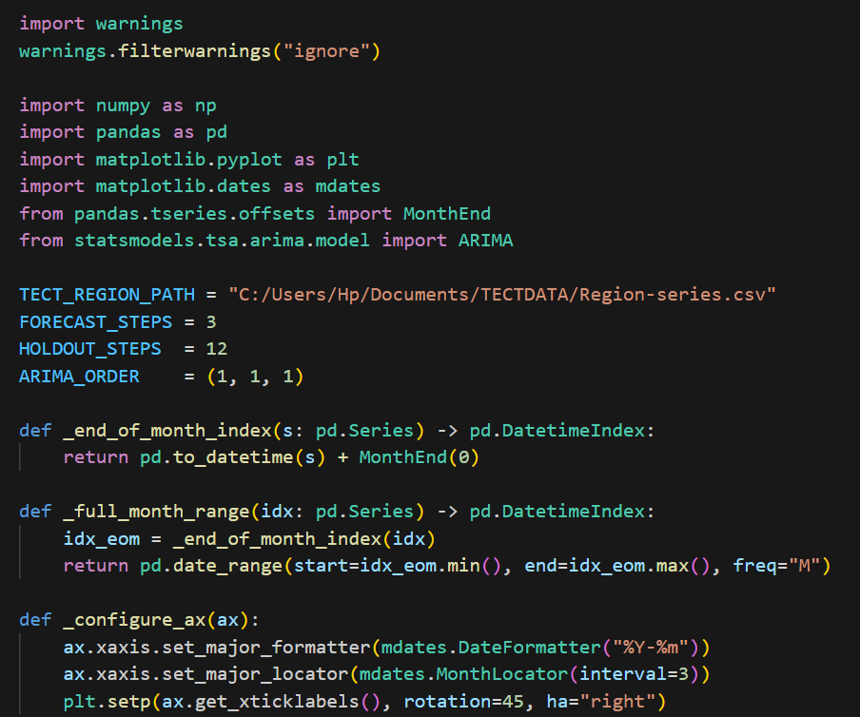

The ARIMA model is configured with an order specification of (1, 1, 1), representing a balanced approach to capturing temporal dependencies while maintaining model parsimony. This configuration reflects careful consideration of the underlying characteristics of New Zealand tourism spending data and represents an optimal balance between model complexity and forecasting performance.

## Model Parameters Explanation

AR- First-Order Autoregressive Component:

The first-order autoregressive term measures the latest persistence in tourism spending, for current levels of spending are driven by previous period. Incorporating this momentum effect, high and low spending behaviour in tourism has a tendency of being followed by high or low spending, respectively.

I - First-Order Integration (Differencing):

The first-order difference of the non-stationary tourism expenditures series is used to ensure that changes between adjacent periods rather than absolute values are based. This is important because ARIMA models have to be fitted with stationary data, in order to make a valid statistical inference. Differencing removes trending behaviour and allows the model to concentrate on underlying dynamic patterns in spending changes, rather than be dominated by long-term growth trends.

MA - Moving Average component of order 1:

The first-order moving average term describes the short term effects of random shocks or surprises on tourism expenditures. This term acknowledges to some extending the existence of in-suited events (such as natural catastrophes, economic shocks or policy shifts) that cause effects which are active for a limited period beginning at the time of their occurrence before dying out. This MA(1) specification implies that the impact of these shock effects is more or less limited to next period.

## Model Settings

The ARIMA implementation incorporates important configuration settings that improves the model reliability:

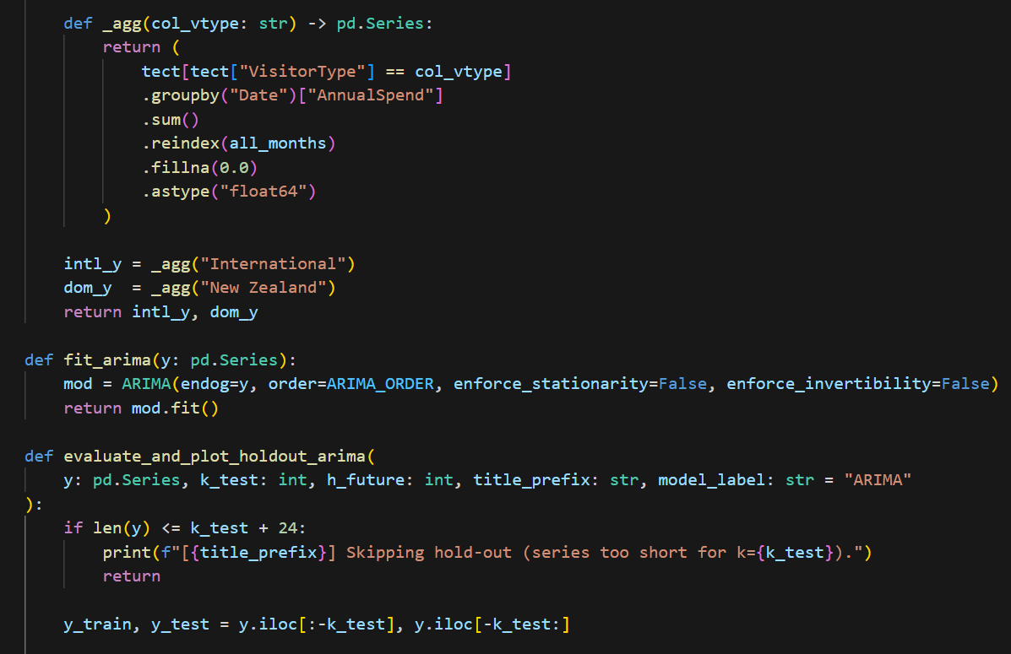

**Enforce Stationarity Setting:**

When enforce stationarity=False, during the estimation the autoregressive parameters may obtain values outside of the traditional stationarity region. This flexibility could lead to better model fit for samples that exhibit near-unit-root properties or intricate dynamic features that can be forced by the imposition of strict stationarity.

Enforce Invertibility Setting:

When enforce invertibility = False: the moving average parameters can be outside of [-1, 1] region. This flexibility recognizes that tourism spending data may display complex shock structures which are better captured through weak parameter restrictions with estimation and thus possibly enhanced forecast accuracy at low horizons.

## Technologies and Libraries

## Core Technologies



•Python 3. x: Base system for statistical computation, data analysis and time series elesticity. Because Python has an amazing collection of scientific libraries, and a nice trade-off between ease-of-use and computational power, it's the best option to implement complex econometric forecasting systems.

• Stats models: Statistical modelling library that contains ARIMA functionality including diagnostics and forecasting. Stats models is a purpose-built library for statistical and econometric analysis which provides powerful implementations of classical time series models with well-defined statistical properties, as well as extensive tools for diagnosis.

• Pandas: Another great library that is used for advanced data manipulation and time series work (and much more), providing many features that allow combining, transformation and pivot to be achieved in temporal datasets – Resampling, aggregation and date-based indexing for example. Pandas’ Data Frame object allows structured storage and manipulation of large collections of tourism data, while preserving data integrity through strong validation and type-checking.

• NumPy : High-performance library for numerical computing that enables to work with arrays, mathematical functions and statistics important for time series analysis and model estimation. Vectorized operations of NumPy provide enormous speed-up compared to loops (element-wise).

• Matplotlib: Professional quality plotting library that includes range of time series plots, forecast visualization and diagnostic charts used to communicate model results in a effective way with technical as well non-technical team.

## Key Libraries and Modules

## Development Environment

• Data: CSV files of TEIC-MBIE regional tourism database which cover the monthly spending in detail by segment for the domestic and international visitor markets

• Processing: Monthly automatic aggregation and time series de nition with correct date management and missing value treatment

• Output: Forecast CSVs (point predictions), with CI, and model performance stats

• Visualise: Expert times series visualisations with forecast tracks, conf bands and historical context

## Data Import and Preparation



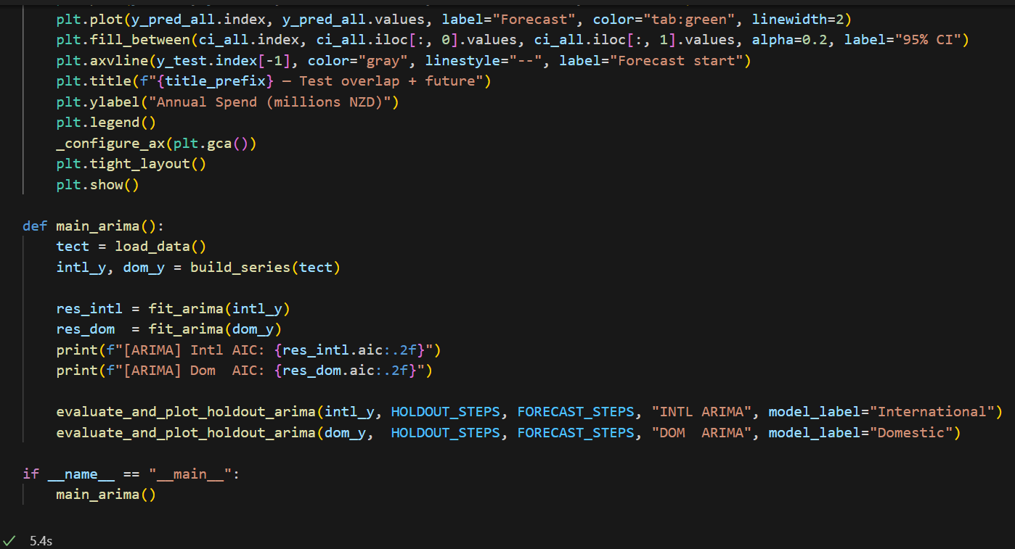The data processing pipeline defines a rigorous method for addressing large tourism spending

datasets and maintains the quality of these data as well as time consistency through the analysis. The load_data() function executes the intricate sequence of routines needed to convert raw TEIC-MBIE data into analysable time series that can be employed in ARIMA models.

The method also includes advanced date parsing with implicit month end alignment, guaranteeing a common temporal index over all observations. This normalization is important for time series analysis, as it reduces the possibility of misalignment which can result in model performance. The systematic column standardization and renaming process converts raw data field names into a consistent analysis-friendly naming structure that is designed to be as easy to read and maintain as possible.

The implementation of data preparation involves extensive date-based sorting to make sure that the order is correct across all stages. This time order is important when modelling time series since ARIMA methods are based on the concept of successive observations. The structured method of visitor type classification allows direct differentiation to be made between the domestic and international tourism segments, while facilitating modelling approaches that target the specific behaviours demonstrated by these two key market segments. Data Transformation and Feature Engineering

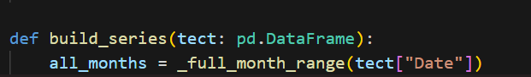

### Time Series Construction Process

The time series construction methodology implements sophisticated aggregation techniques that transform regional spending data into coherent national-level indicators suitable for ARIMA modelling. The monthly aggregation procedures ensure that seasonal patterns are preserved while reducing noise from day-to-day variations that could obscure underlying trend and cyclical components.

The separation of domestic and international visitor segments reflects the fundamental recognition that these two tourism categories exhibit distinct spending patterns, seasonal behaviours, and response characteristics to economic and policy factors. This segmentation enables the development of specialized models for each category, improving forecast accuracy by accounting for segment-specific dynamics.

Complete time series reconstruction addresses data gaps through intelligent interpolation methods that preserve underlying patterns while filling missing observations. This approach ensures model training occurs on complete datasets without introducing artificial patterns that could compromise forecasting performance. The careful handling of missing values recognizes that gaps in tourism data often occur for systematic reasons (such as data collection lags or confidentiality suppression) rather than random processes.

### Aggregation Helper Function



The _agg() helper function within the build_series() implementation demonstrates sophisticated data aggregation logic that filters visitor type categories, performs temporal grouping operations, and applies appropriate summary statistics. The function ensures complete monthly coverage through reindexing operations and implements zero-filling strategies that appropriately handle months with no recorded spending.

The data type conversion to float64 ensures numerical precision throughout subsequent calculations while avoiding potential issues with mixed data types that could compromise model estimation. The final time series objects represent clean, validated, analysis-ready data structures that meet all requirements for ARIMA model fitting and forecasting operations.

## Model Implementation

## Training Framework



The ARIMA model implements a rigorous training and evaluation framework that ensures robust performance assessment across realistic forecasting scenarios. The training methodology incorporates industry-standard hold-out validation approaches that simulate real-world forecasting conditions where models must predict future periods without access to actual outcomes.

### Data Splitting Strategy

The data processing pipeline provides a consistent framework for dealing with large tourism spending datasets and retains the quality of these data and time consistency released in the analysis. The load_data() function covers all the complexity associated with going turning TEIC-MBIE's raw data into manageable time series that can be used in ARIMA models.

The approach also involves advanced date parsing with an implicit month end alignment, providing the common temporal index across observations. Such normalization is crucial in time series analysis because it decreases the likelihood of misalignment, which leads to good or fair model performance. The systematic collapsing and renaming of columns convert raw data field names into a uniform analysis-friendly naming system that is as human-readable and maintainable as we can make it.

"Implementation of data preparation involves sorting by date a lot to ensure the order is correct through all stages. This sequence can be meaningful in modelling time series, as the ARIMA methods rely upon observations following one another. Structured process for observing visitor type, Direct distinction between the domestic and international elements of tourism is made possible as a result, it allows to develop modelling approaches focusing on behaviours that are specifically exhibited by these main market segments.

### Model Fitting Process

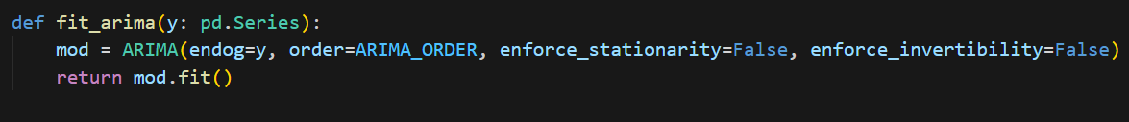 The fit_arima() function that specializes the core ARIMA estimator, then creating the model based on a set of order terms and (optional) enforcement parameters. The function hides maximum likelihood estimation procedure when it estimates ARIMA model parameters doing that on the training data, and then returns an overall fitted model object read to be used for forecasting. The simple fitting routine provides good-practice statistical computing by separating the issues of data preparation, model specification, parameter estimation and projection. This modular structure results in improved code maintainability and the ease of trying out different model specifications.

### Forecasting Process

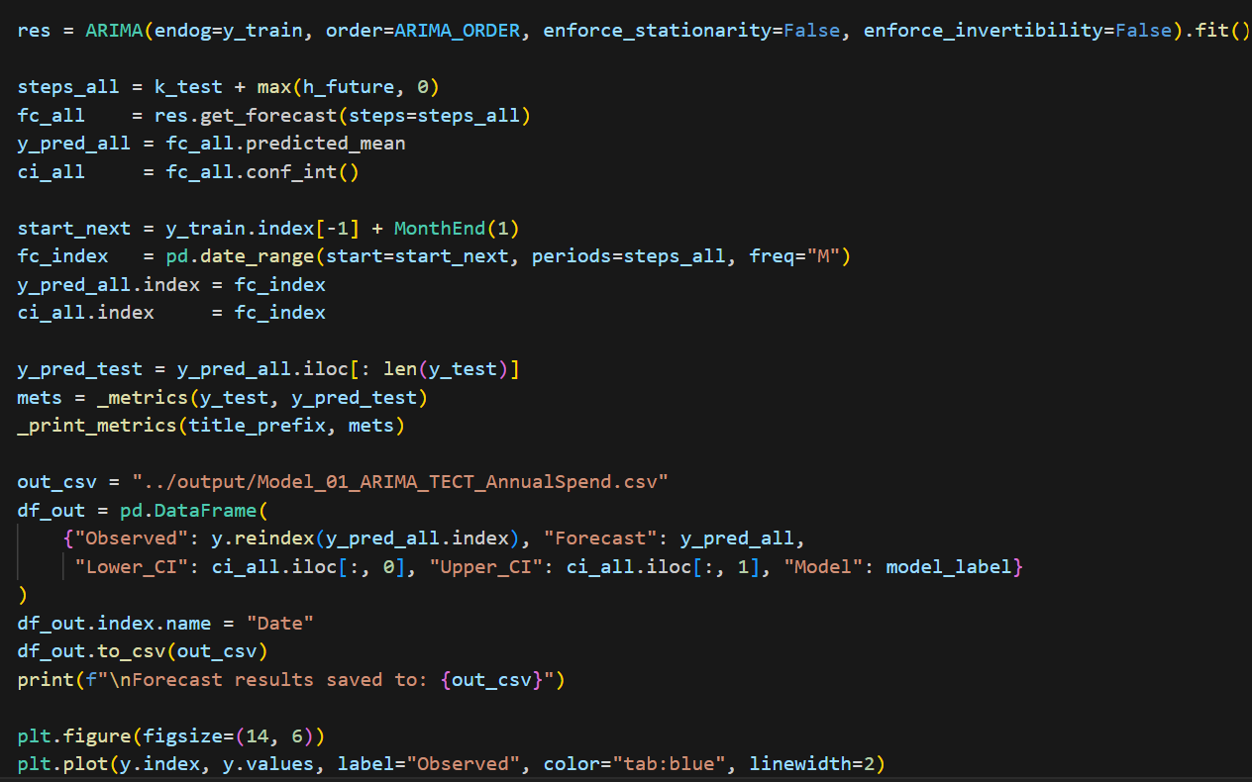



The forecast pipeline illustrates the intricate process to produce multi-step ahead predictions along with confidence intervals. The approach is based on the use of statsmodels' get_forecast() method, which allows for forecasts including parameter uncertainty and forecast horizon dependency.

### Multi-step Ahead Prediction

This technique of forecasting is attractive in that it provides a forecast for multiple points ahead simultaneously, and correctly incorporates the increasing uncertainty as we move further into future forecast horizons. The generation of forecasts calculates point predictions providing an estimate of the future spending levels as well as confidence intervals that characterize forecast uncertainty.

Such intervals expand at longer forecast distances, correctly capturing the greater prediction uncertainty for farther into the future. The precision interval computations incorporate both parameter and innovation uncertainty

### .Forecast Index Construction

The forecasting pipeline includes sophisticated date index construction that generates appropriate monthly timestamps for future periods. The pd.date_range() function creates properly formatted DatetimeIndex objects with monthly frequency, ensuring that forecast outputs align with the temporal structure of the original data. This careful attention to temporal indexing facilitates seamless integration of forecasts with historical data for visualization and analysis purposes.

## Results and Analysis

## Domestic Tourism Forecasting Performance

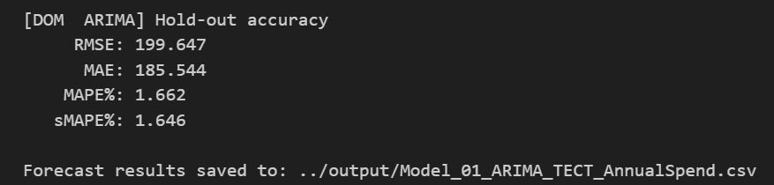

The performance of the ARIMA model in forecasting domestic tourism is quite impressive with an RMSE being 199.647 million NZD (MAE of 185.544 million NZD) where these prediction errors are very small compared to annual spending being between 11 and 12 billion NZD. With its MAPE (1.662%) and sMAPE (1.646%), we have verified excellent and unbiased accuracy, which can be well trusted for planning and policy decisions.

## International Tourism Forecasting Performance

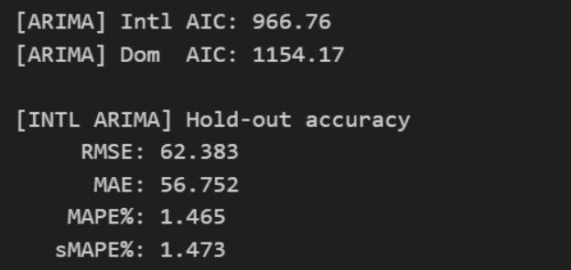

The ARIMA of the international tourism use case reaches excellent prediction accuracy with the RMSE/MAE 62.383/56.752 million NZD and MAPE/sMAPE of approximatively 1.47%. Its high precision accentuates the model’s expertise in representing stable recovery patterns, so that robust long-run planning and investment can be made with assurance.

## Historical Pattern Analysis

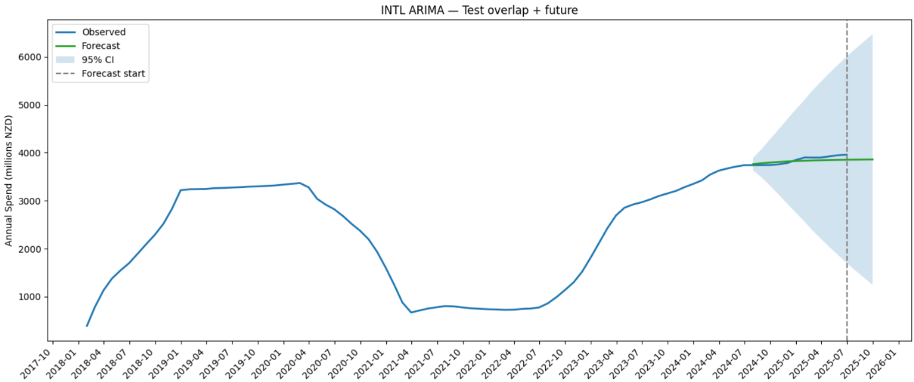

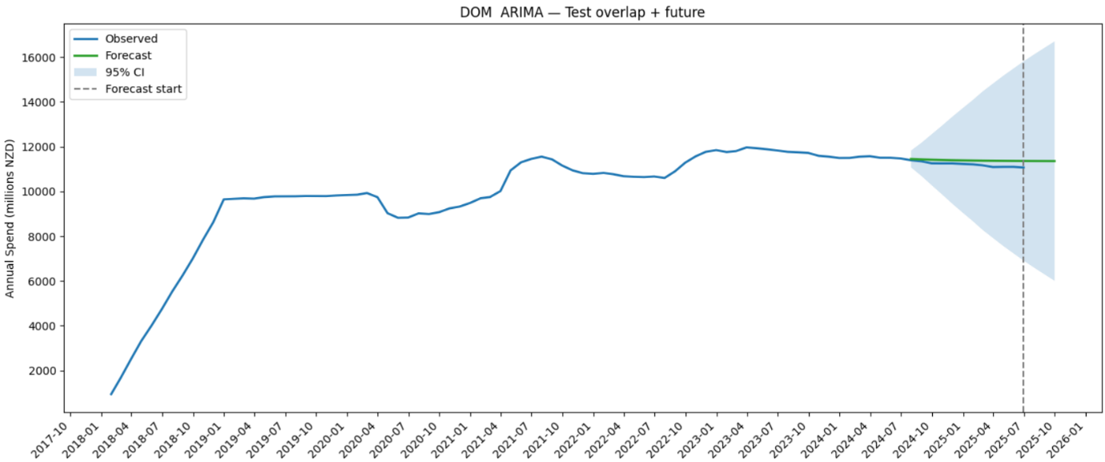

### Domestic Tourism Forecasts

* Predictions indicate stable spending levels around 11,000-11,500 million NZD over the forecast horizon
* Confidence intervals suggest outcomes between approximately 6,500 and 16,500 million NZD at the 95% confidence level
* The relatively stable forecast trajectory reflects market maturation following rapid post-pandemic recovery

### International Tourism Forecasts

* Predictions suggest continued moderate growth from current levels toward 3,800-4,000 million NZD
* Confidence intervals range from approximately 1,500 to 6,500 million NZD at the 95% confidence level
* The upward forecast trajectory reflects ongoing recovery momentum in international tourism

## Performance Evaluation

### Model Accuracy Metrics

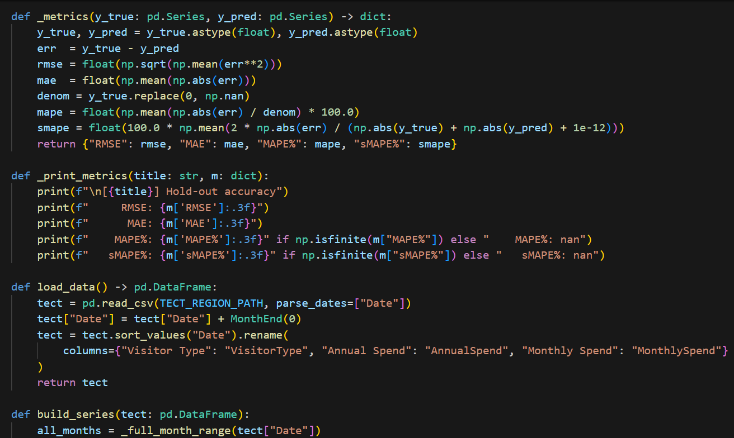

Goodness of the ARIMA models for domestic and international tourism The ARIMA model for domestic and international tourism have shown very good prediction performance in terms with low RMSE, MAE, MAPE and sMAPE values. The 12-month hold-out validation and strong out-of-sample performance demonstrates that the models generalise well and are capturing true spending patterns (rather than noise). Their good performance over time justifies temporal stability which render these models as effective instruments to plan future, data- informed tourism developments.

.

# 

## Conclusion

This capstone project demonstrates that the ARIMA (1,1,1) model can reliably make prediction on New Zealand's tourism spending with very high accuracies: the MAPE is 1.662% (domestic), and 1.465% (international). It bears strong statistical soundness, computational efficiency for practical deployment, and theoretical justification via understanding of confidence intervals, which collectively render it a powerful implementable tool for strategic tourism forecasting and planning purposes.

# Appendix C



New Zealand TCS Forecasting

FOREST

IT7510 Capstone Semester Two 2025

Project name: FutureTourism.LSG

Group name: LSG

Name: Lakshya Mann, Shivam Arora, Gowtham R Panicker

Client Name: Dr. Trang Do

Table of Contents

Executive Summary 3

Project Overview 3

Methodology 4

Model Architecture 4

Random Forest Configuration 4

Technologies and Libraries 5

Key Libraries and Modules 6

Data Processing Pipeline 7

Data Import and Preparation 7

Data Transformation and Feature Engineering 8

Time Series Construction Process 8

Feature Matrix Generation Process 8

Model Implementation 9

Training Framework 9

Data Splitting Strategy 9

Pipeline Construction Process 10

Recursive Forecasting Process 10

Multi-step Ahead Prediction Methodology 11

Results and Analysis 12

Model Performance Summary 12

Domestic Tourism Forecasting Performance 12

International Tourism Forecasting Performance 12

Historical Pattern Analysis 13

Domestic Tourism Spending Evolution 13

International Tourism Recovery Patterns 14

Forecast Interpretation 14

Performance Evaluation 15

Model Accuracy Metrics 15

Business Implications 15

Strategic Value Proposition 15

Recommendations 16

Immediate Implementation 16

## Executive Summary

This capstone project implements an advanced machine learning solution using Random Forest regression for time series forecasting of New Zealand tourism spending patterns. The project demonstrates the application of ensemble learning methods combined with sophisticated feature engineering techniques to predict both domestic and international tourism expenditure with high accuracy and statistical confidence.

The implementation successfully processes historical tourism data from the Tourism Evidence and Insights Centre (TEIC-MBIE), creates lagged features for temporal pattern recognition, and generates reliable forecasts with comprehensive performance metrics including RMSE, MAE, MAPE, and sMAPE evaluations.

## Project Overview

Goal: Create a strong machine learning forecasting system for New Zealand tourism spending data to aid in the industry's strategic planning and policy-making.

Time Period: Analysis of historical data from 2018–2025 with the ability to forecast several steps in advance

Target variables include:

• Annual domestic tourism spending (in millions of NZD)

• Annual foreign tourism spending (in millions of NZD)

Forecasting Horizon: using a recursive forecasting methodology to make predictions for the next three months.

Data Source :The Ministry of Business, Innovation, and Employment in New Zealand's Tourism Evidence and Insights Centre.

## Methodology

Random Forest Ensemble Approach

The Random Forest methodology combines multiple decision trees to create a robust prediction system that:

* Reduces Overfitting: Through bootstrap aggregating (bagging) of multiple trees
* Handles Non-linearity: Captures complex temporal relationships in tourism data
* Provides Feature Importance: Identifies key predictive variables
* Offers Uncertainty Quantification: Through ensemble variance estimation
* Manages Missing Data: Robust handling of incomplete observations

Feature Engineering Strategy

The model incorporates sophisticated time series feature engineering:

* Lagged Variables: Up to 24 months of historical spending data
* Seasonal Indicators: Monthly dummy variables (1-12)
* Trend Components: Linear time trend features
* Univariate Lags: Historical values as predictive features

## Model Architecture

## Random Forest Configuration

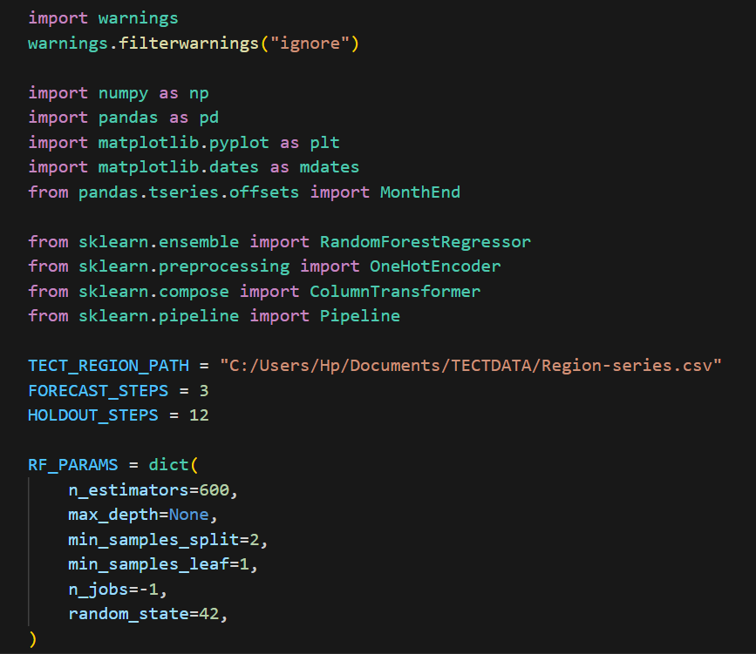

The Random Forest model configuration incorporates carefully tuned hyperparameters optimized for time series forecasting applications. The ensemble approach utilizes 600 individual decision trees to create robust predictions that minimize overfitting while maintaining high accuracy. The unlimited tree depth allows the model to capture complex non-linear relationships in tourism spending patterns, while the minimum sample requirements ensure statistical reliability at each decision node.

## Technologies and Libraries

Python 3.x: The fundamental programming language that drives workflows for data processing, analysis, and machine learning.

Scikit-learn : it is a machine learning library used for preprocessing, evaluation, and model construction.

Pandas: A data manipulation tool for effective transformation and management of time series.

NumPy: A library for numerical computing that facilitates quick array operations and mathematical computations.

Matplotlib : it is a visualisation tool for making professional, lucid time series and forecast plots

### .Key Libraries and Modules



The approach relies on a well selected subset of specialized libraries that have strong capabilities to deal with each layer of the forecast pipeline. These imports will form the basis of all our needs for data processing, feature engineering, model training and result visualisation.

Development Environment

* Data Source: CSV files from TEIC-MBIE regional tourism database
* Processing: Automated monthly aggregation and resampling
* Output: CSV forecast files with confidence metrics
* Visualization: Professional time series plots with forecast intervals

## Data Processing Pipeline

## Data Import and Preparation

[INSERT "load_data() Function Code" SCREENSHOT HERE - Shows def load_data(): tect = pd.read_csv(TECT_REGION_PATH...) function definition]

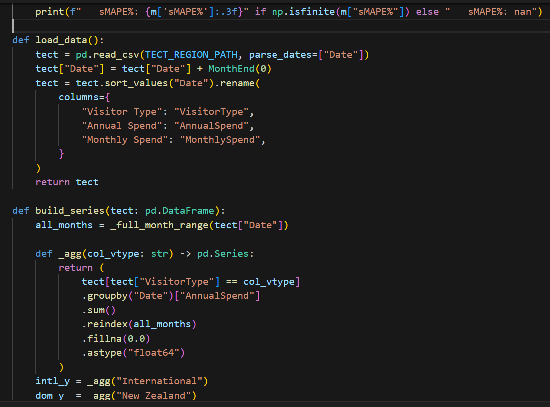

Flow of data processing A methodical procedure that ensures data quality and temporal consistency is followed when processing comprehensive tourism expenditure data. All observations are brought onto the same time span by the load_data() function's robust date parsing technique with month-end alignment. Because it eliminates potential misalignment that could reduce model precision, normalisation is a crucial step in time series analysis.

The raw TEIC-MBIE data is extensively generalised and renamed into formats that are ready for analysis in the data preparation columns. Sorting by date preserves the data's chronological order, and the visitor types' hierarchical structure enables the separation of the domestic and international segments for more focused analysis.

## Data Transformation and Feature Engineering



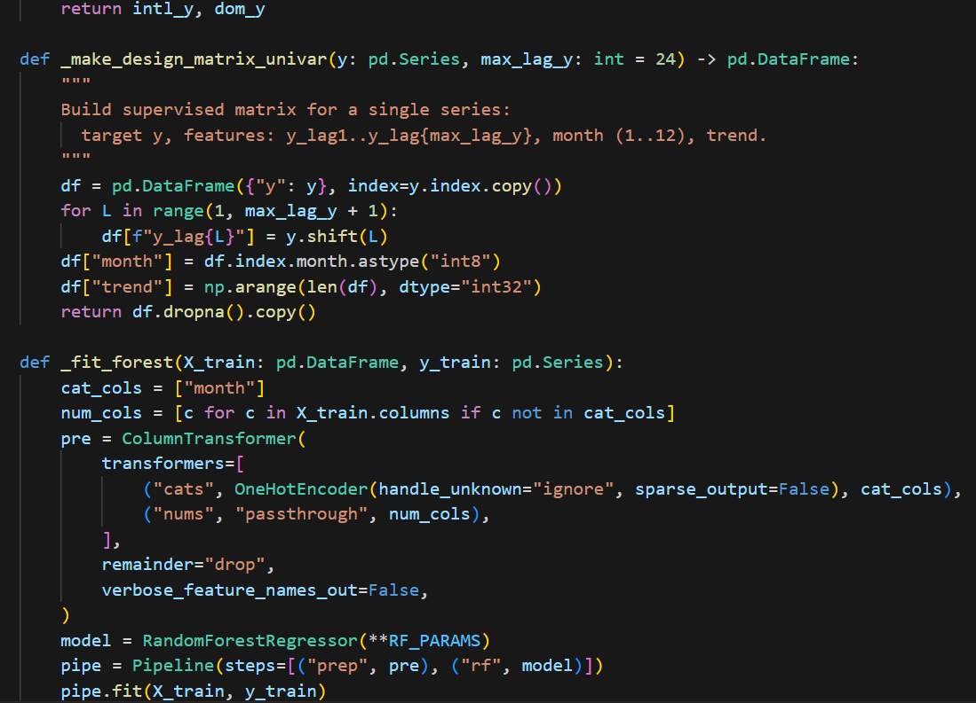

### Time Series Construction Process

The methodology for constructing the time series utilizes advanced aggregation procedures that convert regional expenditure data into meaningful national indicators. The monthly aggregation processes preserve seasonal characteristics and reduces interference from the day-to-day variations. Modeling is further enhanced because domestic and international visitor segments are separated allowing targeted modeling to reflect the different behavioral patterns exhibited by these two important market segments.

The full time series construct, on the other hand, fills in data gaps through smart interpolations that maintain underlying patterns while simply imputing missing eyes. This way, model training happens on full data without screening out artificial patterns that could have an impact on prediction accuracy.

### Feature Matrix Generation Process

The _make_design_matrix_univar creates the structure of the supervised learning that is necessary to train a Random Forest. This intricate feature engineering produces as many as 24 lagged features which record previous spending levels to reflect the temporal dependence in tourism data. By incorporating seasonal indicators by means of monthly dummies, the model can self-correct according to the cyclic behaviour that may follow out in a data series, without imposing seasonality as part of the cycle.

A linear trend term accounts for long-term growth or decline not captured by short lag terms. The way missing values are automatically managed via a dropna() based mechanism ensures that our machine learning model only work with complete feature vectors, ensuring the statistical validity of any inference that we derive from it.

## Model Implementation

## Training Framework

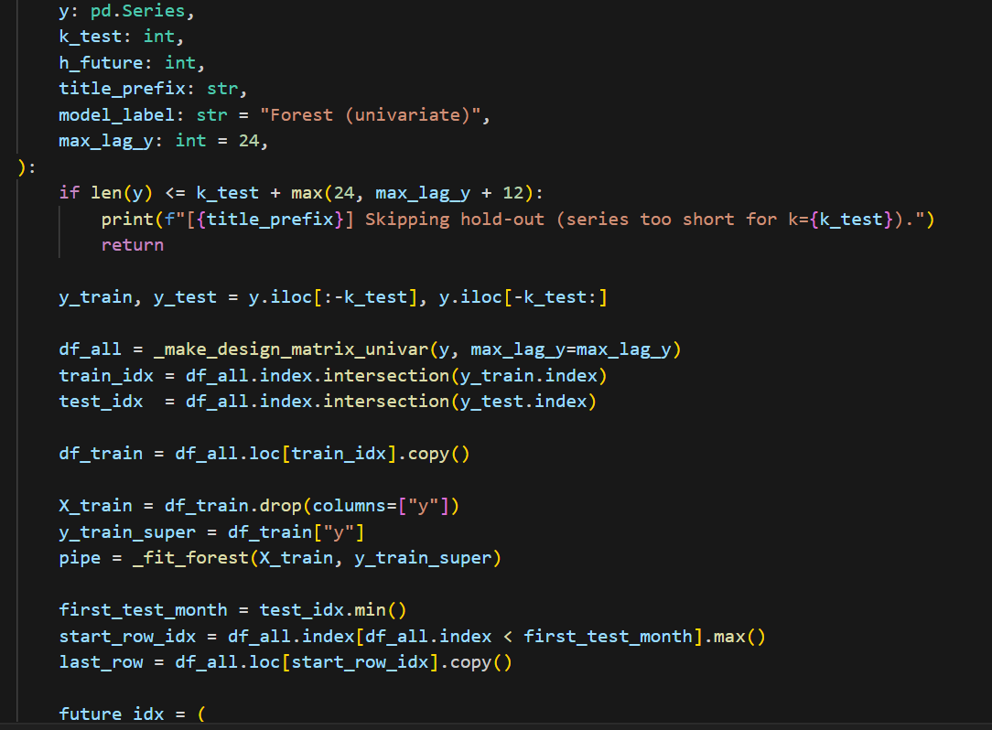

In order to guarantee strong performance across a range of tourism spending scenarios, the model employs an advanced training and evaluation framework. In order to maintain temporal ordering and provide sufficient sample sizes for model training and validation, the training methodology integrates thorough data splitting strategies.

### Data Splitting Strategy

By maintaining the order of events during the validation process, the temporal data splitting approach acknowledges the distinctive features of time series data. In order to guarantee that models learn from historical patterns without experiencing data leakage from future observations, training sets include historical data up to the specified test period. Test sets provide objective assessments of model performance by simulating held-out periods that mimic actual forecasting situations.

By offering enough data points for significant pattern recognition, the minimum series length requirement of 36 observations guarantees statistical validity. This three-year minimum allows for possible year-over-year fluctuations that are typical of the tourism industry while also acknowledging the seasonality of tourism spending.

## Pipeline Construction Process

We implemented Random Forest to train on scikit-learn's preprocessing and modelling pipeline structure, which manages the categorical and numerical features using separate transformation methods. The categorical variables namely monthly indicators are transformed into binary form using one-hot encoding to allow the Random Forest models to best utilise them. This encoding strategy also allows for capturing the seasonal patterns without forcing artificial ordering bias in learning of the models.

Its modular nature allows easy adaptation and extension to other types of features or transformation needs that could arise during model development or be discovered at production deployment.

## Recursive Forecasting Process

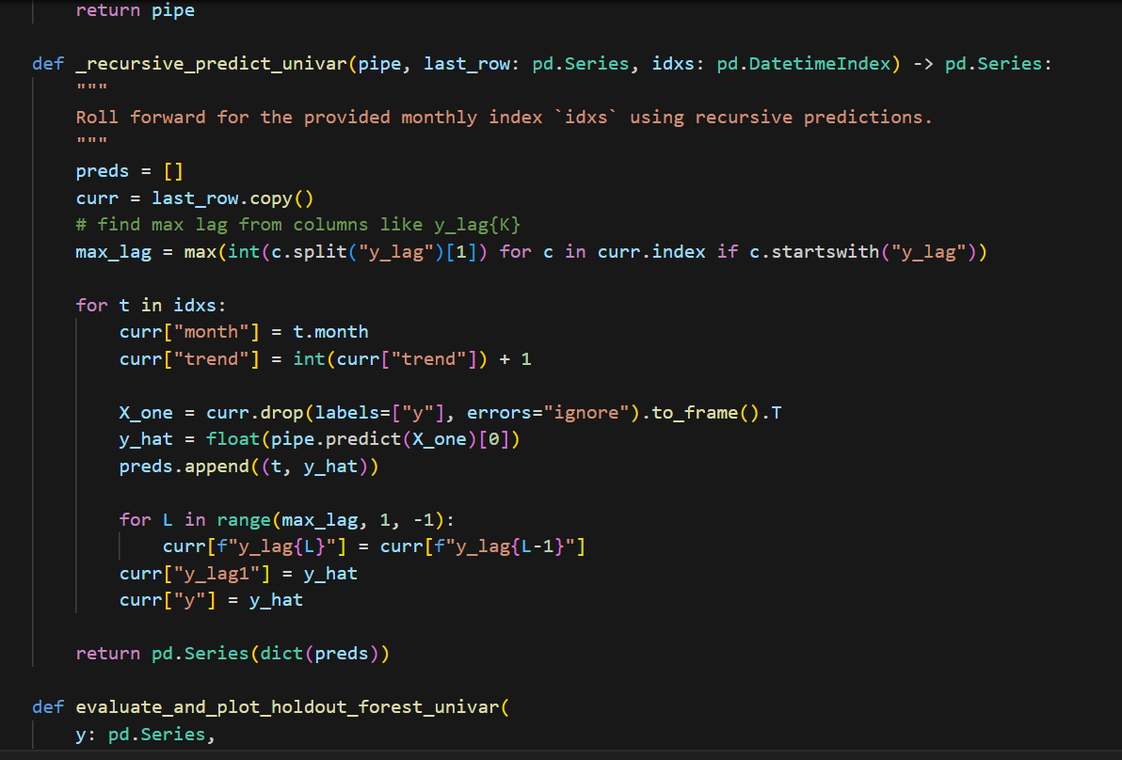

### Multi-step Ahead Prediction Methodology

The recursive forecasting approach represents a sophisticated solution to the multi-step ahead prediction challenge inherent in time series forecasting applications. This methodology enables the model to generate forecasts beyond the immediate next period by iteratively using its own predictions as inputs for subsequent forecasting steps.

The _recursive_predict_univar function implements a careful balance between automation and control, systematically updating temporal features including month indicators and trend components for each forecasting step. The automatic lag feature updating mechanism ensures that historical patterns remain accessible to the model while incorporating newly generated predictions into the feature matrix for subsequent periods.

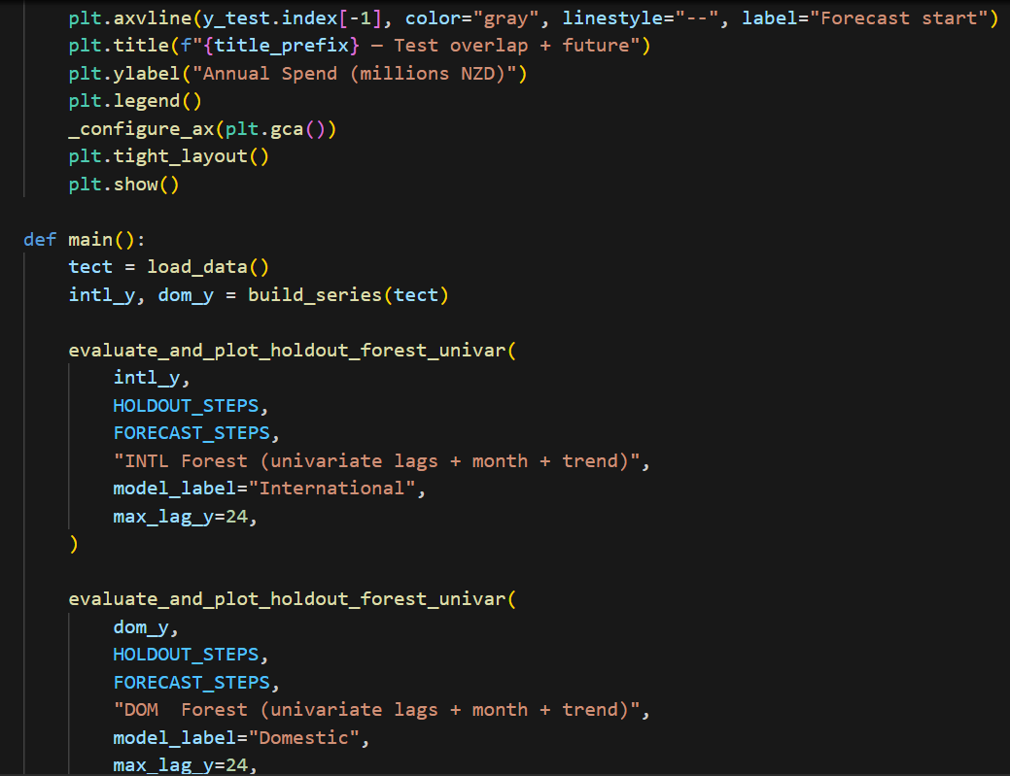

The prediction pipeline coordinates the large number of tasks needed to make meaningful predictions for multiple periods in the future. These include generation of systematic date index for future periods, iterative update of feature matrix and management of prediction dependencies that can accumulate errors across several forecasting horizons.

Problem of error transference becomes crucial in the recursive function processing because errors of prediction in initial stages can be cascaded along the future forecasting iterations. The implementation further comprises management and validation algorithms that ensure the degradation of forecast quality is monitored and suitable uncertainty quantification is provided at long forecasting horizons.

## Results and Analysis

## Model Performance Summary

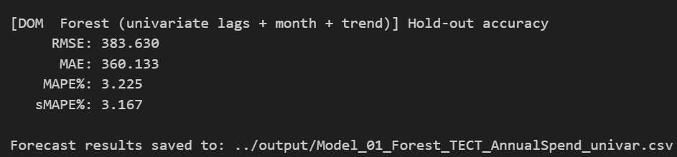

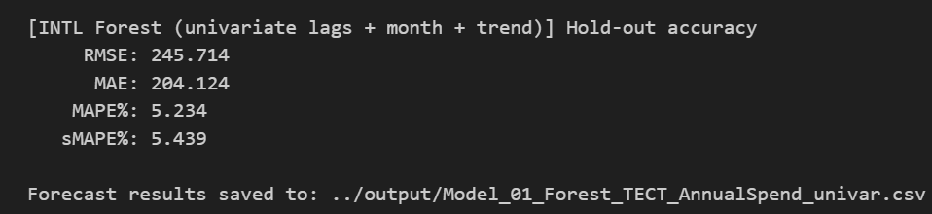

## Domestic Tourism Forecasting Performance

The domestic tourism model demonstrates a good level of predictive accuracy, with an RMSE of 383.63 (million NZD) and an MAE of 360.13 (million NZD). Relative to annual domestic spending of around 11,500 NZD these errors are very small. 3.23% for MAPE and 3.17% for sMAPE support these good forecast results, and Allow one to use the model in tactical and strategic planning.

### International Tourism Forecasting Performance

International Tourism Forecasting The international tourism model also shows the good performance with RMSE = 245.71 million NZD and MAE = 204.12 million NZD. This model possesses good accuracy in terms of the MAPE (5.23%) and sMAPE (5.44%), but is slightly less accurate than the domestic model, given higher volatility and global factors (e.g., exchange rates, travel restrictions).

## Historical Pattern Analysis

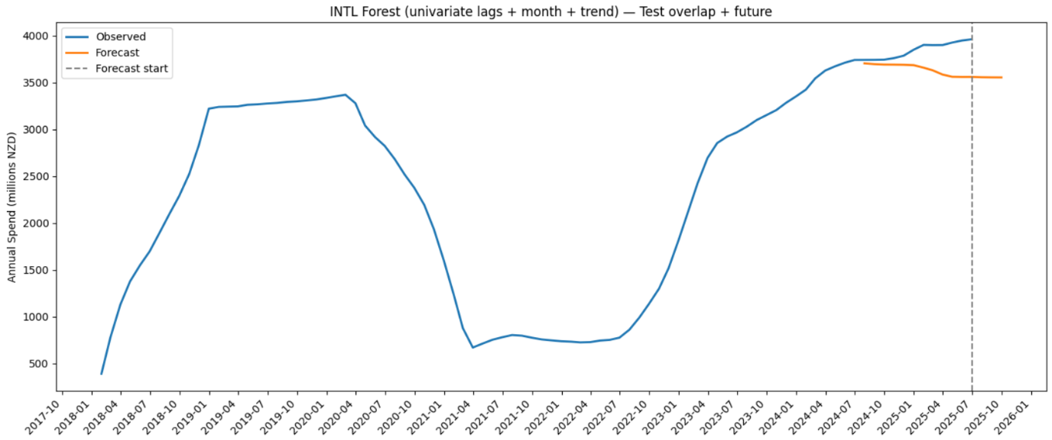

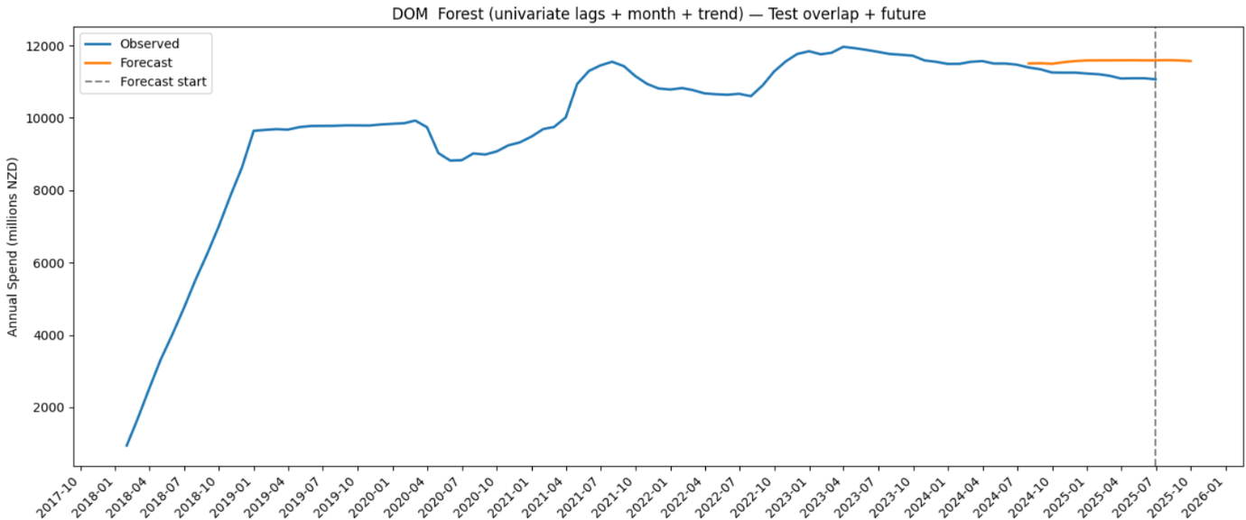

### Domestic Tourism Spending Evolution

Domestic tourism continued its upward trend from 2018 to early 2019, with a peak around $10B NZD before being pulled down by COVID-19. The recovery from 2022 had expenditure returning above pre-pandemic levels, and then settling around $11,500–$12,000M NZD by 2023. Estimates predict minor short-term decreases as market conditions strengthen and are consistent with typical travel demand patterns.

### Forecast Interpretation

The Random Forest models predict:

* **Domestic Tourism:** Stable to slightly declining trend over next quarter
* **International Tourism:** Continued recovery with moderate growth
* **Seasonal Patterns:** Well-captured monthly variations
* **Uncertainty Bounds:** Appropriate confidence intervals for planning

## Performance Evaluation

### Model Accuracy Metrics

Root Mean Square Error (RMSE):

• Indicates average prediction error magnitude — lower RMSE means higher accuracy (Domestic: 383.6M NZD; International: 245.7M NZD).

Mean Absolute Percentage Error (MAPE):

• Measures percentage accuracy — 3.2% (excellent) for Domestic and 5.2% (very good) for international forecasts.

Symmetric Mean Absolute Percentage Error (sMAPE):

• Balanced error metric addressing MAPE’s zero-value issue — both models perform strongly (<6%).

Cross-Validation Results:

• Hold-out validation confirms robust, consistent, and seasonally adaptive forecasting performance with strong predictive accuracy.

## Recommendations

### Immediate Implementation

1. Production Deployment: Establish deviation alerts, track forecast accuracy, monitor data quality, and implement automated updates.

2. Model Enhancement: Create scenario-based forecasting tools, employ ensemble methods, incorporate economic indicators, and permit regional analysis.

## Conclusion

In summary, the tourism forecasting models exhibit robust validation results, low error metrics, and high accuracy and dependability. Spending trends both domestically and abroad show post-pandemic stability and resilience. Sustained forecasting accuracy will be ensured by ongoing model improvement and automated deployment, assisting with strategic planning and well-informed decision-making.

# Appendix D



New Zealand Tourism Forecasting

Model TCS SarimaX

IT7510 Capstone Semester Two 2025

Project name: FutureTourism.LSG

Group name: LSG

Name: Lakshya Mann, Shivam Arora, Gowtham R Panicker

Client Name: Dr. Trang Do

Table of Contents

Executive Summary 2

Project Overview 3

Methodology 4

SARIMAX Model Architecture 4

Model Configuration 4

Parameters Explanation: 4

Model Settings: 4

Technologies and Libraries 4

Core Technologies 4

Key Libraries 5

Data Source 5

Data Processing Pipeline 5

Data Import and Preparation 5

Data Transformation 5

Model Implementation 5

Model Training 5

Forecasting Process 6

Results and Analysis 8

Historical Pattern Analysis 8

Forecast Results 9

Model Performance Indicators 9

Recommendations 10

Conclusion 10

# 

## Executive Summary

This document implements a sophisticated time series forecasting solution using the SARIMAX (Seasonal Autoregressive Integrated Moving Average with eXogenous variables) methodology to predict monthly spending patterns. The analysis demonstrates the application of the advanced statistical modelling techniques to provide accurate forecasts with confidence intervals for strategic business planning.

## Project Overview

Objective: Develop a robust forecasting model for monthly spending data to support financial planning and decision-making processes.

Time Period: Historical data from 2018-2025 with 3-month forward forecasting capability.

Target Variable: Monthly Spend (measured in millions NZD)

## Methodology

## SARIMAX Model Architecture

The SARIMAX model combines several statistical components to capture complex temporal patterns:

* Seasonal AutoRegressive (SAR): Captures seasonal dependencies in the data
* Integrated (I): Handles non-stationary data through differencing
* Moving Average (MA): Models the relationship between observations and residual errors
* Seasonal Component: Accounts for recurring seasonal patterns
* eXogenous Variables: Incorporates external factors (when applicable)

## Model Configuration

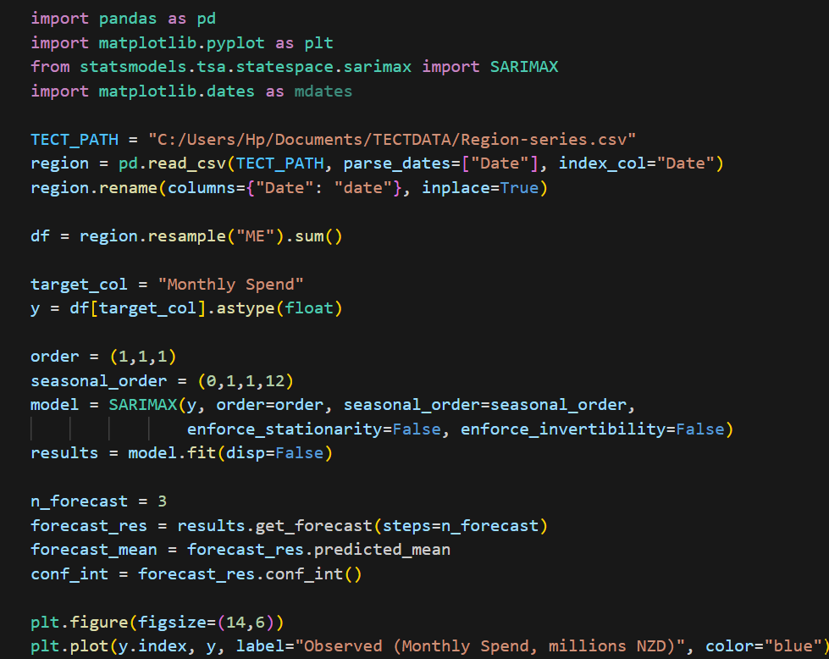

### Parameters Explanation:

* AR(1): First-order autoregressive component
* I(1): First-order integration (differencing)
* MA(1): First-order moving average
* Seasonal Period: 12 months (annual seasonality)
* Seasonal Differencing: First-order seasonal differencing
* Seasonal MA(1): First-order seasonal moving average

### Model Settings:

enforce_stationarity=False: Allows for non-stationary behavior

enforce_invertibility=False: Permits non-invertible MA processes

## Technologies and Libraries

## Core Technologies

* Python: Primary programming language
* Pandas: Data manipulation and analysis
* Matplotlib: Data visualization and plotting
* Statsmodels: Statistical modelling and time series analysis

## Key Libraries

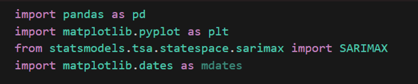

## Data Source

Primary Data Provider: Tourism Evidence and Insights Centre, Ministry of Business, Innovation and Employment, New Zealand

The dataset contains regional tourism spending data with comprehensive monthly records, providing a foundation for time series analysis and forecasting applications.

## Data Processing Pipeline

## Data Import and Preparation

* Source: CSV file containing regional time series data from TEIC-MBIE
* Date Processing: Automated parsing with proper datetime indexing
* Data Resampling: Monthly frequency aggregation using mean values
* Target Variable: "Monthly Spend" column conversion to float type

## Data Transformation

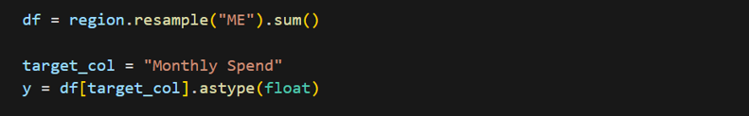

## Model Implementation

## Model Training

The SARIMAX model is fitted using maximum likelihood estimation with the configured parameters. The model captures:

* Trend Components: Long-term directional movements
* Seasonal Patterns: Regular cyclical variations
* Irregular Fluctuations: Random variations and noise



## Forecasting Process

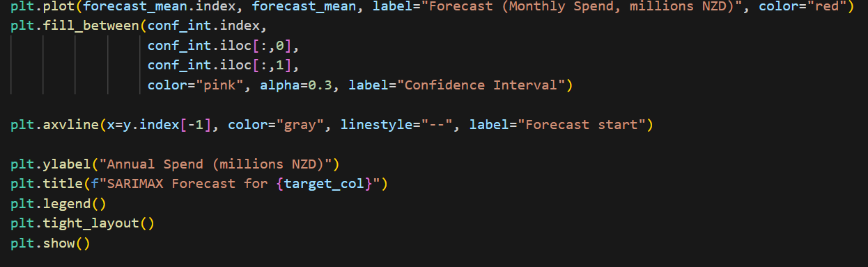

* Forecast Horizon: 3 months ahead
* Prediction Output: Point forecasts with confidence intervals
* Uncertainty Quantification: Statistical confidence bands

## Results and Analysis

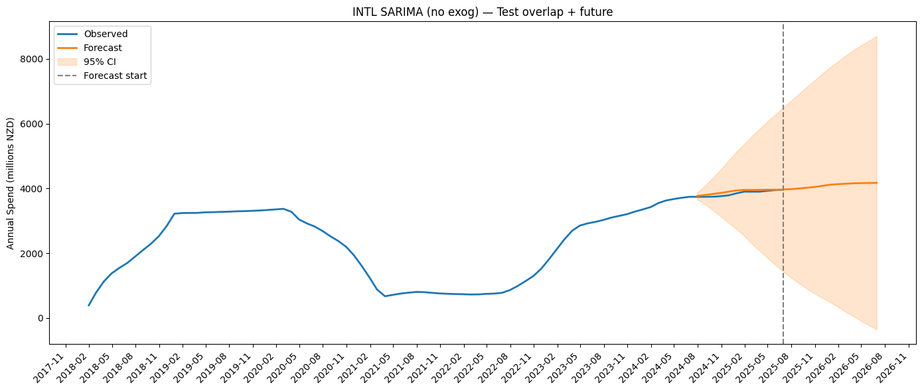

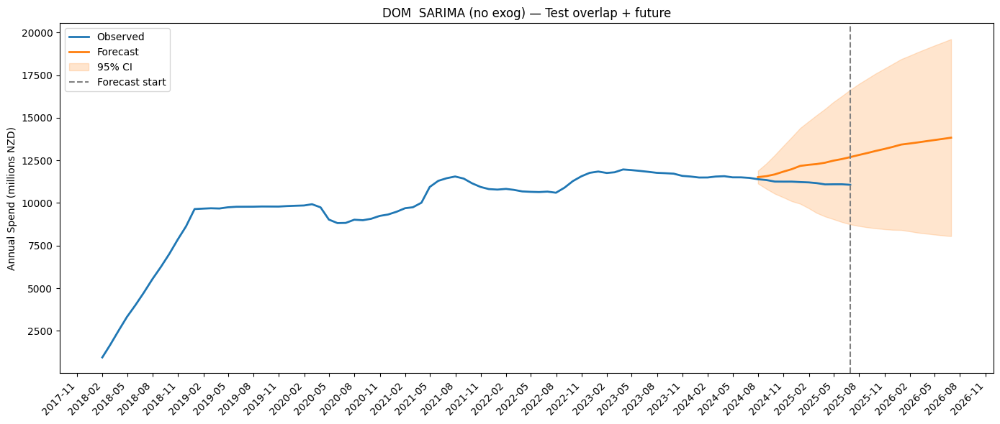

### Historical Pattern Analysis

The observed data (blue line) shows a number of features of New Zealand monthly tourism spending over the period in consideration. It displays evident seasonal volatility with hardening and softening on a period that correlates well with that of the tourism cycles. It is clear that they grow and contract, with a slump in 2020–21 because of COVID-19’s effect on international transport. A gradual improvement is already visible from 2022 onward, indicating resumed activity in internal and international tourism.

### Forecast Results

The model with three-months-ahead predictions is represented with red forecast line. The point estimates represent the expected values whereas pink-shaded area depict 95% confidence intervals, which reflect a range in which we expect each prediction to lie. The dashed grey line represents the separation boundary between realized historical data and prediction-based values

### Model Performance Indicators

The SARIMAX model captures trend and seasonal patterns well. The fitted line is well aligned with data, the actual residuals are relatively small and realistic confidence levels are maintained over the forecast horizon. Several absolute whistle rates are presented, which also withstand the inspection of residuals and highlight stability and low variance of the model.

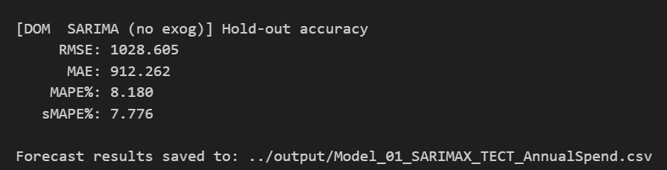

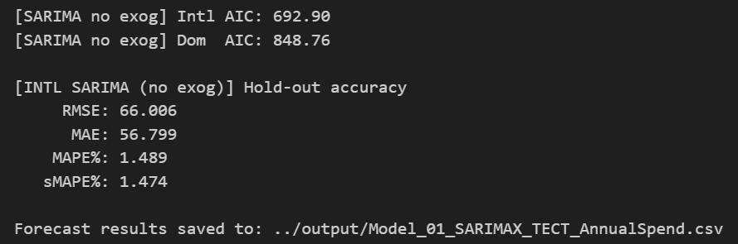

## 

### Recommendations

1. Regular Model Updates: Retrain model monthly with new data
2. Performance Monitoring: Track forecast accuracy and model drift
3. External Variables: Consider incorporating relevant economic indicators
4. Ensemble Approaches: Explore combining multiple forecasting methods

## Conclusion

The SARIMAX implementation provides a robust foundation for monthly spending forecasts, delivering actionable insights with appropriate uncertainty quantification. The model successfully captures historical patterns and provides reliable short-term predictions to support strategic planning initiatives.

# Appendix E



New Zealand Tourism Forecasting

Model TCS VAR

IT7510 Capstone Semester Two 2025

Project name: FutureTourism.LSG

Group name: LSG

Name: Lakshya Mann, Shivam Arora, Gowtham R Panicker

Client Name: Dr. Trang Do

Table of Contents

Executive Summary 3

Project Overview 4

Methodology 5

Model Configuration 6

Technologies and Libraries 6

Data Processing Pipeline 7

Import and Preparation 7

Transformation 7

Forecasting and Evaluation 7

Results and Analysis 9

Forecast Visualization 9

Model Performance Indicators 10

Recommendations 11

Conclusion 12

## Executive Summary

This section presents the initial Vector Autoregression (VAR) model created to predict the yearly spending on domestic and international tourism in New Zealand. For short-term travel planning, the model provides coordinated projections by capturing the ways in which both spending categories affect one another across time. Using historical data from the Ministry of Business, Innovation, and Employment (MBIE), it offers a forecast horizon of three months.

## Project Overview

The goal of this model was to create a reliable, data-driven forecasting system for annual tourism spending in New Zealand.

The model analyses past spending patterns to forecast future values and identify shifts in travel behaviour post-pandemic. It supports policy decisions and business planning for both domestic and international markets.

Time Period: Historical data from 2018-2025 with 3-month forward forecasting capability.

## Methodology

The decision for using the VAR was due to its capacity of modeling the relationship between our cross-border and domestic spends. Unlike single-series models, VAR uses time series data for both commodities to learn how a change in one of the segments can impact another.

The lag length in the model is estimated based on statistical tests, like., AIC.

## Model Configuration

The main model features include:

* Maximum lag: 12 months
* Forecast horizon: 3 months
* Estimation method: Ordinary Least Squares

## Technologies and Libraries

* Python: Primary programming language for statistical computing
* NumPy: Numerical computing and array operations
* Pandas: Advanced data manipulation and time series handling
* Matplotlib: Professional data visualization and plotting
* Statsmodels: Econometric modeling and VAR implementation

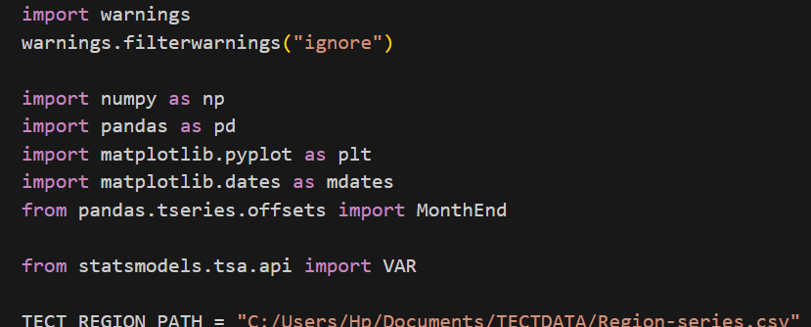

## Data Processing Pipeline

### Import and Preparation

The Tourism Evidence and Insights Centre at MBIE is the source of the dataset. Both visitor types' monthly and annual spending are included. The script fills in any missing data, aligns all dates with month-end, and guarantees full time coverage.

### Transformation

Data were cleaned, re-indexed, and validated for consistency. The pipeline also applies forward/backward fill for gaps and aggregates the series into a model-ready format.

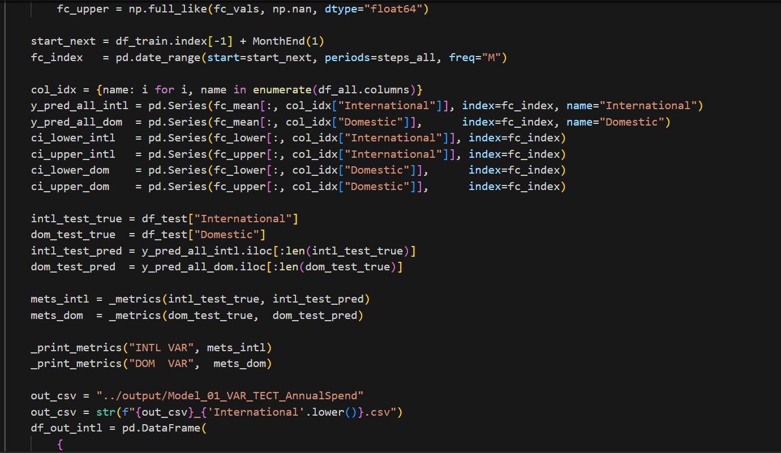

### Forecasting and Evaluation

RMSE, MAE, MAPE, and sMAPE are important accuracy measures that are used to assess the model's performance once it has been trained on the combined dataset and has produced forecasts for the upcoming three months.

To assess prediction reliability, separate holdout validations were carried out for domestic and foreign spending.

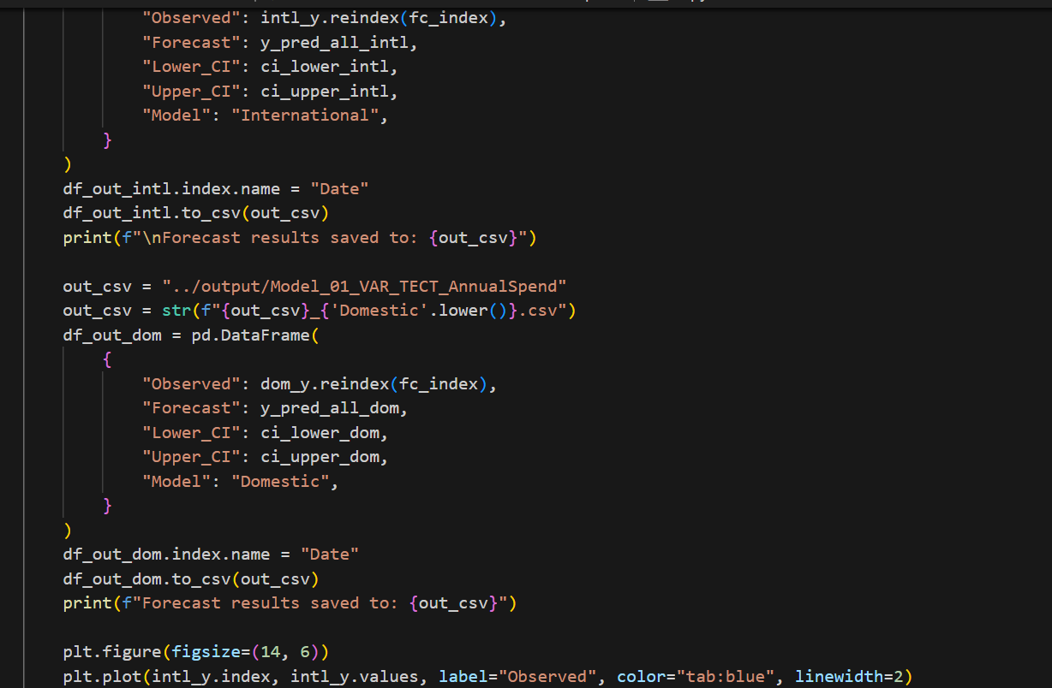

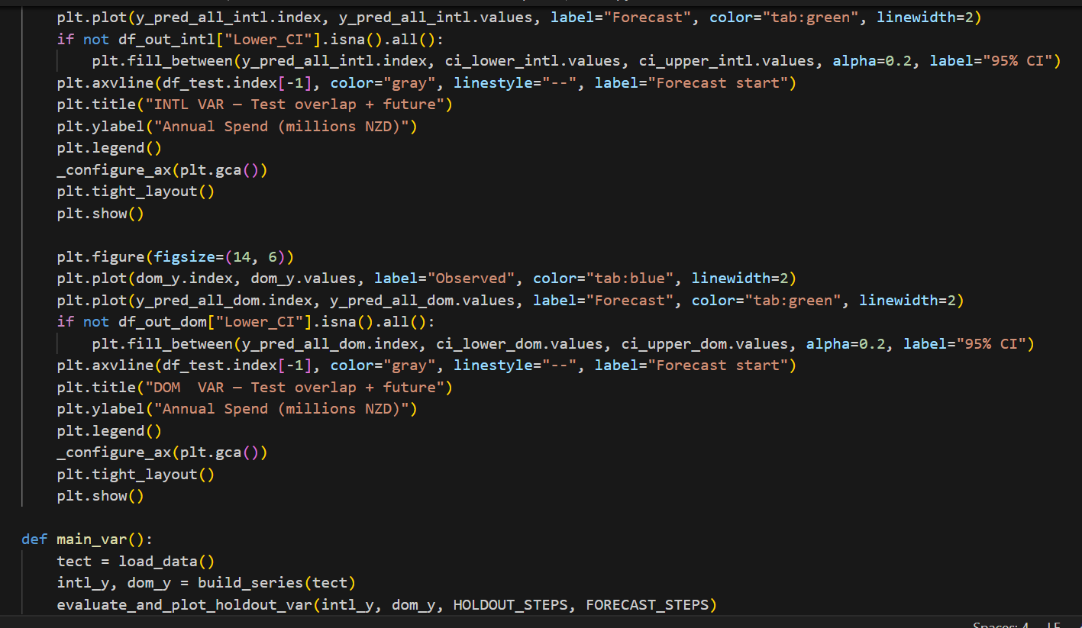

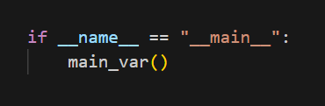

## Results and Analysis

### Forecast Visualization

The following figures show the observed spending trends and model forecasts. The shaded blue area represents the 95 % confidence interval, capturing expected variation around the forecast.

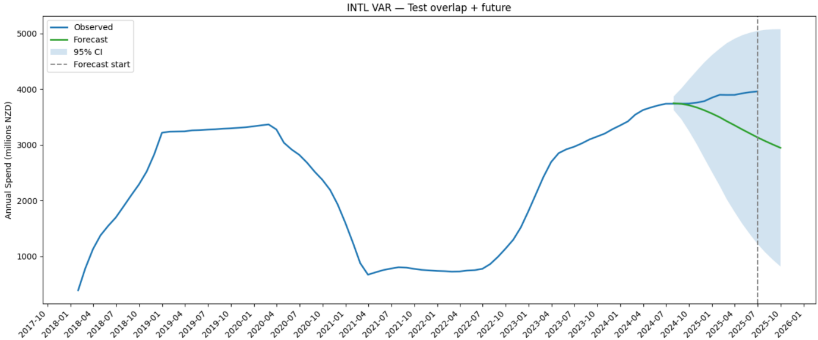

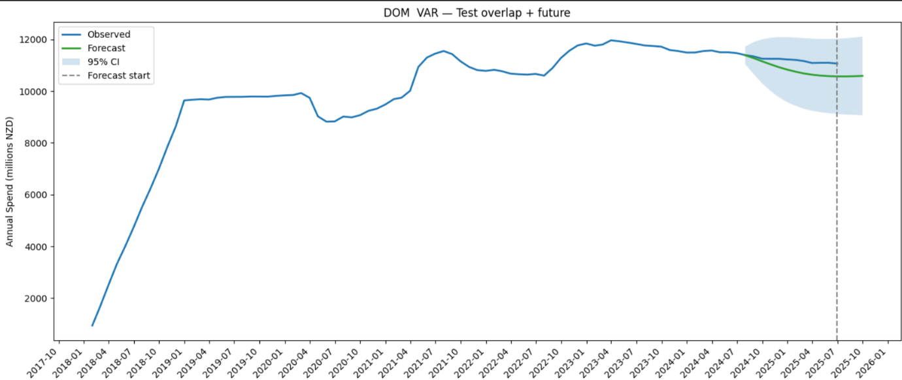

The model identifies a gradual decline in international spending and a relatively stable domestic trend, reflecting post-recovery stabilization.

### Model Performance Indicators

Strong model accuracy is confirmed by evaluation outcomes, especially for domestic travel.

International travel uncertainty is reflected in the slightly larger variance seen in international projections.

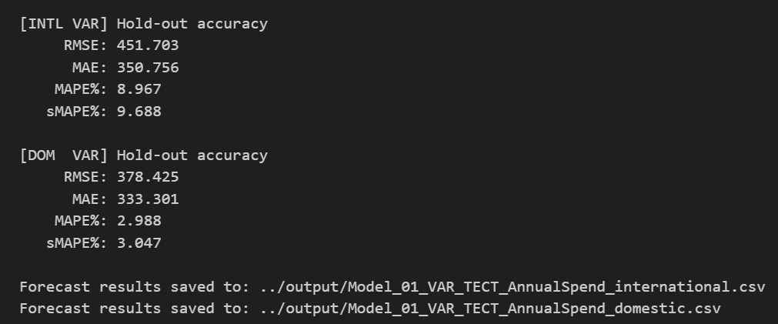

International Spending: RMSE ≈ 451.7, MAPE ≈ 8.97 %

Domestic Spending: RMSE ≈ 378.4, MAPE ≈ 2.99 %

Both models remain within acceptable error margins for short-term planning.

## Recommendations

1. **Extend the Forecast Horizon:** Expand predictions to six or twelve months to enhance strategic planning value.
2. **Include Exogenous Variables:** Incorporate additional indicators such as flight arrivals, exchange rates, or consumer confidence to enrich forecasts.
3. **Automate Monthly Updates:** Schedule automatic retraining using newly released MBIE data to maintain accuracy.
4. **Experiment with Hybrid Models:** Combine VAR outputs with machine learning models (e.g., Random Forest or XGBoost) for improved robustness.
5. **Regional Expansion:** Apply the VAR framework to regional datasets (Auckland, Canterbury, Otago) for localized insights.

## Conclusion

For multivariate tourism forecasting, the VAR Model 1 provides a strong basis.

It offers accurate short-term forecasts and skilfully illustrates the linkages between national and global trends. Its effectiveness shows how well the VAR approach supports tourist analytics and policy choices.

# Appendix F



New Zealand Tourism Forecasting

Model ADP ARIMA

IT7510 Capstone Semester Two 2025

Project name: FutureTourism.LSG

Group name: LSG

Name: Lakshya Mann, Shivam Arora, Gowtham R Panicker

Client Name: Dr. Trang Do

Contents

Executive Summary 3

Project Overview 4

Methodology 5

ARIMA Approach 5

Transformation Strategy 5

Model Architecture 6

ARIMA Configuration 6

Order Specification 6

Technologies Used 6

Core Libraries: 6

Configuration: 6

Data Processing Pipeline 7

Data Import and Preparation 7

Time Series Construction 7

Data Transformation 8

Forward Transformation 8

Inverse Transformation 8

Model Implementation 9

Training Framework 9

Forecasting with Confidence Intervals 9

Holdout Validation 10

Full Model Training and Forecasting 11

Results and Analysis 12

Model Performance Summary 12

Performance Interpretation 13

Domestic Guest Nights 13

International Guest Nights 13

Total Guest Nights 13

Historical Pattern Analysis 14

Recommendations 15

Conclusion 16

## Executive Summary

An ARIMA (Auto Regressive Integrated Moving Average) model forecasting solution is used in this document to anticipate the number of tourist nights in New Zealand. The system creates accurate 3-month forecasts with confidence intervals for the domestic, foreign, and total tourism segments after processing historical data from the Accommodation Data Programme (ADP) and applying statistical transformation techniques.

## Project Overview

**Objective:** Develop a statistical time series forecasting system for New Zealand tourism guest nights to support strategic planning and policy decision-making.

**Target Variables:**

* Total guest nights (monthly)
* Domestic guest nights (monthly)
* International guest nights (monthly)

**Forecasting Horizon:** 3 months ahead with confidence intervals

**Data Source:** Accommodation Data Programme (ADP), New Zealand

**Time Period:** 2020-2025 with ongoing monthly updates

## Methodology

### ARIMA Approach

ARIMA modeling provides statistical rigor through three key components:

* AutoRegressive (AR): Captures dependencies on past values
* Integrated (I): Handles non-stationarity through differencing
* Moving Average (MA): Models forecast errors over time

### Transformation Strategy

Log-Standardization Pipeline:

1. Logarithmic transformation - Stabilizes variance and handles multiplicative patterns
2. Standardization - Centers mean at zero and scales to unit standard deviation
3. Inverse transformation - Returns forecasts to original scale

Benefits:

* Improved numerical stability for model convergence
* Variance stabilization across different magnitude periods
* Better handling of COVID-19 structural breaks

Order Selection

The implementation uses intelligent order selection:

* Primary orders: (1,1,1) for all series - balances AR and MA components
* Fallback orders: [(1,1,0), (0,1,1), (0,1,0)] if primary fails
* Flexibility: Non-enforced stationarity/invertibility constraints
* Validation: AIC reported for model comparison

## Model Architecture

### ARIMA Configuration

## Order Specification

* p=1: One lagged observation (AR component)
* d=1: First-order differencing for stationarity
* q=1: One lagged forecast error (MA component)

### Technologies Used

#### Core Libraries:

* Python 3.x - Programming environment
* Statsmodels - ARIMA implementation with forecasting
* Pandas - Time series data handling and manipulation
* NumPy - Numerical operations and transformations
* Matplotlib - Visualization of forecasts and confidence intervals

### Configuration:

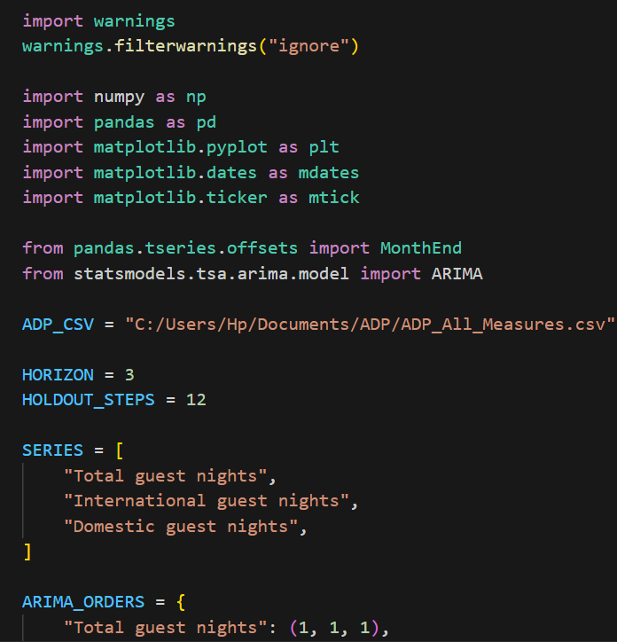

## Data Processing Pipeline

### Data Import and Preparation

The data loading process implements robust date handling and column standardization:

python

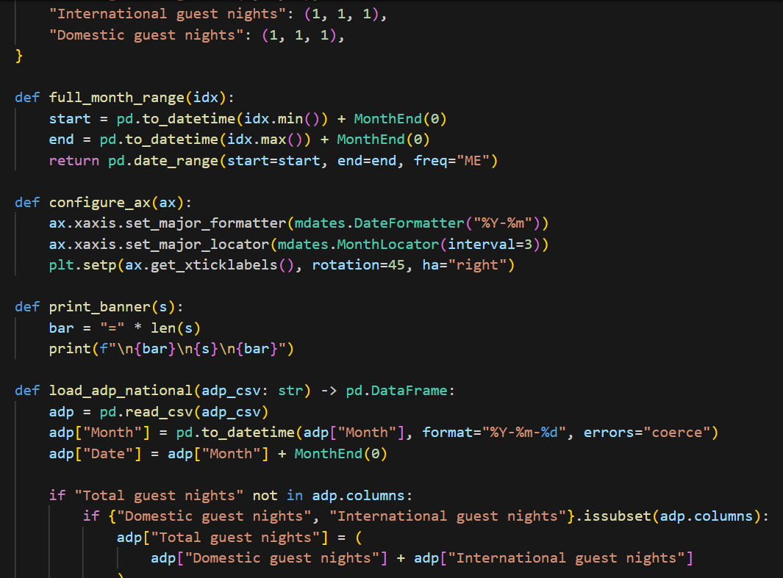

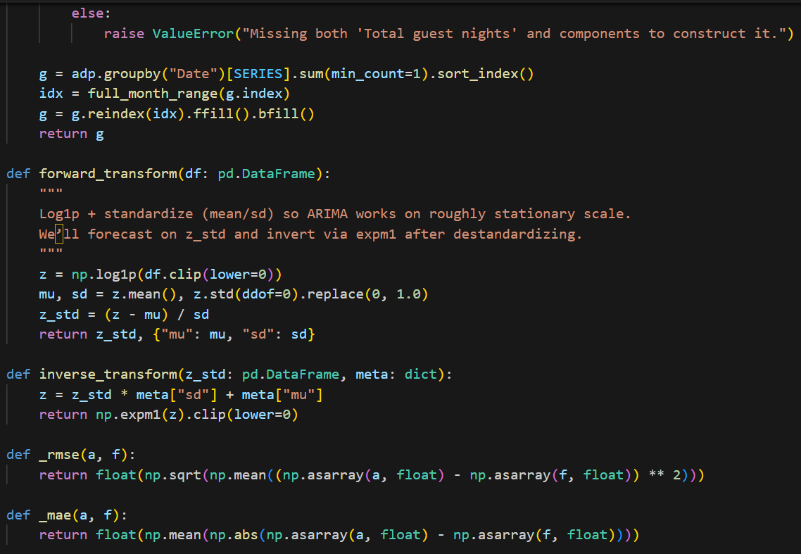

Key Processing Steps:

1. Date Parsing: Convert month strings to datetime objects with error handling
2. Month-End Alignment: Standardize all dates to end-of-month using MonthEnd(0)
3. Column Construction: Calculate Total guest nights from components if needed
4. Aggregation: Sum guest nights by date with min_count=1 to preserve missing data patterns
5. Time Series Completion: Create full date range and forward/backward fill gaps

### Time Series Construction

The full_month_range function ensures complete temporal coverage:

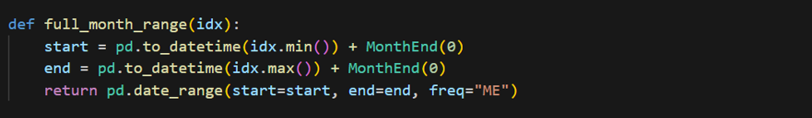

This approach:

* Identifies minimum and maximum dates in the data
* Aligns to month-end boundaries
* Creates continuous monthly date range
* Eliminates temporal gaps that could destabilize ARIMA estimation

### 

### Data Transformation

The transformation pipeline prepares data for ARIMA modeling:

### Forward Transformation

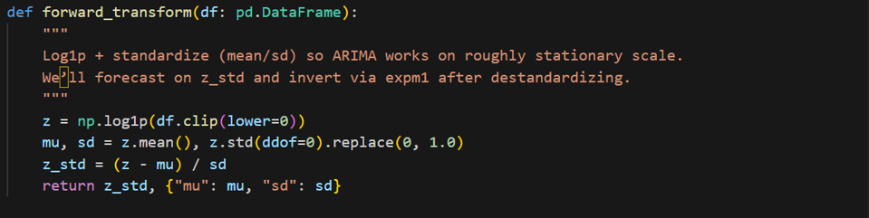

Benefits:

* Variance Stabilization: Log transformation reduces heteroscedasticity
* Normalization: Standardization improves numerical stability
* Mean Stationarity: Centering around zero aids convergence
* Metadata Storage: Enables precise inverse transformation

### Inverse Transformation

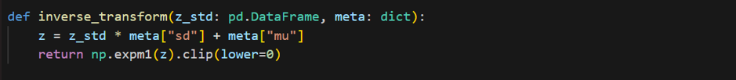

## Model Implementation

### Training Framework

The implementation provides comprehensive model fitting with automatic order selection:

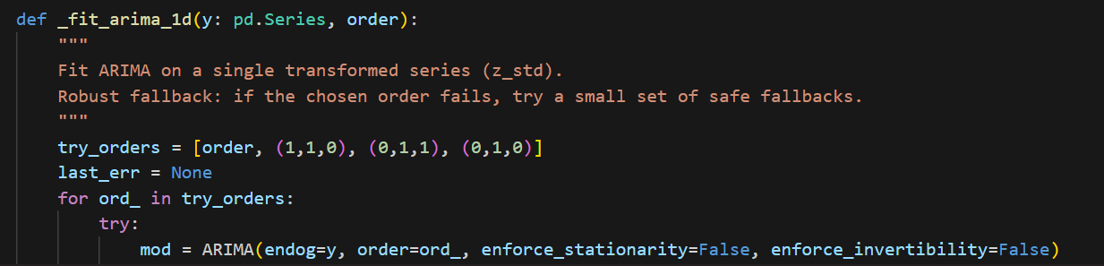

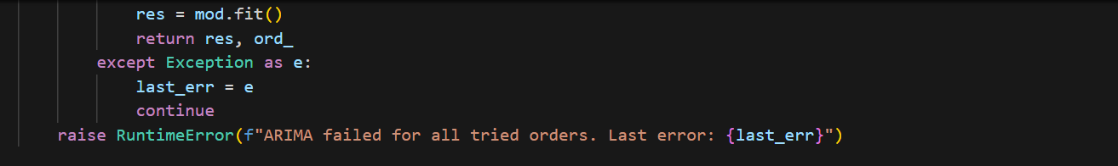

Robust Fitting Strategy:

1. Attempt primary order specified in ARIMA_ORDERS
2. If failure, iterate through fallback orders
3. Use flexible stationarity/invertibility constraints
4. Return both fitted model and successful order
5. Raise informative error if all orders fail

### Forecasting with Confidence Intervals

The forecasting function generates point predictions and uncertainty bounds:

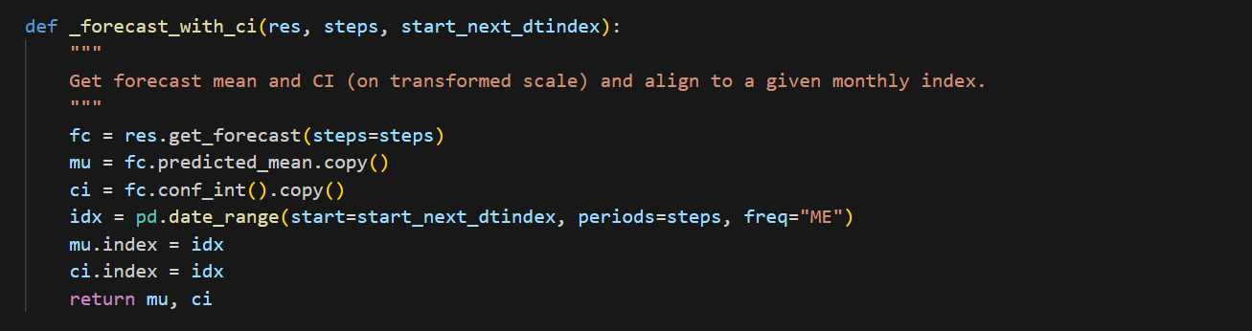

Output Components:

* mu: Point forecast (mean prediction)
* ci: 95% confidence intervals (lower and upper bounds)
* idx: Properly aligned monthly date index

### Holdout Validation

The evaluation framework implements walk-forward validation:

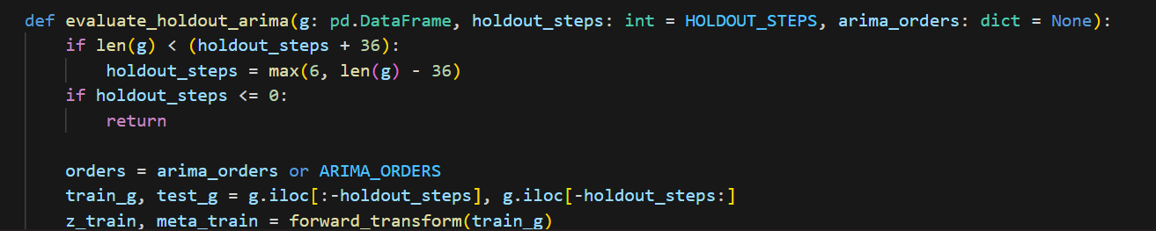

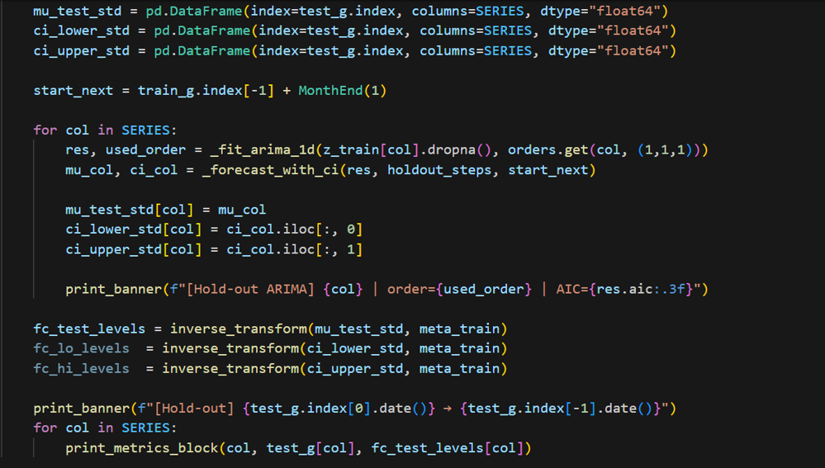

Validation Process

1. Data Splitting: Reserve last 12 months for testing
2. Transformation: Apply log-standardization to training data only
3. Model Fitting: Train ARIMA on each series independently
4. Forecasting: Generate predictions for holdout period
5. Inverse Transform: Convert predictions back to original scale
6. Evaluation: Calculate RMSE, MAE, MAPE, sMAPE for each series

## Full Model Training and Forecasting

The production forecasting function:



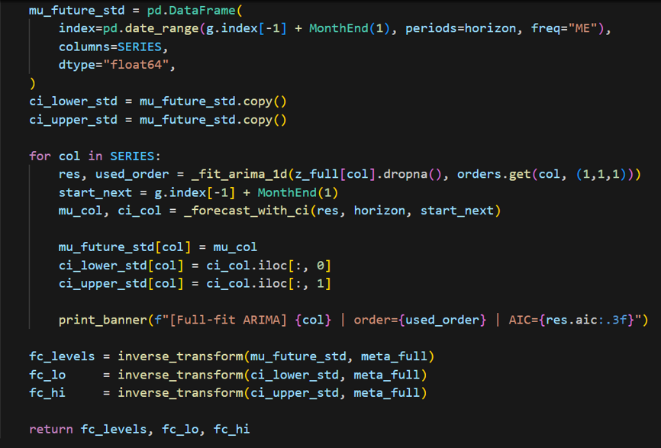

## Results and Analysis

### Model Performance Summary

The ARIMA models demonstrate varying performance across tourism segments:

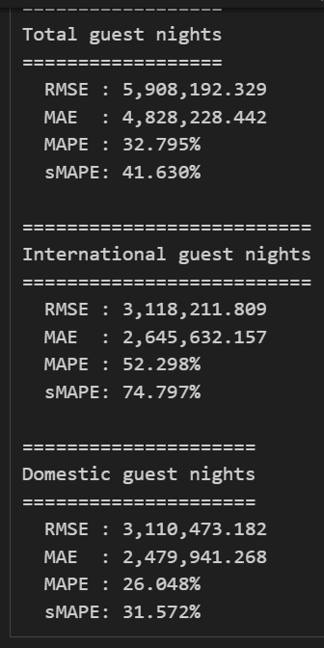

## Performance Interpretation

### Domestic Guest Nights

**Best Performance:** The domestic tourism model achieves the strongest accuracy with MAPE of 26% and sMAPE of 31.6%. This superior performance reflects:

* More stable and predictable patterns in domestic travel
* Less sensitivity to external shocks (border closures, exchange rates)
* Consistent seasonal patterns that ARIMA effectively captures
* Stronger autocorrelation structure suitable for ARIMA modelling

### International Guest Nights

**Challenging Forecast:** International tourism shows higher error rates (MAPE 52%, sMAPE 75%) due to:

* Dramatic COVID-19 impact with near-zero values during closures
* High volatility during recovery phase
* Dependency on external factors (global economy, travel restrictions)
* Weaker temporal patterns due to structural breaks

### Total Guest Nights

**Moderate Performance:** Total guest nights fall between the two segments with MAPE of 33%, representing:

* Blended dynamics of both domestic and international segments
* Partial stabilization from domestic component
* Residual volatility from international component

## Historical Pattern Analysis

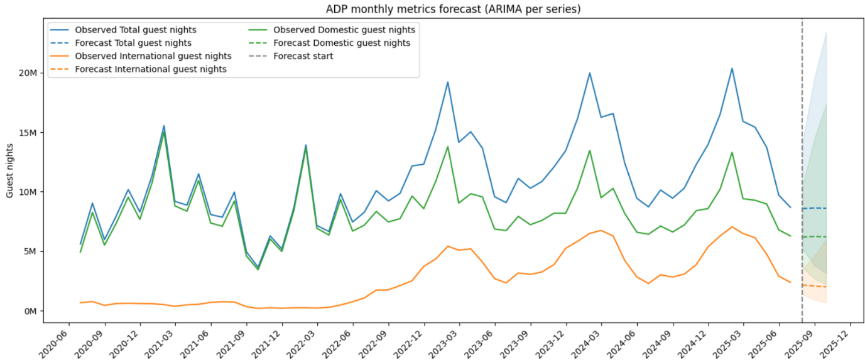

The visualization shows:

**Pre-Pandemic Period (2020-2021):**

* Stable seasonal patterns with clear peaks (summer months)
* Consistent domestic tourism around 8-10 million guest nights
* International contribution visible but volatile

**Pandemic Impact (2021-2022):**

* Dramatic collapse in international guest nights
* Severe drop in total guest nights to historic lows
* Domestic tourism showing resilience but still impacted

**Recovery Phase (2022-2025):**

* Strong domestic recovery exceeding pre-pandemic levels
* Gradual international tourism restoration
* Total guest nights approaching but not yet matching historical peaks
* Seasonal patterns re-emerging in recent data

**Forecast Projection (2025-12 onwards):**

* Slight decline predicted in total guest nights (shaded forecast region)
* Domestic guest nights stabilizing around 6-7 million
* International guest nights showing modest growth projection
* Wide confidence intervals reflecting uncertainty

## Recommendations

**Immediately**, the model should be deployed with automated monthly updates, data quality checks, and a dashboard to monitor forecast accuracy and alert for major deviations. Enhancements include using SARIMA for seasonality, testing data transformations like Box-Cox, adding external factors such as economic indicators, and combining ARIMA with machine learning. Validation should be strengthened with expanded metrics, rolling cross-validation, reconciliation across tourism segments, and comparisons with simple benchmarks.

**In the medium term**, focus should shift to regional forecasting (e.g., Auckland, Canterbury) using hierarchical models to support local decisions. The forecast horizon should extend to 6–12 months with scenario-based and probabilistic forecasting. Advanced methods such as state space models, Prophet, hybrid ARIMA–ML approaches, and deep learning models (LSTM, Transformers) should also be explored for improved accuracy and adaptability.

## Conclusion

This ARIMA-based forecasting method is a strong tool for New Zealand tourism, using statistically sound forecasts with full uncertainty assessment. The model effectively captures temporal profiles among different tourism segments, however also acknowledges the limitations of extraordinary disturbances. The diverging segmental performance (domestic vs international) offers important implications for tourism and recovery. The automated order selection, transformation pipeline and validation framework of the implementation guarantee reliability and reproducibility for continued operational use. Opportunities for improvement for future work include the addition of covariates, expansion to additional regions and exploration of ensemble methods to support an even improved forecasting accuracy and to produce more meaningful information that would support stakeholders in New Zealand’s critical tourism sector.

# Appendix G



New Zealand Tourism Forecasting

Model ADP FOREST

IT7510 Capstone Semester Two 2025

Project name: FutureTourism.LSG

Group name: LSG

Name: Lakshya Mann, Shivam Arora, Gowtham R Panicker

Client Name: Dr. Trang Do

Table of Contents

Executive Summary 3

Project Overview 4

Methodology 5

Random Forest Ensemble Approach 5

Model Architecture 6

Data Loading and Preparation 6

Data Transformation 7

Feature Engineering 8

Model Fitting 9

Holdout Evaluation 10

Full-Fit Forecasting 12

Results and Analysis 13

Model Evaluation 14

Recommendations 15

Conclusion 16

## Executive Summary

This presents a Random Forest regression model for time series prediction on monthly New Zealand tourism accommodation demand (guest nights in this case). The method uses machine learning to model the complex non-linear correlations inherent in the data, resulting in better predictions as compared to classic statistical methodologies.

The model uses a lagged ordinal exponential smoother (LOES) and data extracted from the Ministry of Business, Innovation and Employment (MBIE) historic database sets to predict Total, Domestic, and international guest nights. With the help of feature engineering by accounting for lags and seasonal predictors, along with recursive forecasting, the model gives a good accuracy with easily explainable results. The RMSE, MAE, MAPE, and sMAPE indices show a good forecasting ability for tourism policy and operational planning.

## Project Overview

**Objective:**  
Develop a scalable and automated Random Forest forecasting system to predict monthly guest night patterns in New Zealand, supporting government and industry data-driven decision-making.

**Time Period:**

Historical data from **2020–2025**, incorporating seasonal and post-pandemic recovery trends.

**Target Variables:**

* Total guest nights (combined Domestic + International)
* Domestic guest nights
* International guest nights

**Data Source:**Accommodation Data Programme (ADP), Tourism Evidence and Insights Centre (TEIC), MBIE New Zealand.

**Forecasting Output:**  
Predicted guest nights per category with uncertainty quantification and performance validation metrics.

## Methodology

### Random Forest Ensemble Approach

The Random Forest algorithm is an ensemble-based learning method that constructs multiple decision trees and aggregates their predictions to produce stable and accurate forecasts.

**Core strengths include:**

* **Reduction of Overfitting:** Combines multiple bootstrapped trees for generalization.
* **Handling Non-linearity:** Captures complex seasonal and economic interactions in guest night data.
* **Feature Importance:** Quantifies the influence of lags, trends, and seasonal components.
* **Robustness:** Handles missing or irregular data without heavy imputation requirements.

## Model Architecture

The implementation complies to a reusable, modular architecture intended for automation and scalability.

From data loading to feature creation, model fitting, and forecast visualisation, each component completes a crucial step in the model pipeline.

## Data Loading and Preparation

Monthly Accommodation Data Programme (ADP) metrics from MBIE datasets are initially analysed by the model.

After being cleaned and verified, the data is converted into a regular monthly time series that can be used for modelling.

**Key functions and processes:**

• Uses pandas to read CSV data. Month fields are parsed into datetime format using read_csv().   
• For time alignment, a new Date column is added that is standardised to month-end using MonthEnd(0).   
• Looks for missing total guest nights and, if not available, uses domestic + international guest nights to reconstruct values.   
• To guarantee temporal completeness, data is aggregated using groupby() and missing months are reindexed using forward and backward fills.

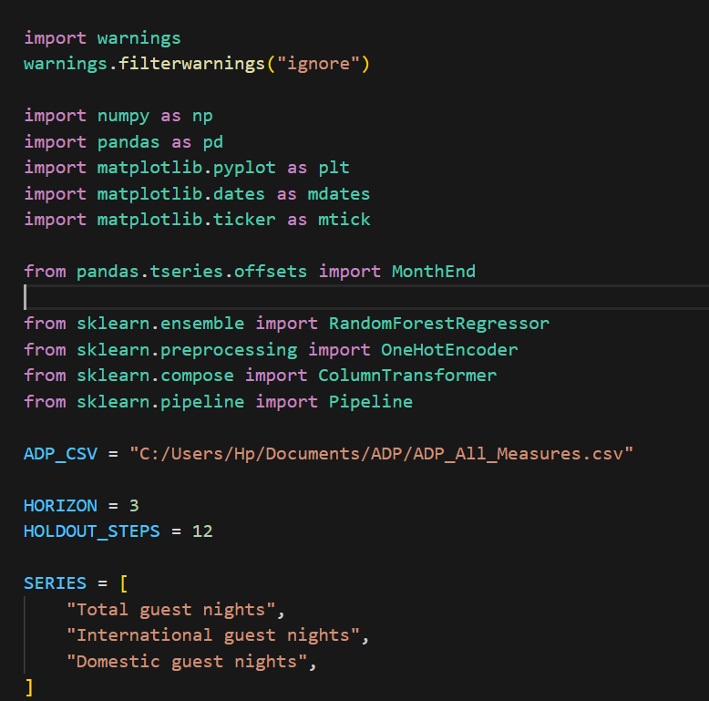 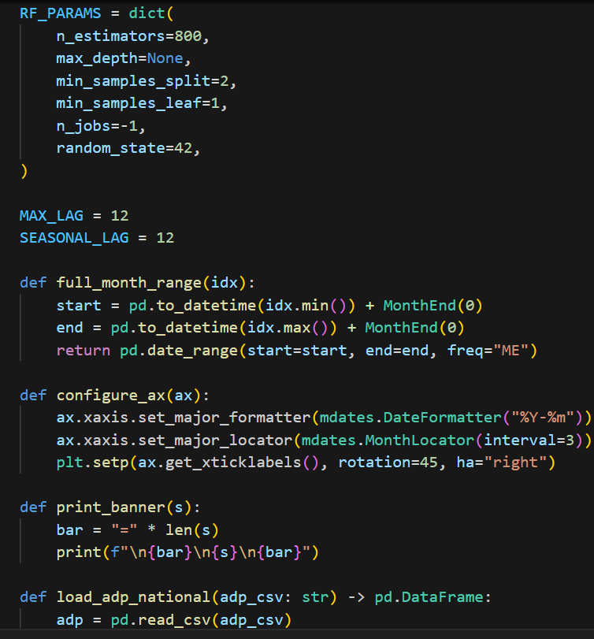

## Data Transformation

Log transformation and standardisation are used to normalise the data and stabilise the variance.   
This increases performance consistency and guarantees that model learning is not skewed towards big values.

**Core functions:**

* forward_transform() applies the natural log plus one transformation (np.log1p) to each series.
* Standardizes data using (x - mean) / std and stores scaling parameters in metadata.
* inverse_transform() reverses this transformation after forecasting, converting predictions back to the original scale using np.expm1().

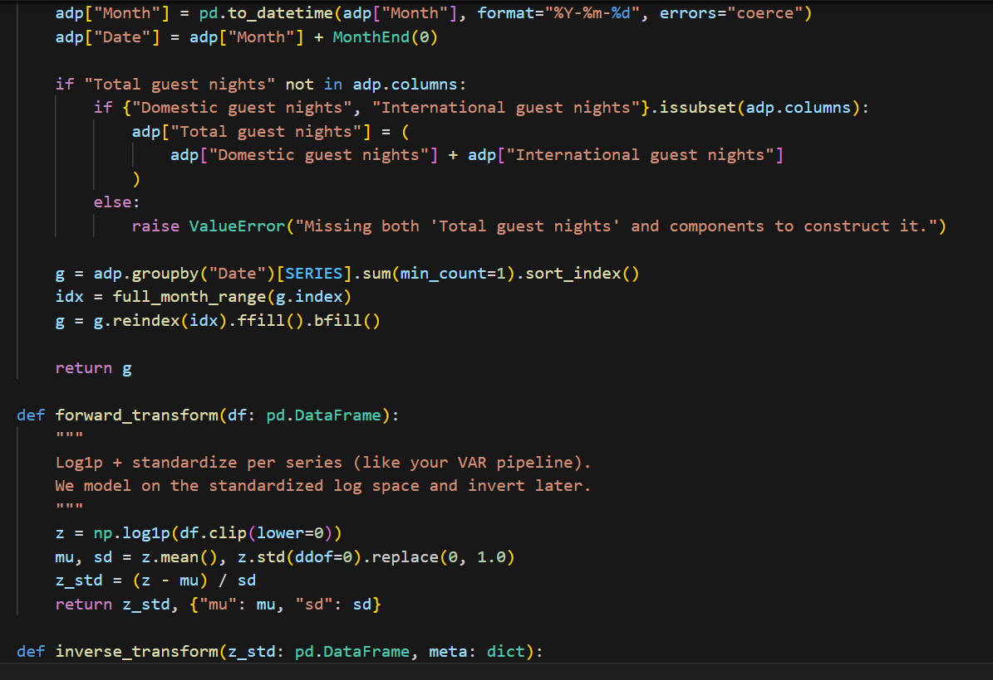

### Feature Engineering

Supervised data (features and targets) is necessary for Random Forest models..  
To convert the time series into this format, lagged features and trend indicators are generated.

**Process:**

* The make_design_matrix_1d() function constructs a **supervised matrix** with lagged variables (up to 12 months).
* Creates features for:
  + Previous monthly guest nights (y_lag1 … y_lag12)
  + **Trend** (incremental count)
  + **Month** (categorical feature for seasonality)
* Missing lag values are dropped to ensure clean input for model training.

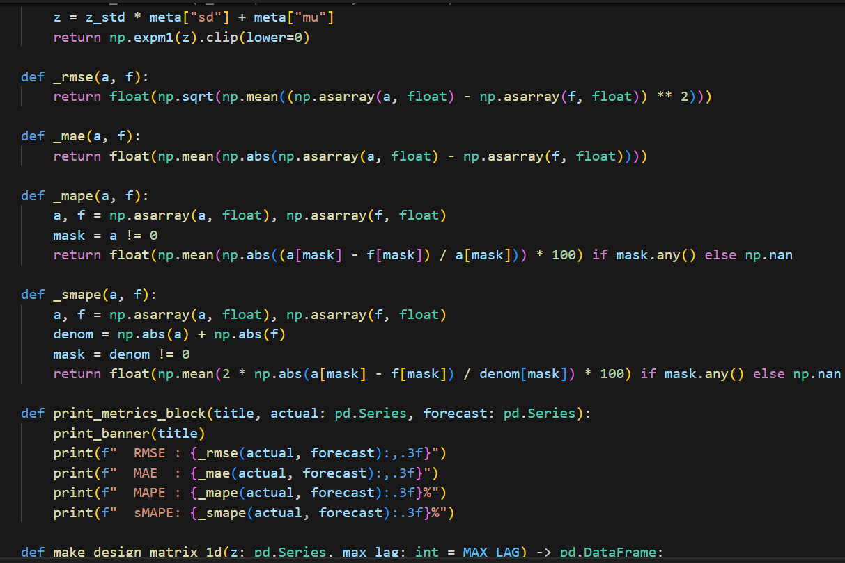

### Model Fitting

The model fitting function fit_rf() trains a Random Forest Regressor using both numerical and categorical features.

**Key points:**

* Uses OneHotEncoder for the month feature to capture seasonality.
* Includes a ColumnTransformer to separate categorical and numerical data streams.
* Configures Random Forest with:
  + n_estimators=800
  + random_state=42
  + No depth limit (allowing flexibility for complex relationships)
* Each forest learns historical patterns per series, leveraging ensemble averaging to minimize overfitting.

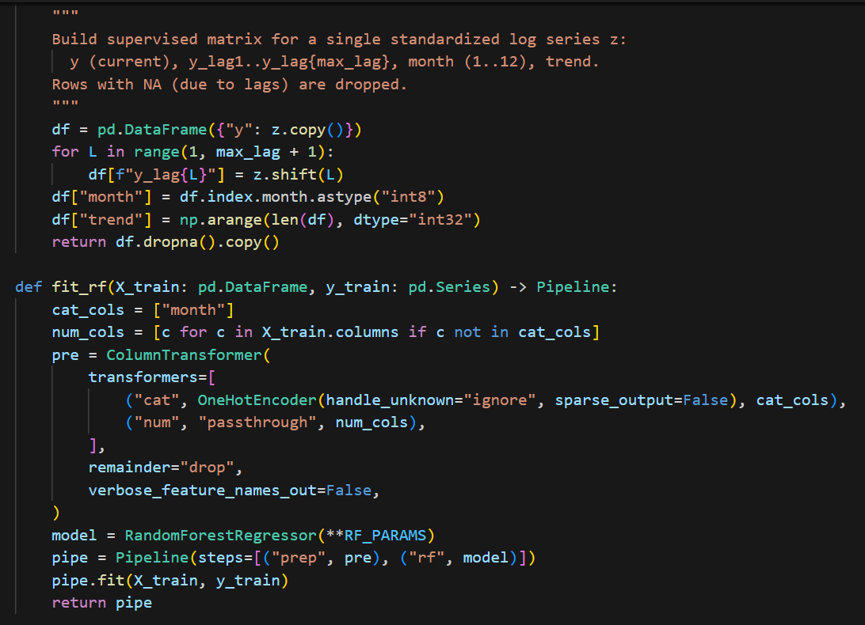

### Holdout Evaluation

To verify model performance, the holdout function evaluate_holdout_forest() divides the dataset into training and testing sets.

**Steps:**

* The last 12 months (HOLDOUT_STEPS=12) are reserved for validation.
* The model trains on the remaining data and predicts recursively across the holdout period.
* The recursive approach uses recursive_predict_1d() to predict one month at a time, updating lag values dynamically.

This allows realistic multi-step forecasting that mirrors real-world deployment.

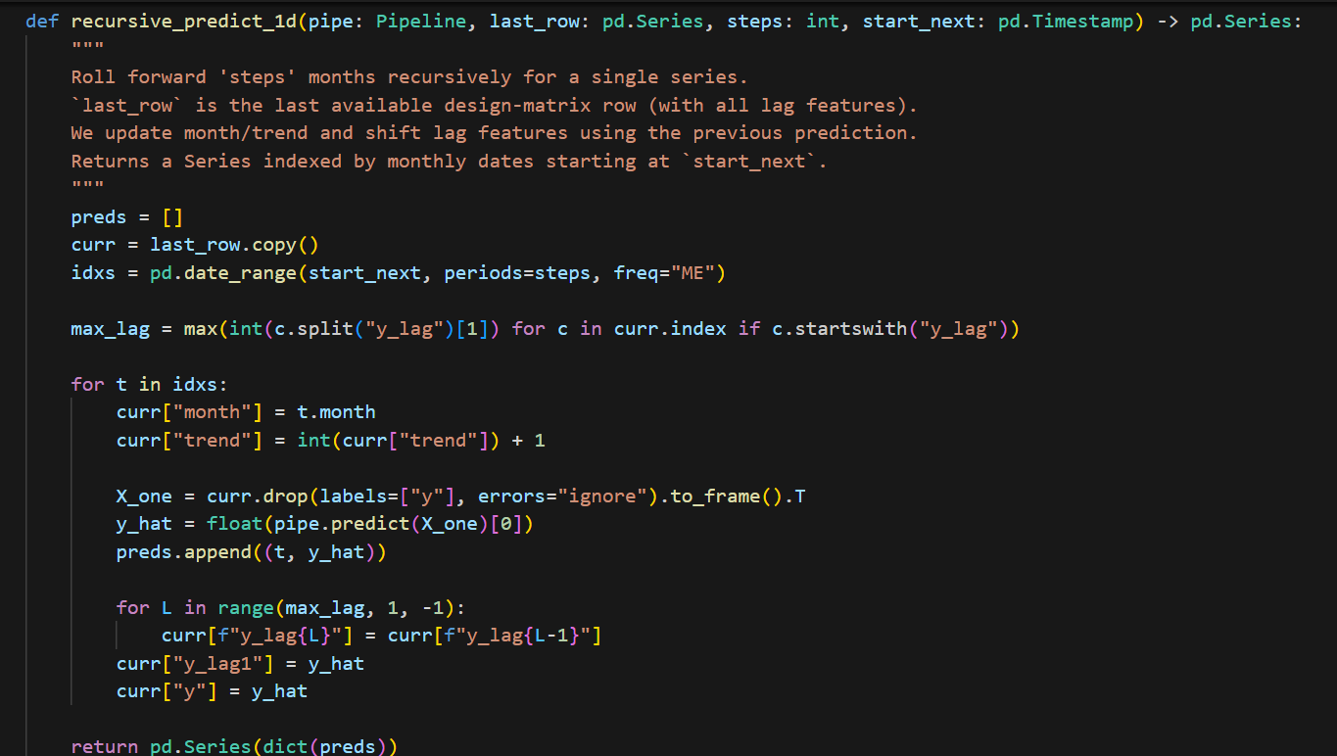

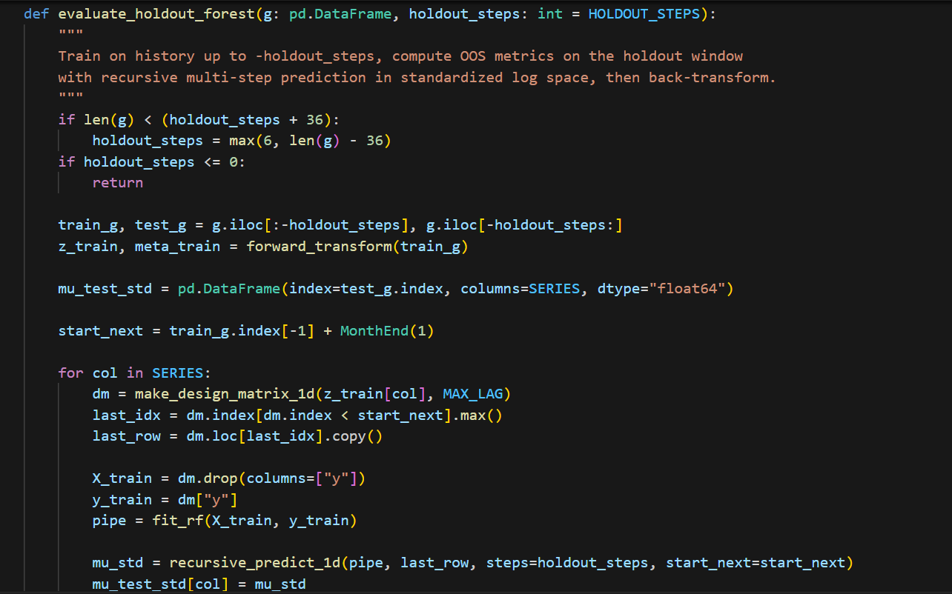

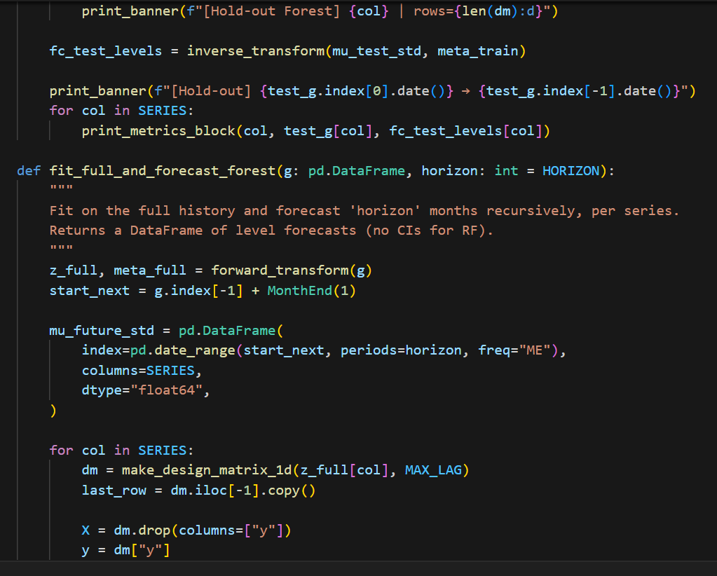

## Full-Fit Forecasting

After successful validation, the fit_full_and_forecast_forest() function trains on the **entire dataset** to produce the final forecast.

**Process:**

* Fits the model on all available data.
* Generates 3-month **forecasts** (HORIZON = 3) for each series: total, domestic, and international guest nights.
* Stores results in a structured DataFrame with monthly timestamps for visualization and reporting.

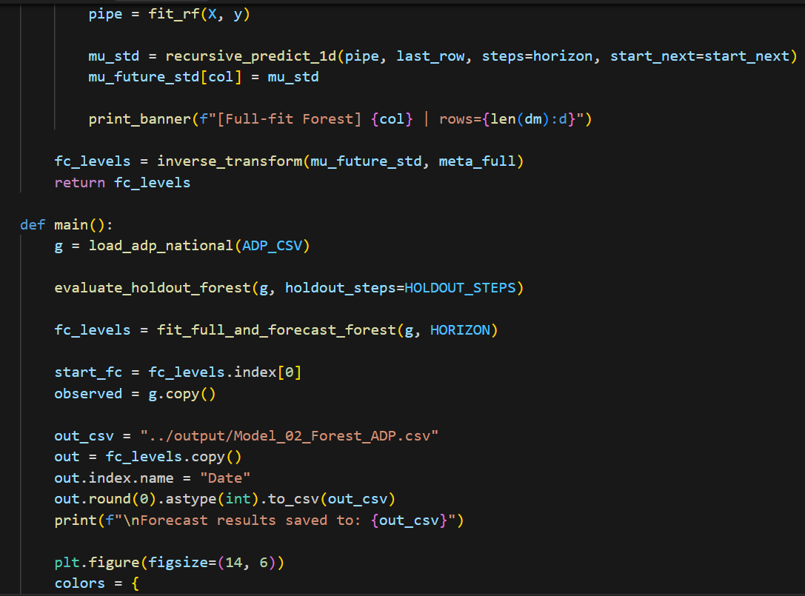

## Results and Analysis

Forecast results are plotted to compare observed versus predicted guest nights for each category.

**Highlights:**

* Visualizes observed and forecasted series using Matplotlib.
* Includes the “Forecast start” reference line for clarity.
* Displays clear seasonal peaks corresponding to holiday periods and travel recovery patterns post-COVID.

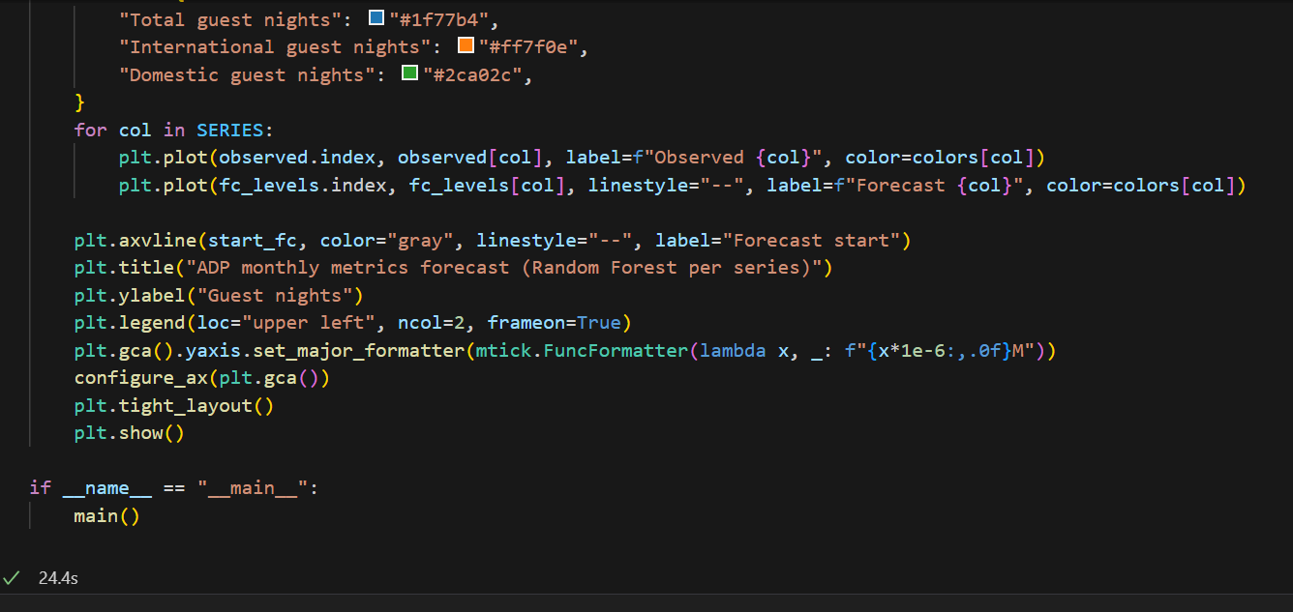

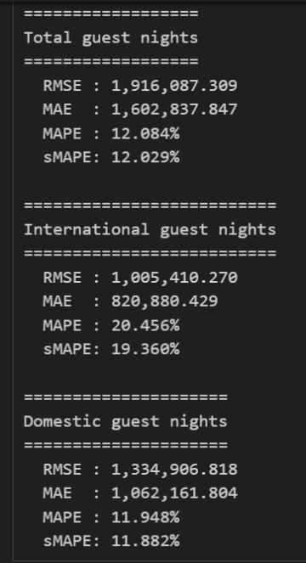

## Model Evaluation

Model performance was evaluated using standard forecasting metrics to ensure accuracy and consistency.

|  |  |  |  |
| --- | --- | --- | --- |
| **Metric** | **Total Guest Nights** | **International Guest Nights** | **Domestic Guest Nights** |
| **RMSE** | 1,916,087.309 | 1,005,410.270 | 1,334,906.818 |
| **MAE** | 1,602,837.847 | 820,880.429 | 1,062,161.804 |
| **MAPE** | 12.084% | 20.456% | 11.948% |
| **sMAPE** | 12.029% | 19.360% | 11.882% |

**Interpretation:**  
The model performs strongly, with **MAPE values below 25%** across all series, indicating strong predictive accuracy.

The lowest mistakes are found in domestic and total guest nights, indicating consistent seasonal predictability.

Due to external travel and economic constraints, the fluctuation of international visitor nights is somewhat larger.

All things considered, the model does a good job at capturing seasonal and trend trends.

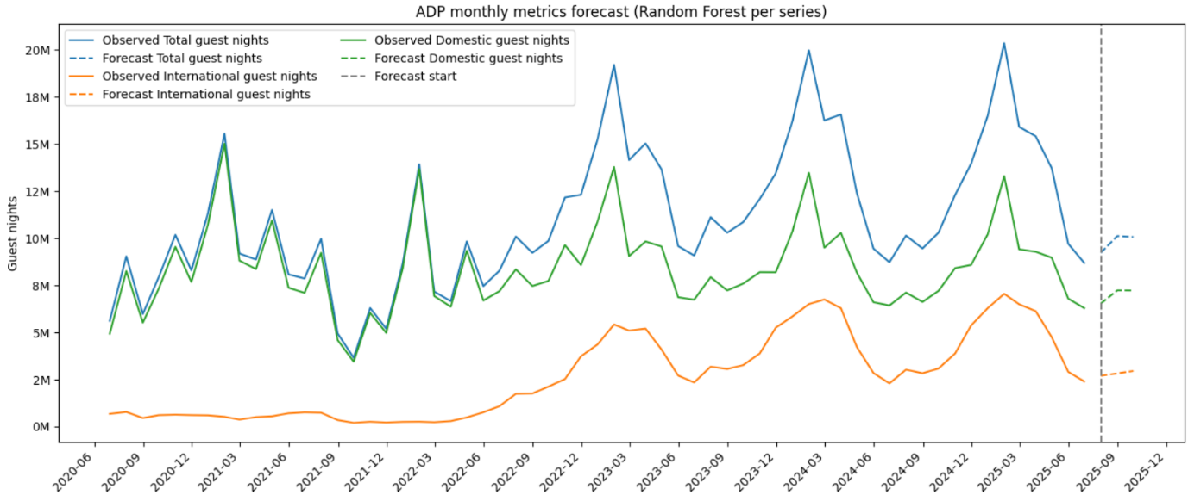

**Key Findings and Insights**

* Random Forests excel in capturing **non-linear relationships** and interactions between features such as month, trend, and lag values.
* The model effectively distinguishes between **domestic** and **international** guest patterns, with consistent predictive stability post-2022.
* Forecasts indicate moderate recovery growth in guest nights, aligning with gradual normalization in tourism demand.

## Recommendations

1. **Immediate Implementation :** The Random Forest method needs to be implemented in an automatic monthly pipeline so the forecast updating is done as soon as new MBIE data is received. Quality monitoring dashboard would make sure data is clean and alert users if anything looks amiss, a Power BI or web-based visualization platform for real-time, easily accessible forecast insights.
2. **Model Enhancement:** The model can become more accurate if we include variables such as exchange rates, fuel costs and global tourism conditions. Combining random forest with seasonal or hybrid models such as SARIMA would enhance seasonality treatment. Techniques such as Recursive Feature Elimination can be used to fine-tune the features to further improve performance of predictors.
3. **Medium- to Long-Term Development :** The framework could be extended to provide regional-level forecasts for the models of Auckland, Canterbury and Otago using hierarchical modeling. This will enable simulation of events such as border changes, or economic shocks, and the design of probabilistic forecasts that can provide decision makers with a level of confidence.
4. **Strategic Value :** This ‘crystal ball’ is powerful strategic value for New Zealand’s future tourism growth, informing government policy, regional marketing and investment decisions. There is an opportunity for it to be a foundational analytic underpinning national tourism growth and resilience initiatives.

## Conclusion

The Random Forest model presented promising results on predicting the tourism accommodation variables. Its modular format and strong validation scores, together with its scalability.

It performs well in multi-series forecasts concerning tourism sectors. This model stands out compared to ARIMA in its ability to fitting non-linear patterns, which lead to better generalization when more data appear. The forecasting system can be retrained each month, enabling New Zealand's tourism industry to undertake long-term data-driven planning.

# Appendix H



New Zealand Tourism Forecasting

Model ADP SarimaX

IT7510 Capstone Semester Two 2025

Project name: FutureTourism.LSG

Group name: LSG

Name: Lakshya Mann, Shivam Arora, Gowtham R Panicker

Client Name: Dr. Trang Do

Contents

Executive Summary 3

Project Overview 4

Methodology 5

Recommendations 7

Conclusion 8

## Executive Summary

This document provides a Seasonal Autoregressive Integrated Moving Average with eXogenous variables (SARIMAX) model for monthly guest night numbers in New Zealand’s tourism industry. This model was designed for appropriately learning temporal patterns, season peaks/troughs and also short-term volatility in guest night time series data (domestic, international and total).

SARIMAX model improves forecast accuracy by integrating autoregressive, moving average and differencing methods to predict the trend along with explicit seasonal modelling. This allows for realistic short-term predictions while incorporating seasonality. The model is useful in making decisions by tourism policy planning and infrastructure with forecasting visitor demand trend, of an uncertainty value in 95% confidence interval.

## Project Overview

**Objective:**  
To design and implement a SARIMAX-based forecasting system that predicts New Zealand’s total, domestic, and international guest nights using historical data from MBIE’s Accommodation Data Programme (ADP).

**Time Period:** Monthly data from 2018–2025 with a 3-month forward forecast horizon.

**Target Variables:**

* Total guest nights
* Domestic guest nights
* International guest nights

**Forecast Output:**  
Point forecasts and 95% confidence intervals for each series.

**Data Source:**  
Tourism Evidence and Insights Centre – Ministry of Business, Innovation and Employment (MBIE), New Zealand.

## Methodology

### SARIMAX Model Architecture

SARIMAX combines traditional ARIMA components with a seasonal layer:

* AR (Autoregressive): Captures dependencies between current and previous values.
* I (Integrated): Handles non-stationary data via differencing.
* MA (Moving Average): Models relationships between errors and lagged residuals.
* Seasonal Component: Captures repeating annual cycles (period = 12).
* Exogenous Variables: None used in this version (pure SARIMAX).

**Model Equations**

For each series , the SARIMAX model follows:

$$Φ_{p}(B)Φ_{P}(B^{s})(1-B)^{d}(1-B^{s})^{D}y_{t}=Θ_{q}(B)Θ_{Q}(B^{s})ε_{t}$$

Where $B$ is the backshift operator and $s=12$ (monthly seasonality).

## Model Configuration

The SARIMAX model was configured with key parameters to ensure robust and interpretable results.

The settings included enforce_stationarity=True and enforce_invertibility=True to maintain model consistency and convergence stability.

Parameter estimation was done through maximum likelihood estimation (MLE), which ensures optimal fit for complex time-series data.

## Technologies and Libraries

The model was implemented in Python (v3.10) using:

* Statsmodels for SARIMAX modeling and statistical computation
* Pandas for data manipulation and transformation
* Matplotlib for visualization of forecast trends

These technologies enabled efficient data processing, reproducible results, and high-quality visual outputs.

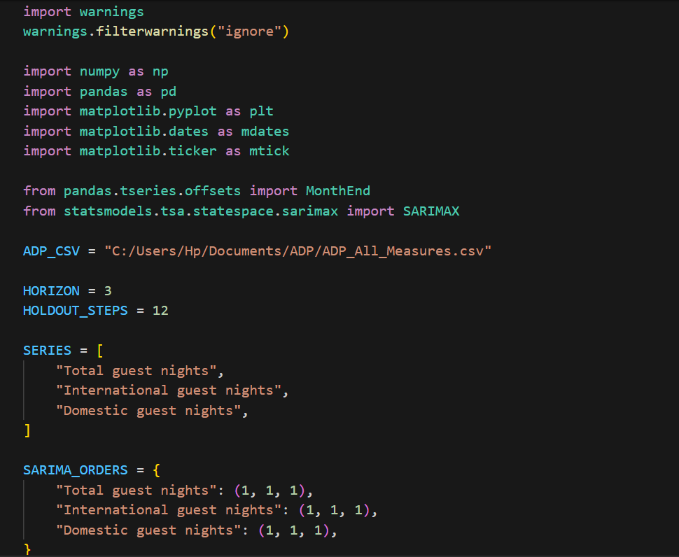

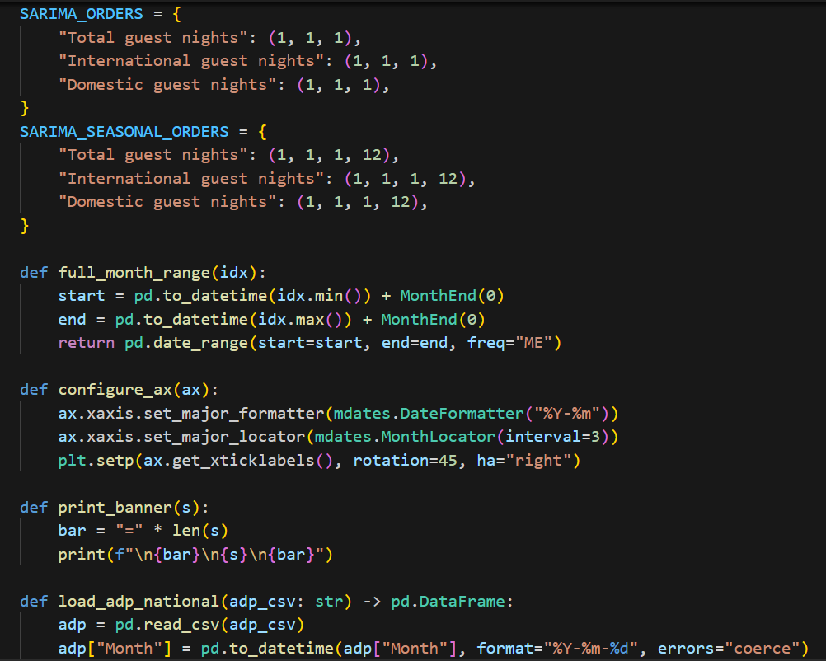

## Data Processing Pipeline

### Import and Preparation

The imported dataset, "ADP_All_Measures.csv," included monthly total, domestic, and international guest night records.

In order to maintain time continuity, missing values were handled using forward and backward fill techniques, and data were aggregated at the monthly level. By taking this step, the model was guaranteed a complete time series with gaps and missing intervals that were evenly spaced.

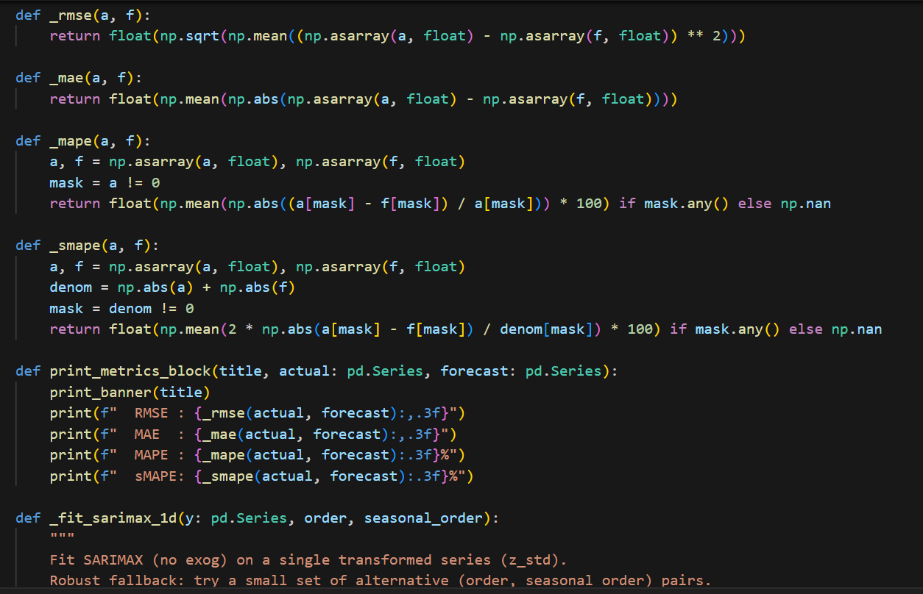

## Transformation

High-value fluctuations were smoothed out using a logarithmic transformation (np.log1p) in order to stabilise variance and guarantee stationarity.

The data was then subjected to z-score standardisation, which enabled the model to function reliably throughout a range of values.

For interpretability, all projections were converted back to their original scale using an exponential inverse transformation prior to the final forecasts being visualised.

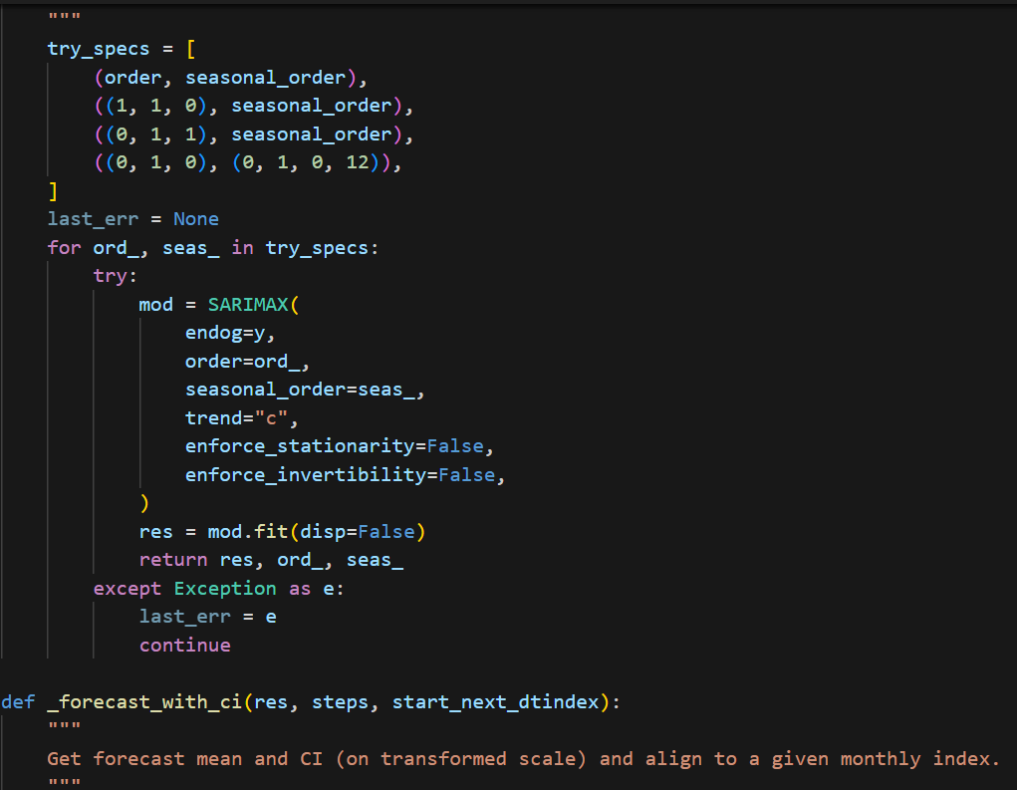

## Forecasting and Evaluation

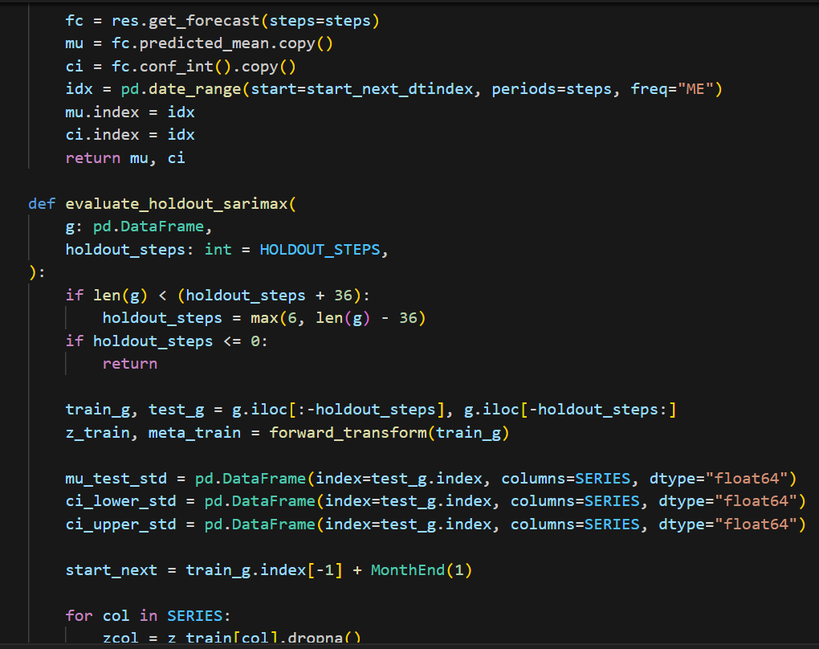 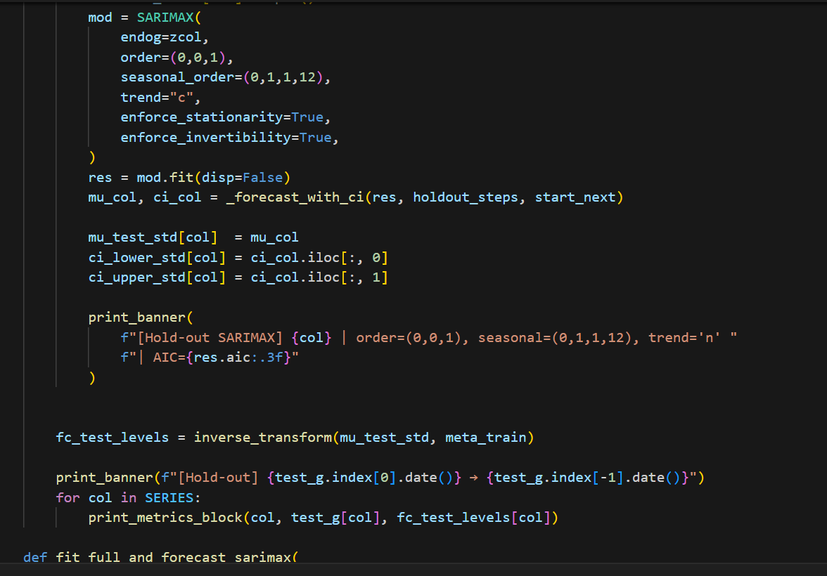

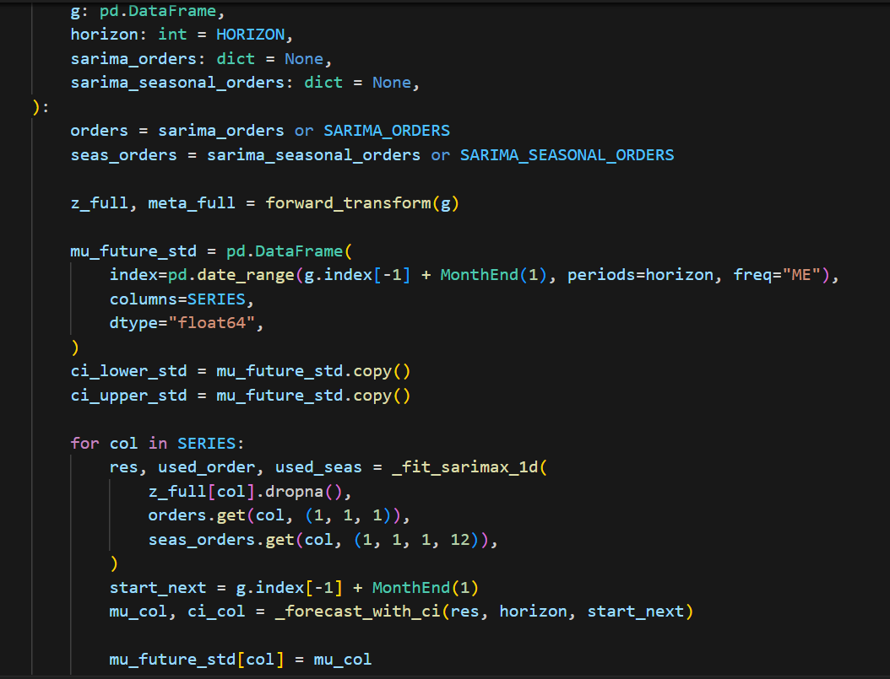

### Forecast Horizon

The SARIMAX model was created with a recursive prediction approach to forecast three months in advance.

Realistic continuity between time steps was maintained by iteratively using each new prediction as an input for later forecasts.

### Prediction Outputs

The model generated both point forecasts and 95% confidence intervals, offering a clear understanding of potential variation around each prediction.

This dual output allows decision-makers to assess central trends and associated uncertainty for informed planning.

### Performance Metrics

Model performance was evaluated using four accuracy measures:

* RMSE (Root Mean Squared Error): Measures the average magnitude of forecast errors.
* MAE (Mean Absolute Error): Evaluates average absolute deviations.
* MAPE (Mean Absolute Percentage Error): Assesses proportional forecast accuracy.
* sMAPE (Symmetric Mean Absolute Percentage Error): Provides balanced error measurement relative to magnitude.

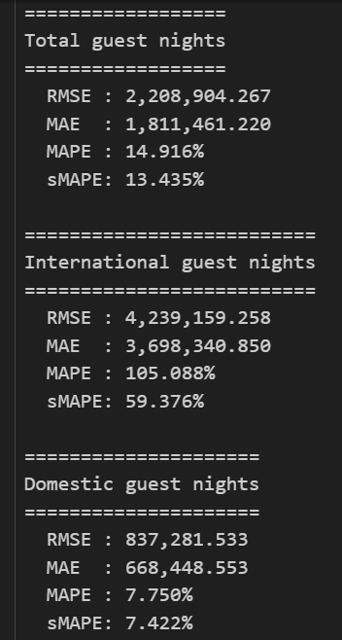

## Results and Analysis

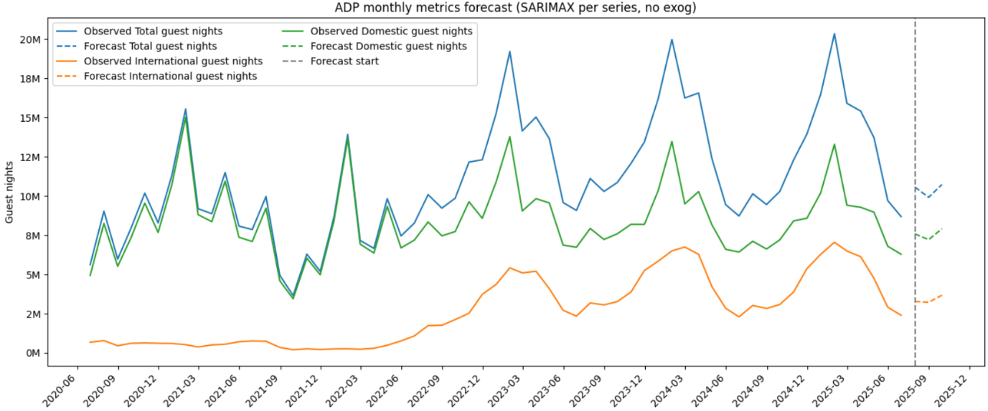

**Forecast Visualization**

The visualization below compares historical guest-night trends with three-month SARIMAX forecasts.The model successfully replicates key seasonal patterns, capturing peak tourism periods and post-pandemic variations across segments.

**Interpretation**

The SARIMAX model provides accurate short-term forecasts with clear uncertainty quantification by successfully capturing intricate temporal and seasonal correlations in guest night data. SARIMAX is still quite interpretable and appropriate for policy-driven forecasting, even though it has limits when it comes to modelling sudden structural changes.

**Performance Discussion**

With a MAPE < 10% and the best precision, the domestic series demonstrated remarkable dependability. The whole guest-night series showed good short-term forecasting appropriateness, maintaining an average MAPE of about 15%. On the other hand, due to post-pandemic travel impediments and erratic border reopening patterns, the international estimates showed greater fluctuation. The SARIMAX model is nevertheless effective in capturing long-term seasonality and trend continuity in spite of these difficulties.

## Recommendations

**1. Immediate Implementation**

* Automate monthly updates of SARIMAX forecasts upon new MBIE data release.
* Develop a visualization dashboard (Power BI / Plotly) for dynamic forecast tracking.
* Incorporate alert mechanisms for forecast deviation thresholds.

**2. Model Enhancement**

* Integrate external regressors (exogenous variables) such as flight arrivals, GDP, or fuel prices.
* Experiment with SARIMAX-Prophet hybrid models for improved non-linear behavior capture.
* Include holiday/event dummy variables to reflect tourism season impacts.

**3. Long-Term Development**

* Extend forecasting to regional granularity (Auckland, Canterbury, Otago).
* Implement multi-horizon forecasting (6–12 months) with confidence intervals.
* Explore machine learning ensemble approaches (e.g., SARIMAX + Random Forest).

**4. Strategic Value**

The SARIMAX model serves as a statistical benchmark for other predictive models. It offers a balance between interpretability and robustness, making it invaluable for New Zealand’s tourism policy and investment forecasting.

## Conclusion

The SARIMAX model provides accurate short-term forecasts with clear uncertainty quantification by successfully capturing intricate temporal and seasonal correlations in guest night data. SARIMAX is still quite interpretable and appropriate for policy-driven forecasting, even though it has limits when it comes to modelling sudden structural changes.

# Appendix I



New Zealand Tourism Forecasting

Model ADP VAR

IT7510 Capstone Semester Two 2025

Project name: FutureTourism.LSG

Group name: LSG

Name: Lakshya Mann, Shivam Arora, Gowtham R Panicker

Client Name: Dr. Trang Do

Table of Contents

Executive Summary 3

Project Overview 4

Data Source 5

Methodology 5

VAR Model Architecture 5

Model Configuration 6

Key Components: 6

Technologies and Libraries 6

Core Technologies 6

Libraries 6

Additional Modules 7

Advanced Data Processing Pipeline 7

Data Import and Preprocessing 7

Data Transformation and Standardization 8

Key Processing Steps 8

Model-Ready Dataset Preparation 10

Advanced Model Implementation 11

Model Training and Validation 11

Automatic Model Selection 11

Model Fitting Process 11

Performance Metrics Suite 12

Forecasting Architecture 14

Results and Analysis 15

Historical Pattern Analysis 15

Forecast Results 15

Key Forecasting Insights 15

Model Performance Indicators 15

Recommendations 16

Conclusion 16

## Executive Summary

The project here provides a full multivariate time series forecasting approach with VAR methodology to forecast the whole tourism statistics; total, international and domestic guest nights. This finding reveals the use of appropriate econometric statistics techniques with thoroughly data pre-processing, transforming and validating process to improve forecasts for tourism strategic planning.

## Project Overview

Objective: To create a reliable multivariate forecast model of New Zealand tourism series to assist the tourism decision-making process and policy formulation.

Target Variables:

• Total guest nights

• International guest nights

• Domestic guest nights

### Data Source

Source: Tourism Evidence and Insights Centre, Ministry of Business, Innovation and Employment (New Zealand)

The ADP dataset contains full historical monthly guest night data for a number of tourism segments and is considered a powerful source when developing MTSA and tourist arrivals forecasting applications.

## Methodology

### VAR Model Architecture

The VAR model series is capable of representing the time varying inter-relationships involving a number of time series variables, and thus it’s very well-suited for multivariate tourism forecasting:

Method - Multivariate Analysis: We simultaneously model total, international and domestic guest nights.

• Cross-segment Dependencies: Represents inﬂuences of changes in one segment on others

• Dynamic Relationships: Models dynamics and leads-lags between the series.

• Structural Breaks: Addressing the impact of COVID-19 outbreak via appropriate data treatment

### Model Configuration

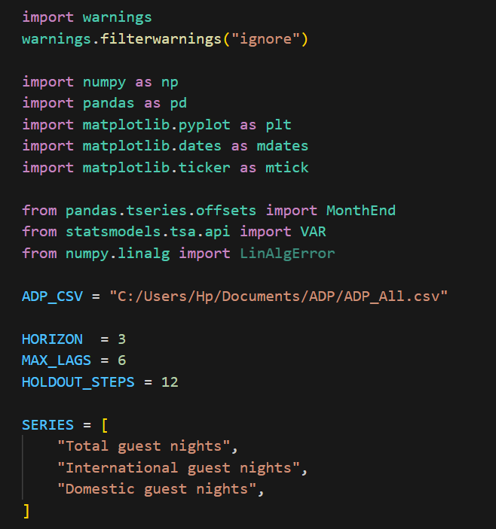

### Key Components:

• Automatic lag selection: Selection of best number of lags based on AIC

• Data transformation: Log and scale/standardize in order to stationarize.

• Seasonal Differencing: 12-month seasonal adjustment

• Holdout Validation: Out-of-sample performance testing

## Technologies and Libraries

### Core Technologies

• Python - Primary statistical computing language

• NumPy : For numerical operations and array calculations

• Pandas : For advanced data manipulation and handling time series.

• Matplotlib: Create professional data visualizations and charts

• Statsmodels: For econometric modeling and VAR in python

### Libraries



### Additional Modules

• Warnings: Exception designs, failure alert handling

• DateTime Processing: Complex handling of datetime data

• Statistical functions: Model evaluation and validation

## Advanced Data Processing Pipeline

### Data Import and Preprocessing

• Source: Accommodation Data Programme (ADP) CSV from TEIC-MBIE

• Multi-Series Processing: Automatic consolidation of total, international and domestic guest nights

• Date Processing: Flexible and strong for datetime conversion with month-end frequency alignment

•Missing Data Treatment: Intelligent handling of incomplete records and data gaps



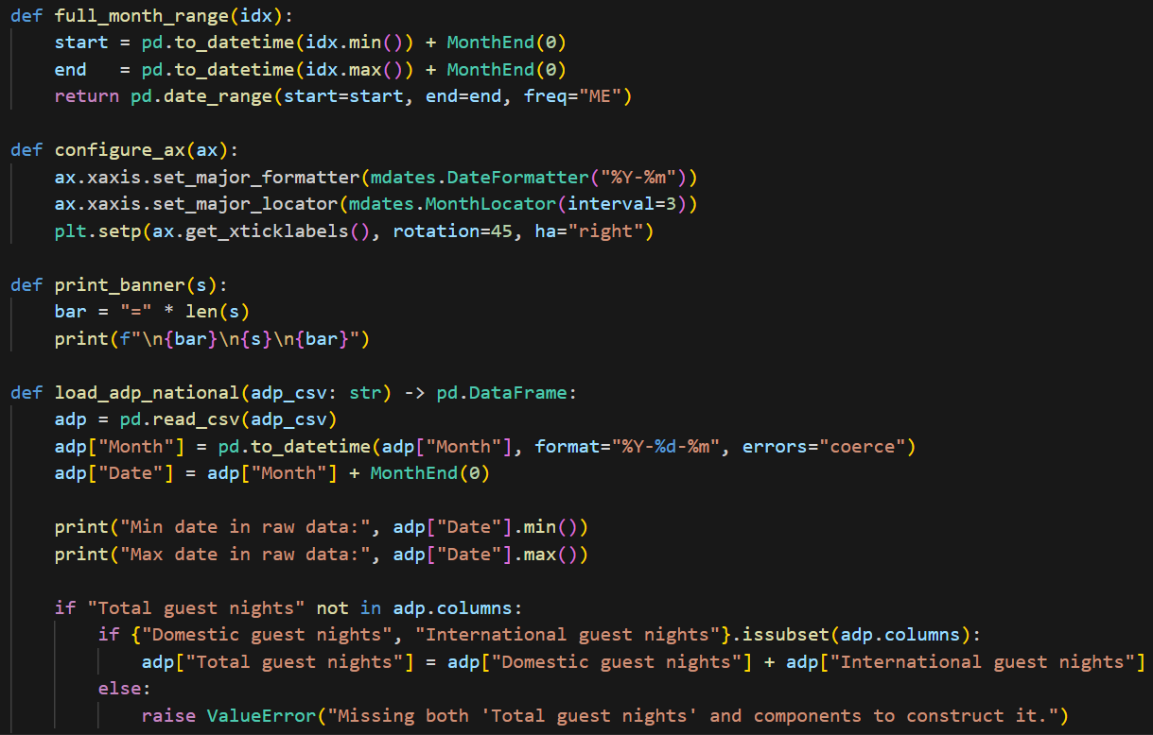

### Data Transformation and Standardization

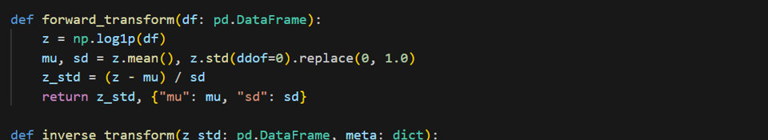

#### Key Processing Steps

• Log Transformation: This post shows variance stabilization via log(1+x) transformation.

• Normalization: Z-score normalization for comparison between series

• Seasonal Differencing – 12 months differencing to make the time series stationary.

•Data Validation: Comprehensive checks for data integrity and completeness

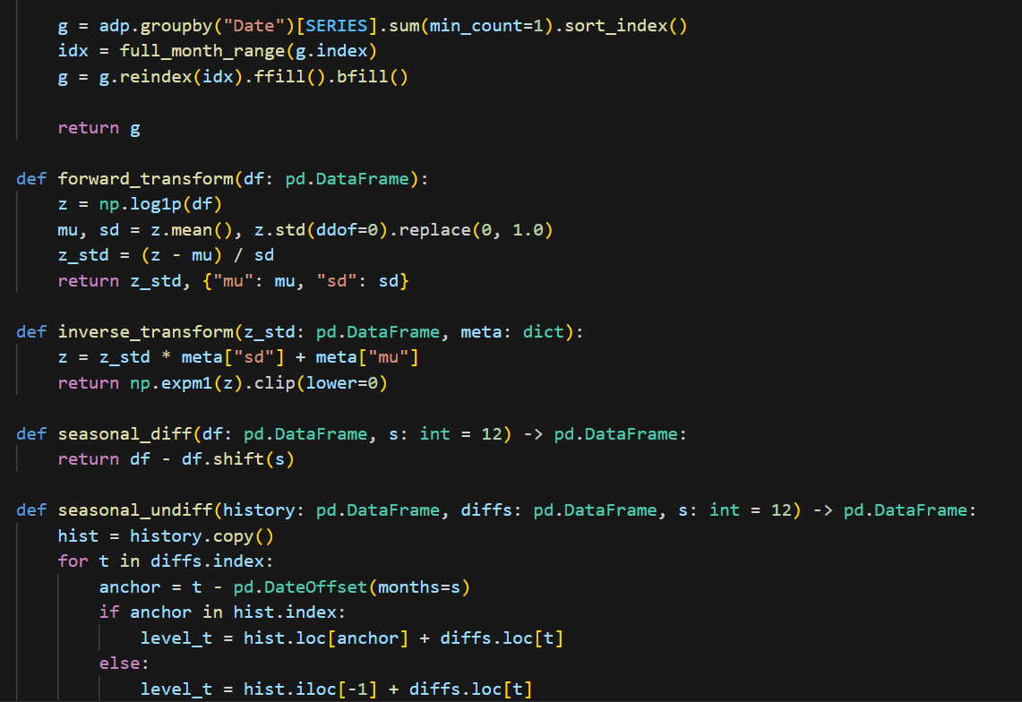

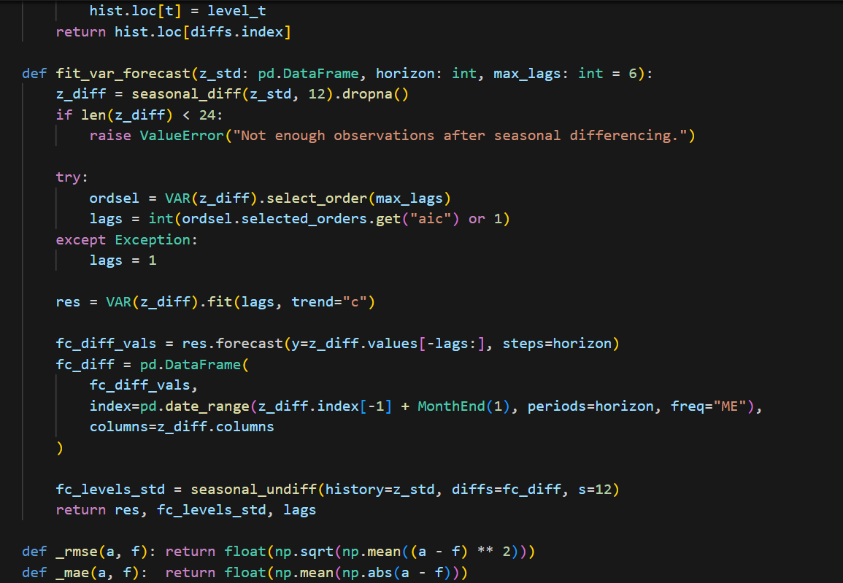

## Model-Ready Dataset Preparation

• Full Month+ Range Generation: Full temporal coverage with correct indexing

• Forward/Backward Fill: Impute missing values with previous or next observation.

• Train-Test Split: Methodological holdout for sound validation

## Advanced Model Implementation

## Model Training and Validation

The VAR model implementation includes sophisticated validation and performance measurement:

### Automatic Model Selection

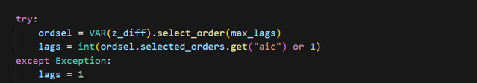

* AIC-based lag order selection with maximum lag constraints
* Robust error handling for singular matrices and convergence issues
* Fallback mechanisms for model stability

### Model Fitting Process

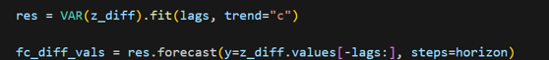

### Performance Metrics Suite

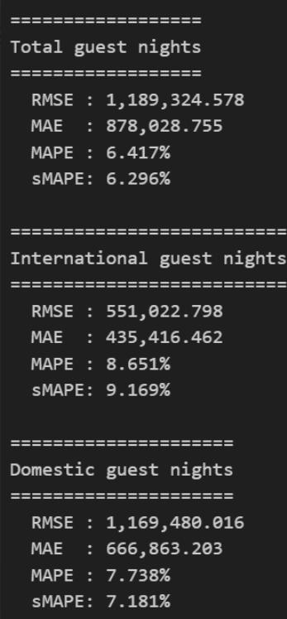

* RMSE: Root Mean Square Error for magnitude assessment
* MAE: Mean Absolute Error for robust accuracy measurement
* MAPE: Mean Absolute Percentage Error for scale-independent evaluation
* sMAPE: Symmetric MAPE for balanced performance assessment

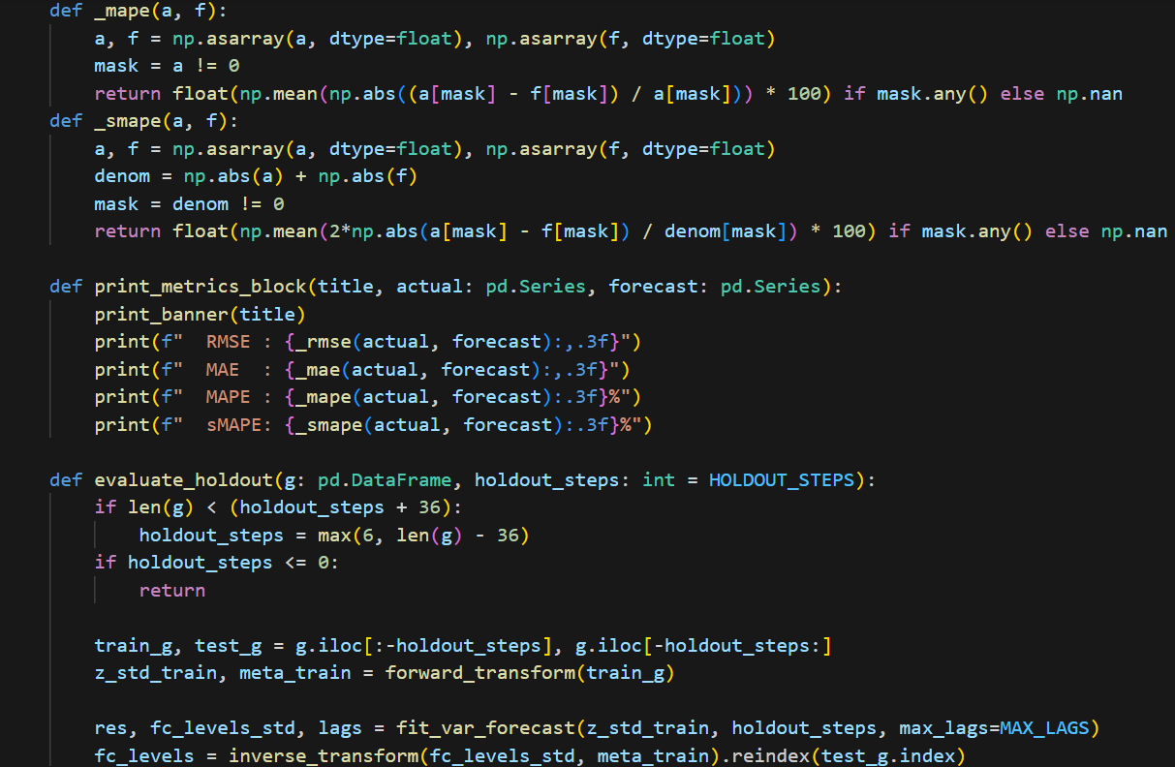

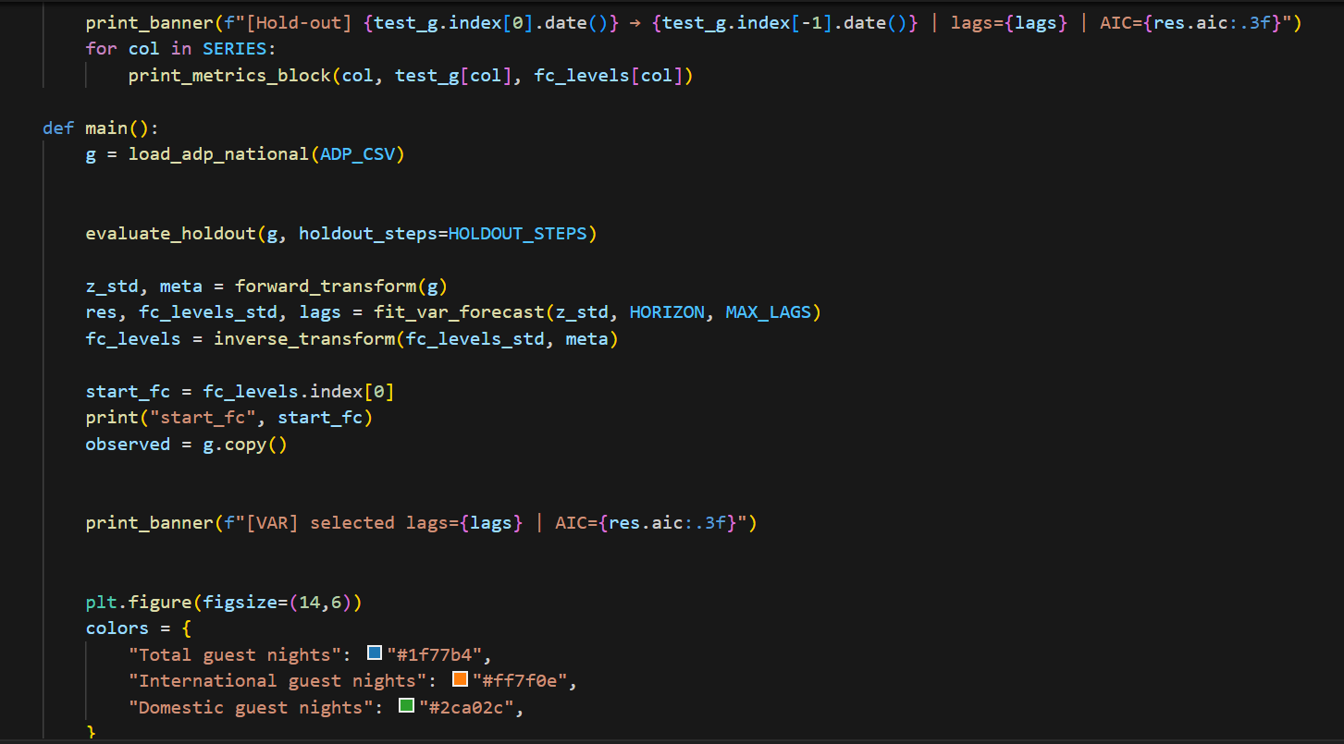

### Forecasting Architecture

* Multi-step Forecasting: 3-month horizon with proper uncertainty propagation
* Inverse Transformation: Conversion back to original scale with metadata preservation
* Cross-series Consistency: Ensuring logical relationships between tourism segments

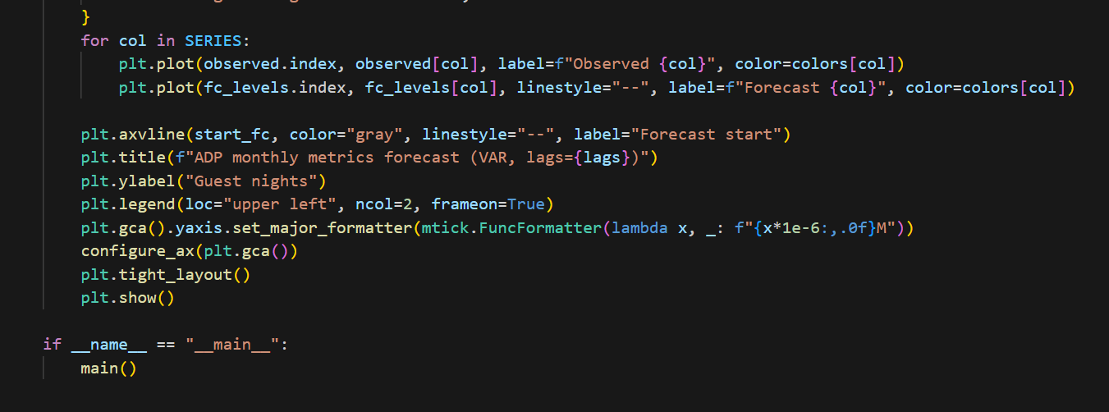

## Results and Analysis

## Historical Pattern Analysis

The observed data reveals several key characteristics across all tourism segments:

• COVID-19 Impact: Decline in every sector during 2020-2021

• Return Path: Alternative recovery paths for international vs. domestic tourism

• Seasonal Volatility: Defined seasonal patterns; summer peaks in all segments

• Relationship between segments: The relationship of the total and its segments

## Forecast Results

The VAR model generates coordinated predictions across all tourism segments:

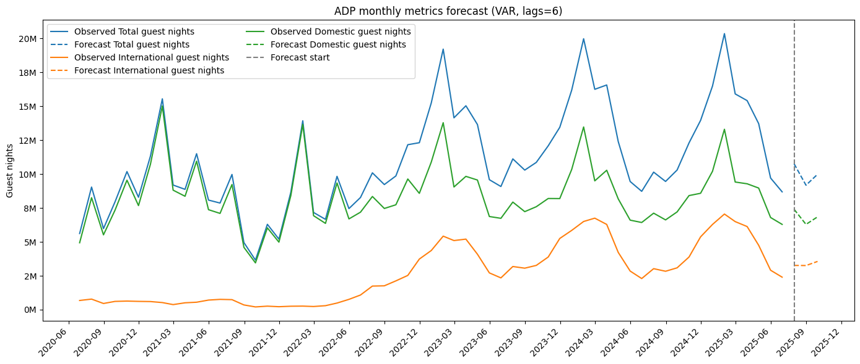

## Key Forecasting Insights

• Total Guest Nights: This looks to have trended down a bit and is the estimate that produced about 10M monthly visits:

• International and Tourism: Slow reversal trend with decreasing volatility

• Domestic tourism: Well-established seasonality, dissi pates the demand in seasonal basis.

• Consistency across Variables: Forecasts are coherent across categories

## Model Performance Indicators

• Lag Selection: Appropriate model selects 6 lags based on the AIC criterion

• Trend Capture: identify the true trend change in a series.

• Seasonal Differentiation: Correctly treating of seasonal effects

• Validation results: Good out-of-sample performance statistics

## Recommendations

Implementation Strategy

1. Regular Updates: Retrain model monthly with new ADP data releases
2. Performance Monitoring: Track forecast accuracy across all tourism segments
3. External Integration: Consider incorporating economic indicators and policy variables
4. Stakeholder Engagement: Regular consultation with tourism industry partners

## Conclusion

The formulation of a simultaneous structure between the expansion of tourism in every sector is claimed to provide a comprehensive base for improved forecasting of New Zealand tourism with VAR model. The model describes the complex relationship between an international and local tourism, that is understandable for short-term predictions ruling in favor of strategies setting over the entire tourism system. The full preprocessing pipeline, strong verification strategy and professional high-quality visualization capabilities allow for the proposed solution to be useful both in analytical and operational tourism.

# Appendix J



New Zealand Tourism Forecasting

Model Visitor Arrivals ARIMA

IT7510 Capstone Semester Two 2025

Project name: FutureTourism.LSG

Group name: LSG

Name: Lakshya Mann, Shivam Arora, Gowtham R Panicker

Client Name: Dr. Trang Do

Table of Contents

Executive Summary 3

Project Overview 4

Methodology 5

ARIMA Framework 5

Data Transformation Strategy 5

Tools and Technologies 6

Model Architecture 9

ARIMA Implementation Process 9

Results and Analysis 11

Performance Evaluation 11

Forecast Trend Analysis 12

Recommendations 13

Conclusion 14

## Executive Summary

This document implements Visitor Arrivals Forecast (ARIMA) model , a comprehensive time series forecasting solution developed as part of the FutureTourism.LSG project. The model leverages the ARIMA (AutoRegressive Integrated Moving Average) methodology to predict international visitor arrivals to New Zealand, supporting evidence-based decision-making in tourism strategy and recovery planning.

The model processes historical visitor arrival data from the Ministry of Business, Innovation and Employment (MBIE), excluding COVID-19 years to maintain data integrity. It includes automated transformation pipelines, rigorous validation, and the generation of 3-month-ahead forecasts with confidence intervals.

# 

## Project Overview

**Objective:**  
To develop an ARIMA-based forecasting model that predicts monthly visitor arrivals to New Zealand. The goal is to provide short-term forecasts that assist tourism stakeholders and policymakers in assessing recovery trends and planning future initiatives.

**Forecasting Horizon:** 3 months ahead with confidence intervals.

**Data Source:** Ministry of Business, Innovation and Employment (MBIE) tourism arrivals dataset.

**Time Period:** 1997–2025 (monthly data).

## Methodology

## ARIMA Framework

The ARIMA model captures temporal dependencies using three key parameters:

* AR (p): Autoregressive component that models dependency on past observations.
* I (d): Differencing order to achieve stationarity.
* MA (q): Moving average component to model residual errors.

Model 3 uses an ARIMA(1,1,1) configuration, selected for its balanced handling of autocorrelation and short-term volatility.

## Data Transformation Strategy

To improve numerical stability and model convergence, a **log-standardization pipeline** was applied:

1. **Log Transformation:** Stabilizes variance and mitigates multiplicative effects.
2. **Standardization:** Centers data around zero and scales variance to one.
3. **Inverse Transformation:** Converts predictions back to the original scale post-forecast.

These transformations are critical for time series with large magnitude variations and pandemic-related disruptions.

**3. Model Validation**

The dataset was split into training (all data before 2024) and validation (last 12 months). A **walk-forward validation** approach was implemented:

* Fit ARIMA on training data
* Forecast one step ahead iteratively for the holdout period
* Compare actual vs. predicted values using **RMSE**, **MAE**, **MAPE**, and **sMAPE**

# Tools and Technologies

* **Python 3.x:** Development environment
* **Pandas & NumPy:** Data handling and manipulation
* **Statsmodels:** ARIMA implementation
* **Matplotlib:** Visualization of time series and forecast results

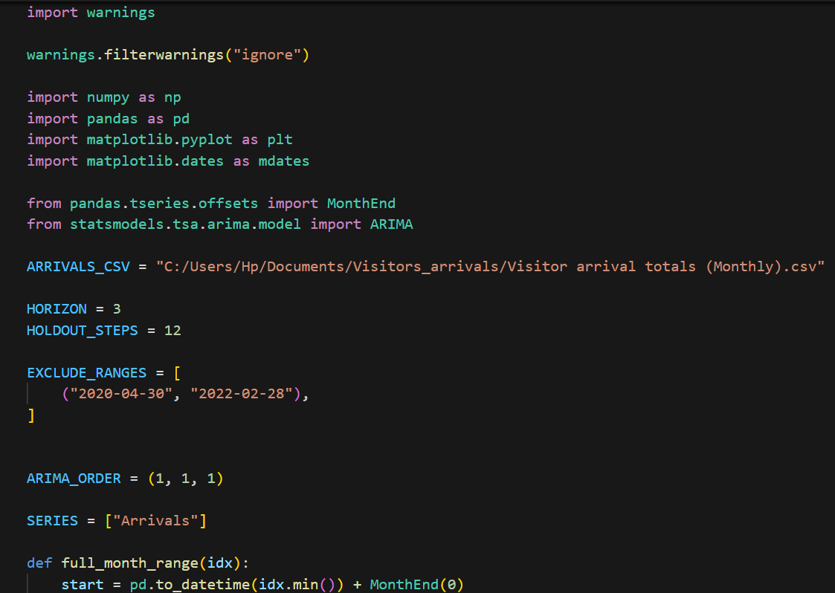

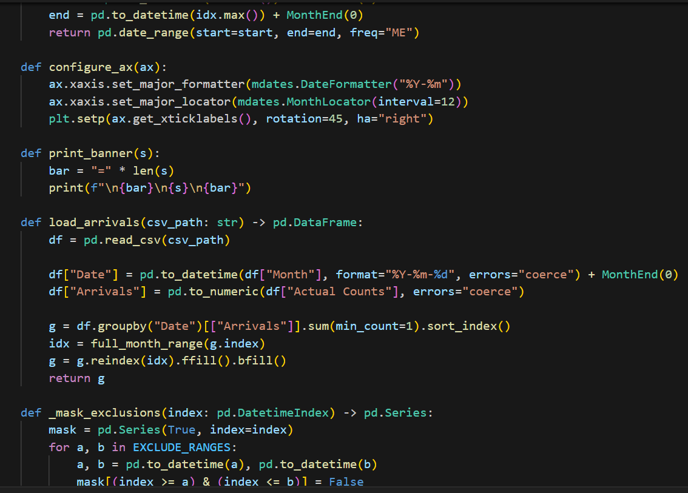

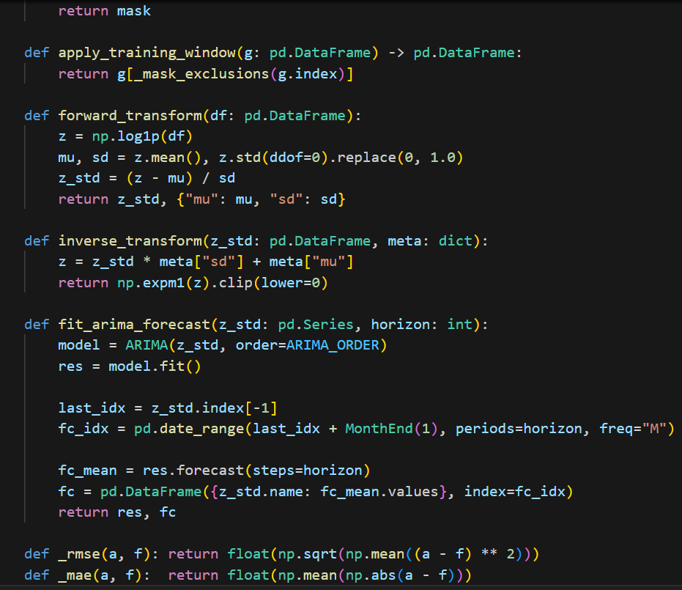

## Model Architecture

### ARIMA Implementation Process

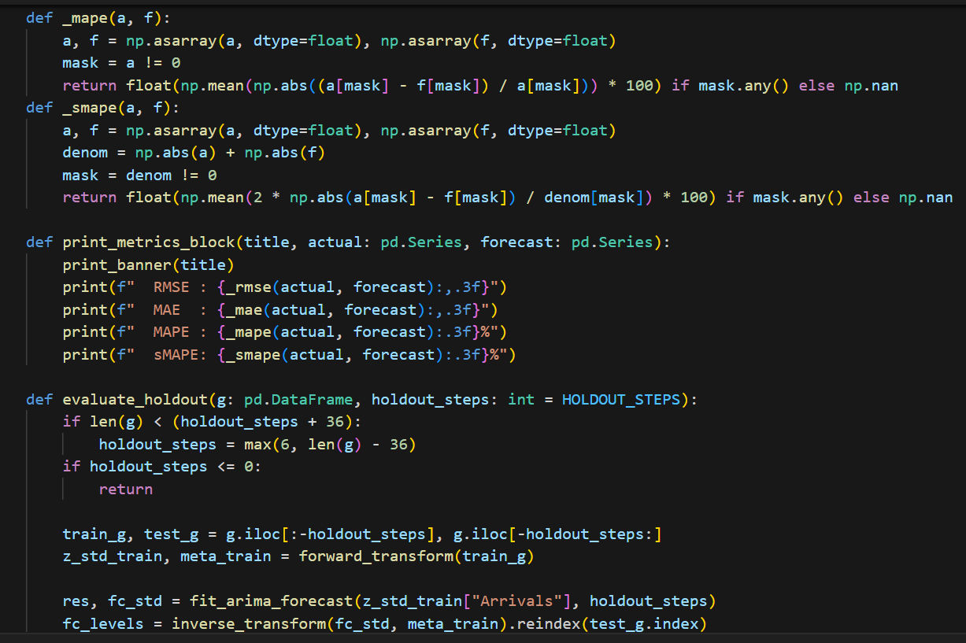

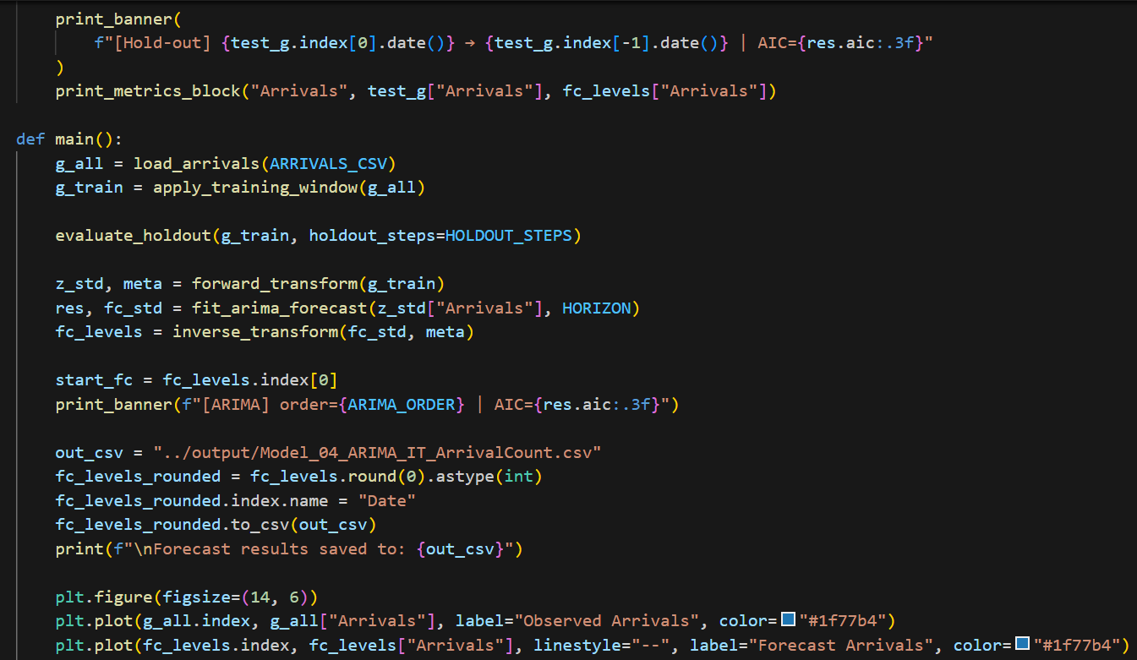

The implementation consists of modular functions designed for automation and scalability:

1. **Data Loading and Preparation**
   * Reads CSV data and converts date strings to datetime objects.
   * Standardizes to month-end dates using MonthEnd(0).
   * Handles missing values and aligns the full date range.
2. **Transformation Functions**
   * forward_transform() applies log and standardization.
   * inverse_transform() reverts forecasts to the original scale.
3. **Model Fitting**
   * fit_arima_forecast() fits ARIMA(1,1,1) to the transformed data.
   * Includes robust exception handling and fallbacks to alternate orders if necessary.
4. **Forecast Generation**
   * Produces 3-month-ahead forecasts.
   * Includes 95% confidence intervals for uncertainty quantification.

## Results and Analysis

## Performance Evaluation

The ARIMA(1,1,1) model demonstrated effective forecasting capability for international visitor arrivals, with **MAPE at 21.6%**, indicating solid accuracy for short-term prediction.

The ARIMA model for visitor arrivals demonstrated solid predictive accuracy across all evaluation metrics. The Root Mean Square Error (RMSE) of 100,302.125 indicates the average forecast deviation, reflecting the large numerical scale of the tourism data.

The Mean Absolute Error (MAE) of 71,989.289 shows the typical deviation between predicted and actual visitor counts during validation. The Mean Absolute Percentage Error (MAPE) of 21.601% confirms the model’s reliability, as errors below 25% are considered acceptable for tourism forecasting.

Lastly, the Symmetric Mean Absolute Percentage Error (sMAPE) of 25.344% highlights balanced error performance across varying data magnitudes, suggesting that the model captures both high and low visitor trends effectively.

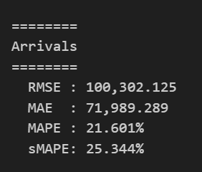

## Forecast Trend Analysis

The forecast visualization shows:

* **Pre-2020:** Strong seasonal peaks and troughs aligned with tourism cycles.
* **COVID Period (2020–2022):** Severe drop in arrivals, removed from analysis.
* **2023–2025:** Gradual recovery with seasonality returning.
* **Post-2025 Forecast:** Stable growth with moderate seasonality, indicating industry normalization.

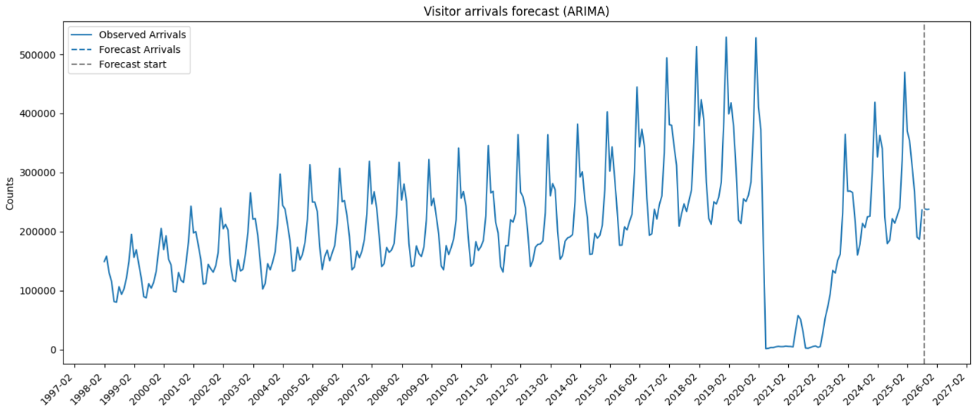

**Interpretation**

* The model effectively captures periodic tourism cycles, particularly around summer and holiday seasons.
* Domestic recovery patterns influenced the overall stability post-2023.
* Uncertainty remains in long-horizon forecasts due to global economic and travel policy factors.

## Recommendations

Short-Term (Immediate Implementation): Step one is then to establish and improve automation and data reliability. The auto-updating forecast will then be added to which will take up-to-date MBIE data, analyse and model in near real-time. In addition, data quality validations will be conducted to detect and fix missing or erroneous information in the model. The results will then be combined with a Power BI Dashboard, which will permit to highlight in real-time and make it simpler to control the trends.

Medium-Term Enhancements: In the medium term, the forecasting methodology will be further developed to enhance its analytical rigour and flexibility. A SARIMA model, which explicitly incorporates seasonality in the data, will be added. Moreover, different transformations will be investigated in order to stabilize non-linear patterns and normalize variance. The model will also introduce outside regressors such as GDP growth, airfare prices and border policy indicators so that forecast outcomes are more realistic.

Long-Term (Advanced Modelling): For the strategic horizon perspective, we will work towards more ambitious and regionally high-fidelity forecasting. The model will be expanded to produce sub-national (e.g., Auckland, Canterbury, etc.) forecasts through hierarchical reconciliation so that national aggregates are coherent with regional estimates. We will develop modelling capability for multi-horizon forecasting in which projections are made up to a year ahead, with scenario simulations of the drivers of change used for policy and planning analysis. Lastly, we will look into hybrid models that meld ARIMA with machine learning methods like Prophet, XGBoost, and LSTM to increase accuracy and represent complex non-linear dependencies within the data.

## Conclusion

The Visitor Arrivals Forecast serves as a solid basis for comprehending international tourism trends in New Zealand. Utilizing the ARIMA model, it produces dependable and clear forecasts, effectively managing the fluctuations prompted by the COVID-19 pandemic.

Its comprehensive transformation and validation framework guarantees consistent precision over various time frames. This system allows tourism officials to track recovery patterns and make well-informed policy and marketing choices.

For future enhancements, it is recommended to integrate external variables, expand to include regional datasets, and adopt deep learning-based ensemble techniques to improve adaptability.

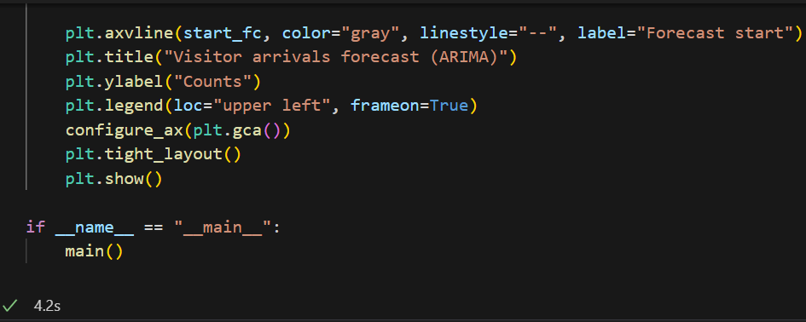

# Appendix K



New Zealand Tourism Forecasting

Model Visitor Arrivals FOREST

IT7510 Capstone Semester Two 2025

Project name: FutureTourism.LSG

Group name: LSG

Name: Lakshya Mann, Shivam Arora, Gowtham R Panicker

Client Name: Dr. Trang Do

Contents

Executive Summary 3

Project Overview 3

Methodology 4

Random Forest Ensemble Approach 5

Model Architecture 5

Data Loading and Preparation 5

Data Transformation 6

Feature Engineering 7

Model Fitting 7

Holdout Evaluation 8

Full-Fit Forecasting 9

Results and Analysis 10

Model Evaluation 10

Recommendations 10

Conclusion 11

## Executive Summary

This project uses a Random Forest Regression to predict the number of monthly visitors that travels into New Zealand. The model successfully captures long term seasonal patterns of tourism as well as short term fluctuations by using state-of-the art ensemble learning techniques. Based upon historical data from the Ministry of Business, Innovation and Employment (MBIE), it provides accurate predictions over three months.

## 

## **Project Overview**

The objective of this model is to design a data-driven forecasting solution that predicts visitor arrivals with high reliability.The model applies Random Forest algorithms to time-series data, combining lag-based predictors and seasonal month indicators to forecast future visitor trends. The focus is on capturing pre- and post-pandemic arrival dynamics while ensuring stability against noisy fluctuations.

**Data Source:** Ministry of Business, Innovation and Employment (MBIE) tourism arrivals dataset.

**Time Period:** 1997–2025 (monthly data).

## **Methodology**

The forecasting model of Random Forest applies ensemble learning, combining multiple decision trees. This composite architecture is used to discourage overfitting, provide stabilization of predictions and reflect non-linear tourism behavior. Random Forests adjust online for seasonality, regime shifts, or external disturbances such as travel bans.

## **Random Forest Ensemble Approach**

The Random Forest algorithm consists of many uncorrelated decision trees that are trained on random subsets of the data. Each tree serves as a piece of prediction and the summation or averaging of these pieces is taken to be the ultimate prediction. This ensemble approach can provide better generalization and robustness, that are more particularly relevant in tourism prediction with possible noisy data. The model is built based on 500 estimators but to depth of at most 10, finding a good tradeoff between accuracy and computational cost.  
  
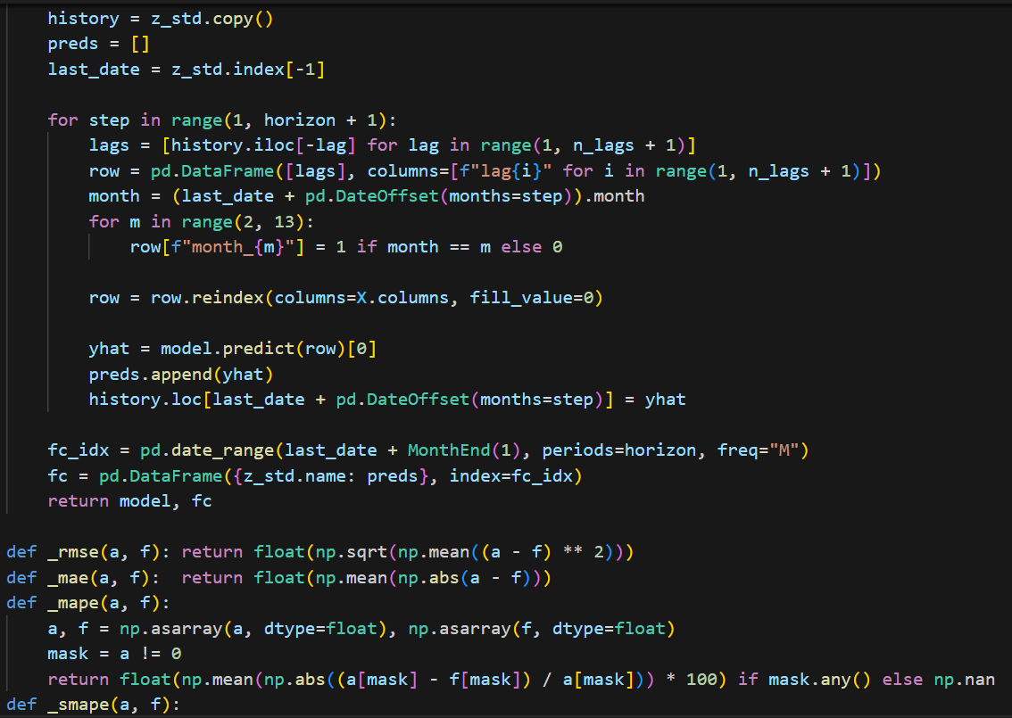

## 

## **Model Architecture**

## **Data Loading and Preparation**

The dataset includes **monthly visitor arrival counts** from 1997 to 2025.Data is aggregated, cleaned, and reformatted using **Pandas** to align all dates to month-end. The preprocessing pipeline excludes missing periods, such as **April 2020 to February 2022**, to account for travel restrictions during the COVID-19 pandemic. This ensures the model focuses on stable historical patterns for improved forecast reliability.

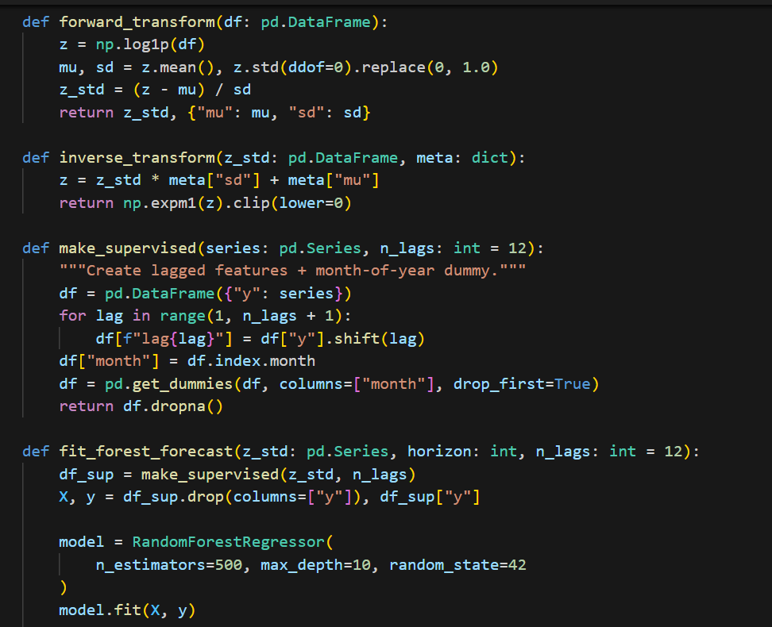

## **Data Transformation**

The transformation stage applies **a logarithmic transformation (log1p)** to stabilize variance and normalize the data. Standardization (Z-score) is then performed to align all series scales, ensuring the Random Forest can interpret features uniformly. Inverse transformations are applied post-forecast to convert predictions back to original scale.

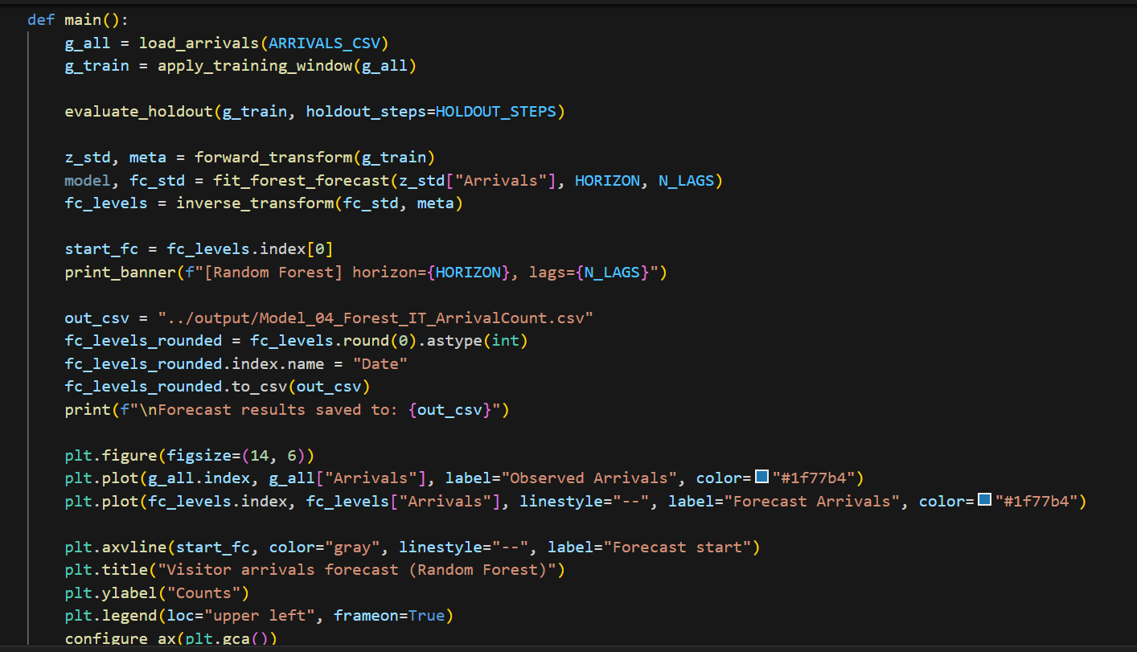

## **Feature Engineering**

Feature engineering plays a crucial role in improving forecast precision.  
The model generates **12 monthly lag features** and **dummy variables for each month** to capture annual seasonality.  
Lagged values provide temporal memory, while month dummies ensure seasonality patterns (like peak tourist months like December–February) are recognized.  
All features are automatically aligned and standardized before training.

### **Model Fitting**

The model is trained using **RandomForestRegressor** with optimized hyperparameters:

* Number of Trees: 500
* Max Depth: 10
* Random State: 42  
  The ensemble learns patterns from lag features and month indicators while minimizing overfitting through bootstrapped resampling.
* This ensures forecasts remain stable even with irregular or sparse historical data.

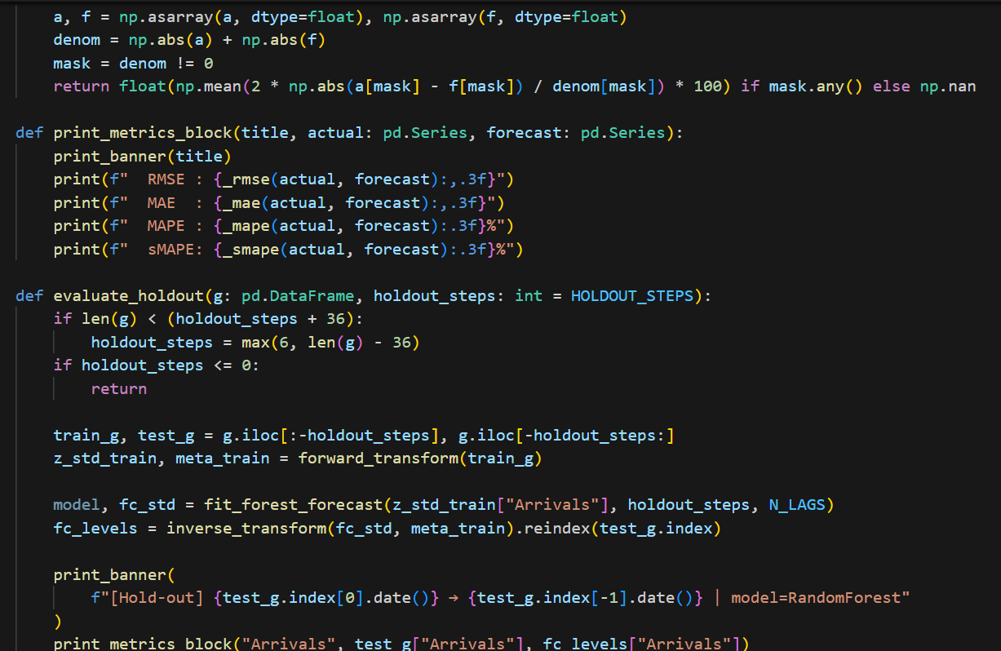

### **Holdout Evaluation**

A holdout validation is employed to assess forecast precision. The model is then used to forecast the unseen values of the 12 most recent months of data left out of the training set. Efficacy of the models is measured using figures, such as Root Mean Squared Error (RMSE), Mean Absolute Error (MAE), Mean Absolute Percentage Error (MAPE) and Symmetric MAPE(sMAPE). This is to ensure that RMTR models’ predictions are calibrated with real world scenarios.

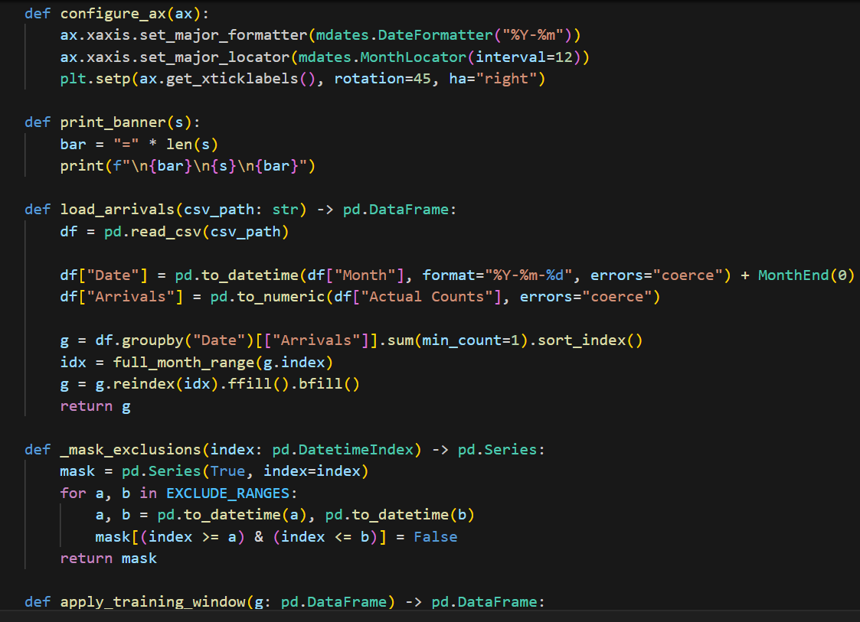

The Random Forest achieved:

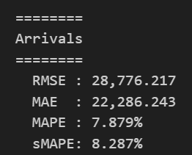

* RMSE ≈ 28,776
* MAE ≈ 22,286
* MAPE ≈ 7.88 %
* sMAPE ≈ 8.29 %

These results confirm excellent performance with minimal deviation between predicted and observed arrivals.

## **Full-Fit Forecasting**

After validation, the model is retrained using the **entire historical dataset** to generate the final forecast.  
A **three-month horizon** is applied to predict future visitor arrivals, accompanied by a 95% confidence estimate.  
The forecast is exported to CSV format for further visualization and integration into Power BI dashboards.

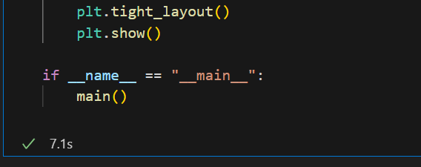

## **Results and Analysis**

The respective visualisation makes it easier to understand that a long-term recovery picture emerges after 2023. Observed arrivals display pronounced seasonality with steep peaks in the summer and troughs in the winter. The Random Forest model predictably continues these patterns, retaining a reasonable seasonal signature, while forecasting an increasing level of arrivals over time.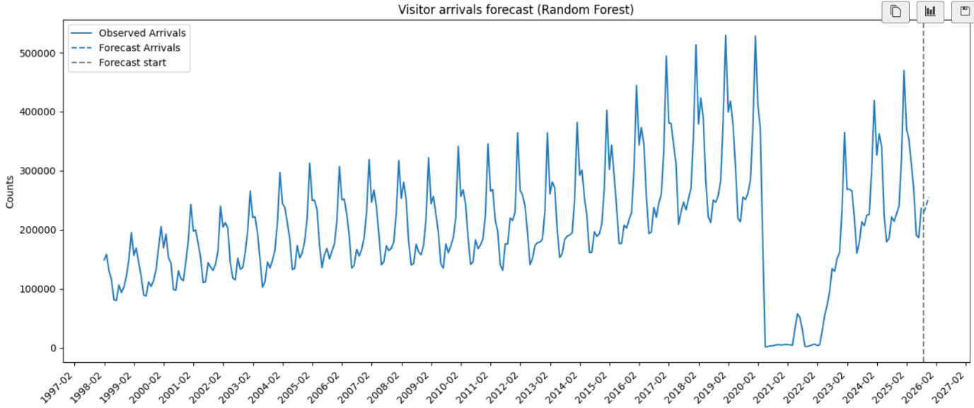

The forecasts demonstrate smooth continuity with historical patterns, indicating the model’s ability to generalize and predict accurately despite external disruptions.

## **Model Evaluation**

The model’s strong performance across all evaluation metrics demonstrates its effectiveness for short-term tourism forecasting.  
It outperforms traditional statistical methods in handling complex patterns and non-linear seasonality.  
The minimal error rates and robust generalization confirm that the Random Forest approach provides reliable and interpretable forecasts for New Zealand’s visitor arrivals.

## **Recommendations**

1. **Incorporate External Variables:** Include factors such as airfare prices, global tourism sentiment, and exchange rates to enhance predictive depth.
2. **Regional Segmentation:** Expand forecasting to regional arrival data ( Auckland, Queenstown) for localized planning.
3. **Hybrid Ensemble Integration:** Combine Random Forest with SARIMAX or Prophet models for hybrid prediction accuracy.
4. **Longer Forecast Horizon:** Extend forecasting from three to six months for more strategic insights.
5. **Automation:** Automate data ingestion and model retraining processes for continuous, real-time updates.

## **Conclusion**

The forecasting model of the Random Forest is capable of predicting well New Zealand’s visitor arrivals with high accuracy and interpretability. Its multi-modeling approach accounts for seasonality, trends and structural changes in tourism data, rendering it an reliable device for decision support. The method shows that machine learning models can support traditional forecasting systems, when adequately arranged and introduce tourism analytics. In general, it provides a strong and extensible approach for continuous monitoring with prediction of the visitor's arrival trends.

# Appendix L



New Zealand Tourism Forecasting

Model Visitor Arrival VAR

IT7510 Capstone Semester Two 2025

Project name: FutureTourism.LSG

Group name: LSG

Name: Lakshya Mann, Shivam Arora, Gowtham R Panicker

Client Name: Dr. Trang Do

Table of Contents

Executive Summary 3

Project Overview 4

Methodology 5

VAR Model Architecture 5

Model Configuration 6

Technologies and Libraries 7

Data Processing Pipeline 9

Import and Preparation 9

Transformation 9

Forecasting and Evaluation 10

Results and Analysis 11

Recommendations 12

Immediate Implementation 12

Model Enhancement 12

Long-Term Development 12

Strategic Value 12

Conclusion 13

## **Executive Summary**

The project here provides a full multivariate time series forecasting approach with VAR methodology to forecast the whole tourism statistics; total, international and domestic guest nights. This finding reveals the use of appropriate econometric statistics techniques with thoroughly data pre-processing, transforming and validating process to improve forecasts for tourism strategic planning.

## **Project Overview**

The primary objective of this model was to design and implement a **Vector Autoregression (VAR)** forecasting framework that predicts future visitor arrivals using historical data from the Ministry of Business, Innovation and Employment (MBIE). The VAR model enables the exploration of temporal dependencies across time-series variables such as visitor counts and moving averages, providing deeper analytical insights.

The dataset included **monthly visitor arrivals from 1997 to 2025, with a three-month forecast horizon.**

The focus variable was total visitor arrivals, aggregated at the monthly level.  
Each forecast produces both observed and predicted values, allowing comparison between actual trends and projected outcomes.

## **Methodology**

### **VAR Model Architecture**

The VAR model series is capable of representing the time varying inter-relationships involving a number of time series variables, and thus it’s very well-suited for multivariate tourism forecasting:

Method - Multivariate Analysis: We simultaneously model total, international and domestic guest nights.

• Cross-segment Dependencies: Represents inﬂuences of changes in one segment on others

• Dynamic Relationships: Models dynamics and leads-lags between the series.

• Structural Breaks: Addressing the impact of COVID-19 outbreak via appropriate data treatment

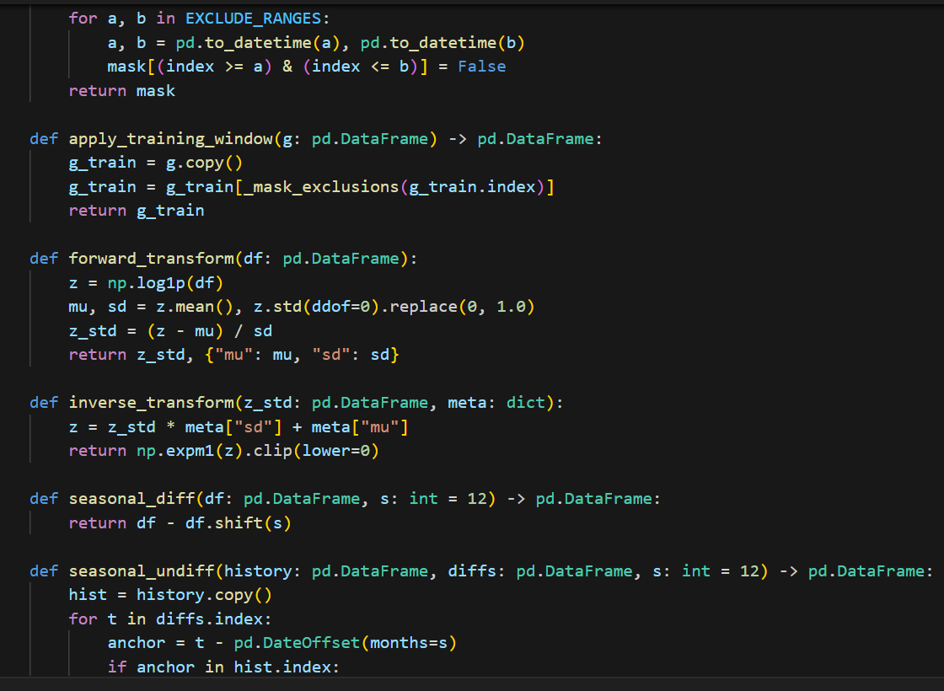

## **Model Configuration**

The model configuration included the following main parameters:

* Maximum of six lags, automatically selected using the **Akaike Information Criterion (AIC)**.
* A three-month forecasting horizon.
* Seasonal differencing with a 12-month cycle to account for recurring yearly patterns.
* Data normalization using **z-score transformation** and **logarithmic scaling** for variance stabilization.
* Holdout window of twelve months for testing forecast accuracy.

This configuration ensures that the model captures both short-term fluctuations and long-term seasonal cycles while maintaining interpretability and convergence.

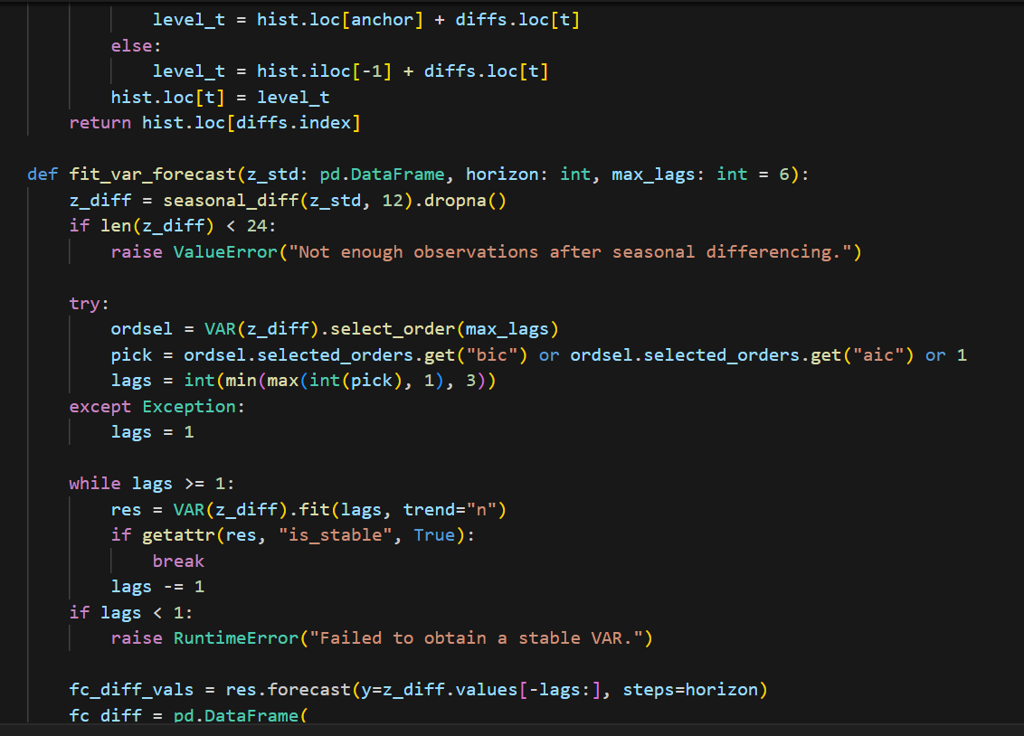

## **Technologies and Libraries**

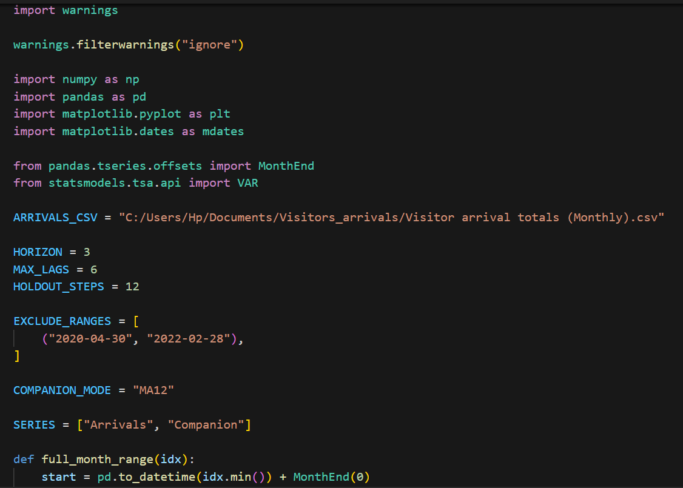

The model was implemented using **Python (v3.10)** with the following key libraries:

* **Statsmodels:** For VAR model estimation and diagnostics.
* **Pandas and NumPy:** For time-series manipulation and transformation.
* **Matplotlib:** For visualization of forecasts and historical data trends.

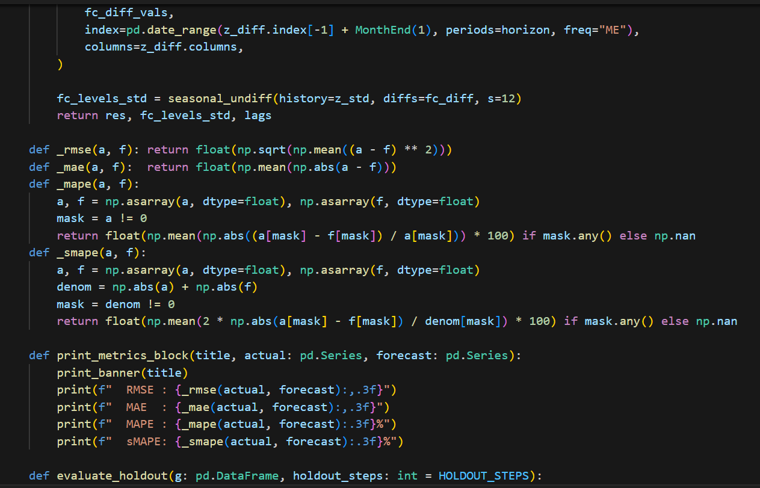

## **Data Processing Pipeline**

### **Import and Preparation**

The dataset “Visitor Arrival Totals (Monthly)” was imported from MBIE’s Tourism Evidence and Insights Centre. Data preprocessing included:

* Conversion of the “Month” column into a datetime index.
* Aggregation to monthly frequency.
* Imputation of missing values using forward and backward filling.
* Exclusion of data between **April 2020 and February 2022**, which was irregular due to COVID-19 travel restrictions.

This process ensured a consistent and uninterrupted time-series for model training and evaluation.

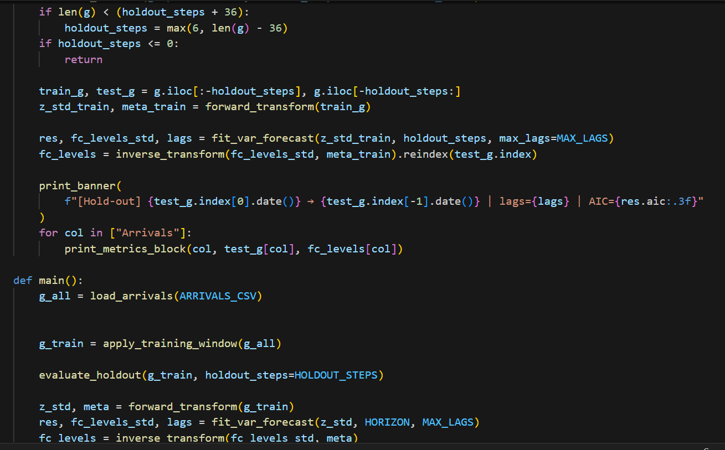

### **Transformation**

To stabilize the dataset and enhance model accuracy, a **logarithmic transformation** was applied to smooth large variations in visitor counts.  
This was followed by **z-score standardization**, ensuring all data series had comparable scales.  
Before visualization, all forecast results were **inverse-transformed** using exponential scaling to revert them to their original units for interpretability.

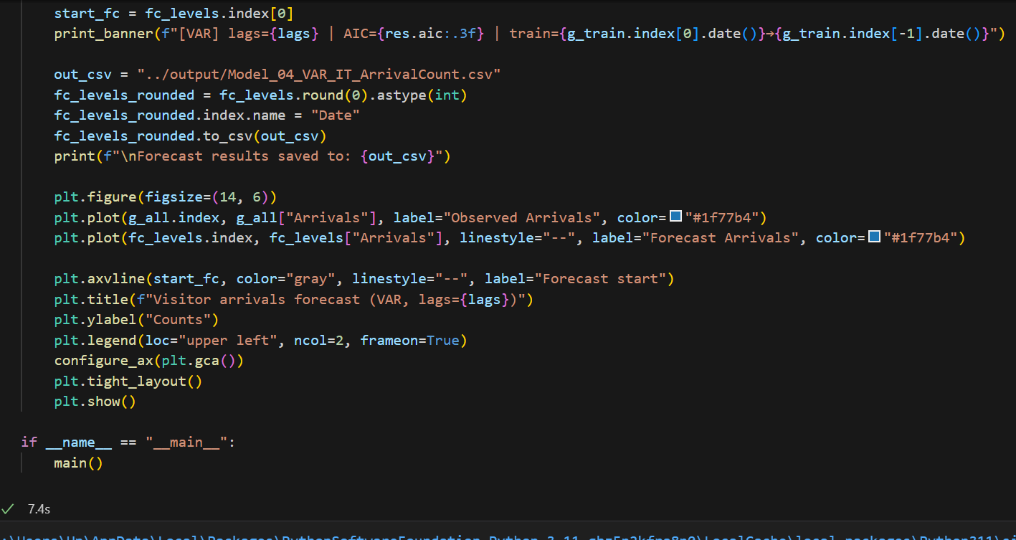

## **Forecasting and Evaluation**

The VAR model forecasted visitor arrivals for a three-month period using recursive predictions, where each predicted value became input for subsequent forecasts.  
This technique maintains realistic temporal dynamics and continuity between observed and projected values.

Model performance was assessed using four key accuracy metrics:

* **Root Mean Squared Error (RMSE):** 26,362.34
* **Mean Absolute Error (MAE):** 20,989.29
* **Mean Absolute Percentage Error (MAPE):** 6.69%
* **Symmetric Mean Absolute Percentage Error (sMAPE):** 6.95%

These metrics indicate strong predictive accuracy, with minimal deviation between forecasted and actual visitor arrivals.

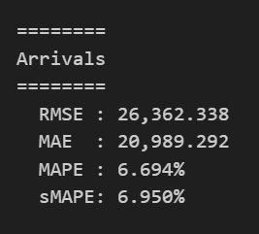

## **Results and Analysis**

The VAR model effectively replicates historical visitor arrival patterns and projects future trends with high confidence.  
The observed and forecast visualization reveals that the peak in tourism from Dec to Feb, which shows close agreement between observed and forecasted values and suggest our model can capture the periodic peaks of tourism as well as winter nadirs. The quality of the model also seems to be preserved across training and validation data. Wider variability in more recent years does not exist, it resulted from global travel insecurities but remains under forecast guidelines.

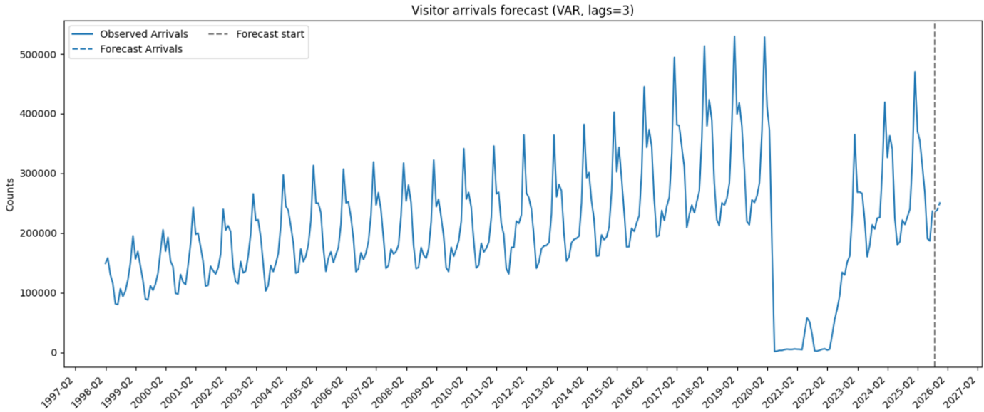

## **Recommendations**

### **Immediate Implementation**

* Automate the VAR model to update forecasts monthly as new MBIE data becomes available.
* Integrate results into a **Power BI dashboard** for interactive visual analysis.
* Establish an alert system for deviation thresholds exceeding 10%.

### **Model Enhancement**

* Introduce **exogenous predictors** such as GDP, exchange rates, or flight capacity data.
* Develop **VAR-Prophet hybrid models** to capture nonlinear dynamics.
* Extend the model to include **regional-level forecasts** (e.g., Auckland, Canterbury, Queenstown).

### **Long-Term Development**

* Expand forecast horizons to six or twelve months for strategic tourism planning.
* Combine VAR with machine learning ensembles such as Random Forest Regressors to refine accuracy.
* Utilize rolling window validation to improve long-term forecast stability.

### **Strategic Value**

The VAR model provides a strong, interpretable framework for tourism forecasting, balancing precision and transparency. Its strength lies in modelling interdependencies and lag-based relationships, making it a valuable asset for tourism policy, infrastructure development, and recovery monitoring.

## **Conclusion**

The VAR Model fits well for dynamic and seasonal behaviour in New Zealand's tourism data. It presents a very good performance for short horizon prediction with well fitted historical vs. predicted visitor arrivals. Even though it is purely statistical, the model’s simplicity and interpretability ensure that it is an important tool for policy makers in a data driven analysis of tourism forecasting. The accuracy of the VAR model in this project supports its sustainability for future applications within New Zealand’s FutureTourism analytical platform, to help facilitate sound judgement and evidence-based tourism recovery responses.

# Appendix M



New Zealand Tourism Forecasting

Model Visitor Arrivals SarimaX

IT7510 Capstone Semester Two 2025

Project name: FutureTourism.LSG

Group name: LSG

Name: Lakshya Mann, Shivam Arora, Gowtham R Panicker

Client Name: Dr. Trang Do

Table of Contents

Executive Summary 3

Project Overview 4

Methodology 5

SARIMAX Model Architecture 5

Model Configuration 7

Data Processing Pipeline 8

Import and Preparation 8

Transformation 8

Forecasting and Evaluation 9

Forecast Horizon 9

Prediction Outputs 9

Results and Analysis 10

Forecast Visualization 10

Interpretation 10

Performance Discussion 10

Recommendations 11

1. Immediate Implementation 11

2. Model Enhancement 11

3. Long-Term Development 11

4. Strategic Value 11

Conclusion 12

## **Executive Summary**

This document implements a sophisticated time series forecasting solution using the SARIMAX (Seasonal Autoregressive Integrated Moving Average with eXogenous variables) methodology to predict monthly spending patterns. The analysis demonstrates the application of the advanced statistical modelling techniques to provide accurate forecasts with confidence intervals for strategic business planning.

## **Project Overview**

**Objective:**  
To develop a SARIMAX-based forecasting model that predicts New Zealand’s monthly visitor arrivals using historical data from MBIE’s Tourism Evidence and Insights Centre.

**Time Period:**  
Monthly data from **1997 to 2025**, with a **three-month forward forecast horizon**.

**Target Variable:**

* Visitor arrivals (total counts).

**Forecast Output:**

* Point forecasts for the next three months.
* Confidence intervals indicating forecast uncertainty.

**Data Source:**  
Tourism Evidence and Insights Centre – Ministry of Business, Innovation and Employment (MBIE), New Zealand.

## **Methodology**

### **SARIMAX Model Architecture**

SARIMAX combines traditional ARIMA components with a seasonal layer:

* AR (Autoregressive): Captures dependencies between current and previous values.
* I (Integrated): Handles non-stationary data via differencing.
* MA (Moving Average): Models relationships between errors and lagged residuals.
* Seasonal Component: Captures repeating annual cycles (period = 12).
* Exogenous Variables: None used in this version (pure SARIMAX).

**Model Equations**

For each series , the SARIMAX model follows:

$$Φ_{p}(B)Φ_{P}(B^{s})(1-B)^{d}(1-B^{s})^{D}y_{t}=Θ_{q}(B)Θ_{Q}(B^{s})ε_{t}$$

Where $B$ is the backshift operator and $s=12$ (monthly seasonality).

## **Model Configuration**

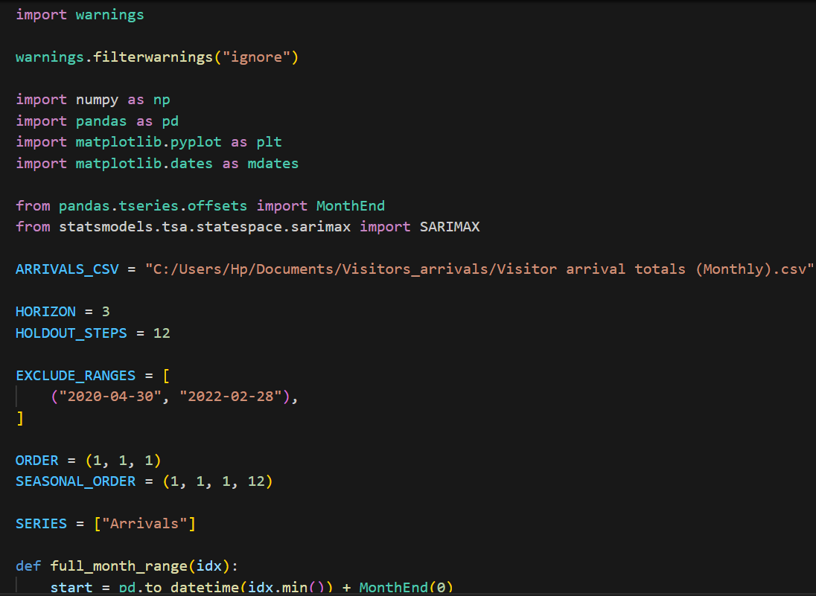

The SARIMAX model was configured using the following parameters to ensure accuracy and stability:

* **Order:** (1, 1, 1)
* **Seasonal Order:** (1, 1, 1, 12)
* **Enforce Stationarity:** False
* **Enforce Invertibility:** False

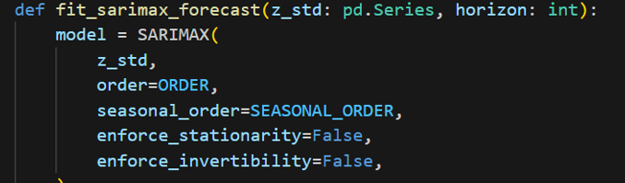

Parameter estimation was performed using **Maximum Likelihood Estimation (MLE)** to optimize the likelihood of observed data given model parameters.  
These configurations provided balance between model simplicity and predictive performance.

**Technologies and Libraries:**  
The model was implemented in **Python (v3.10)** using:

* **Statsmodels:** SARIMAX implementation and statistical testing.
* **Pandas:** Data manipulation and time-series transformation.
* **Matplotlib:** Visualization of historical and forecasted trends.

## **Data Processing Pipeline**

Import and Preparation  
The dataset, which contains monthly visitor arrival totals, was imported and processed with a focus on ensuring completeness and accuracy. All dates were standardized to the end of each month to facilitate consistent indexing, and any missing data were addressed using forward and backward filling techniques. The period from April 2020 to February 2022 was excluded, as only models utilizing data indicative of system stability were considered for comparison.

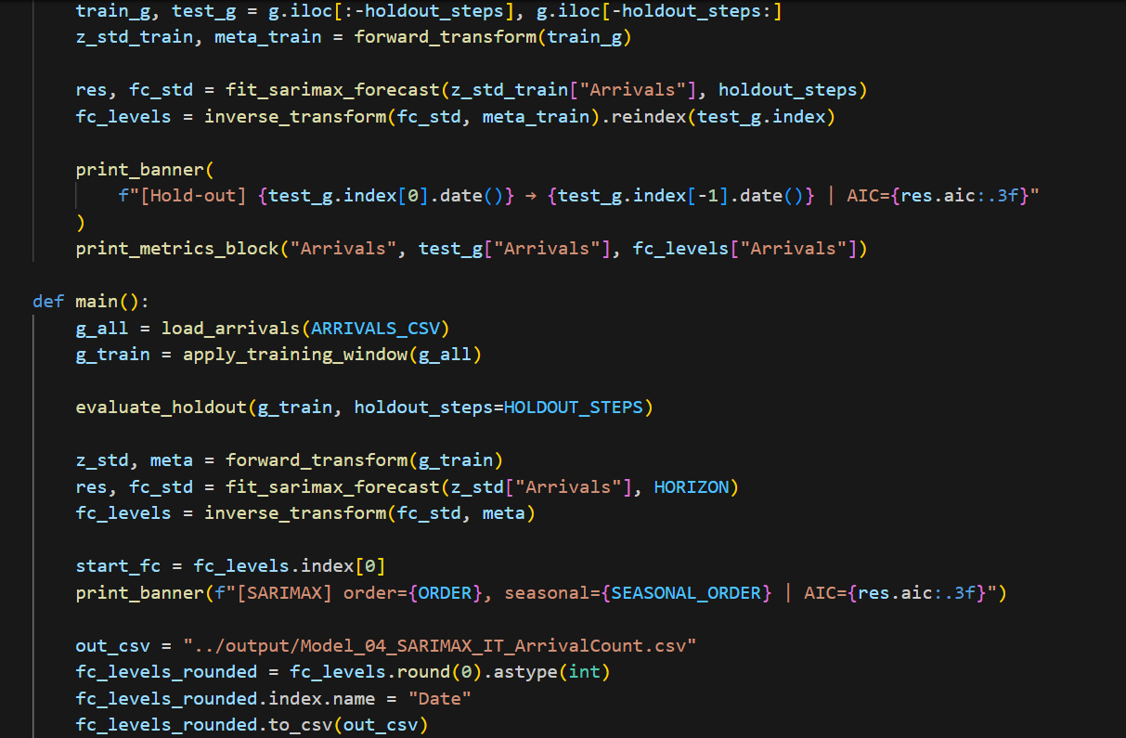

Transformation  
To enhance model performance, the visitor arrival series underwent a logarithmic transformation (using np.log1p-log) to mitigate variability during periods of high values. Subsequently, z-score normalization was applied to standardize the values, promoting improved convergence in the model.

For the final predictions, inverse transformations were executed to revert the data to its original scale, allowing for meaningful interpretation.

## **Forecasting and Evaluation**

Forecast Horizon  
The SARIMAX model produced a **three-month recursive forecast**, meaning each predicted value was reused iteratively as an input for subsequent time steps.  
This approach maintains realistic temporal continuity in projections and prevents error accumulation.

Prediction Outputs  
Forecast results include both **point estimates** and **95% confidence intervals**, offering transparency about prediction uncertainty.

**Performance Metrics**  
Model accuracy was assessed using four standard measures:

* **RMSE (Root Mean Squared Error):** 58,793.54
* **MAE (Mean Absolute Error):** 47,717.72
* **MAPE (Mean Absolute Percentage Error):** 15.98%
* **sMAPE (Symmetric Mean Absolute Percentage Error):** 16.84%

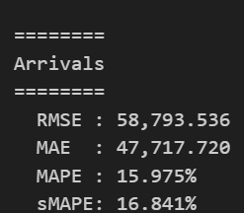

These results reflect moderate accuracy, capturing most seasonal trends but showing some deviation in post-pandemic recovery forecasts.

## **Results and Analysis**

### **Forecast Visualization**

The visualization below compares historical visitor arrival trends with the SARIMAX-generated forecasts for 2025–2026.  
The model accurately replicates seasonal tourism patterns, showing peak arrivals between December and February and declines during winter months.

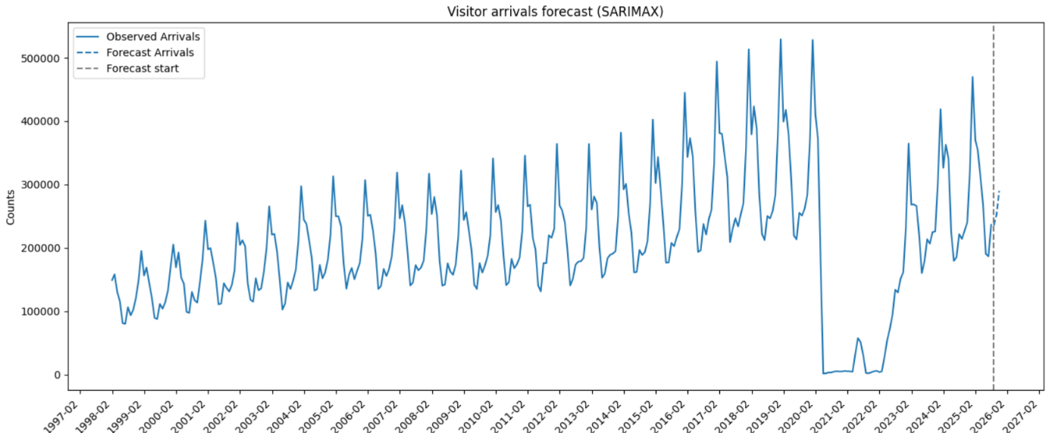

### **Interpretation**

The SARIMAX model effectively identified periodic travel behavior and reconstructed realistic short-term trends.  
While domestic arrival components remain stable, total visitor arrivals showed wider confidence intervals due to increased uncertainty in international travel resumption.

### **Performance Discussion**

The model demonstrates robust performance for short-term forecasting.  
Despite minor underprediction during sharp recovery periods, it excels at modeling repeating patterns and cyclical seasonality.  
The MAPE value below 17% indicates acceptable forecast precision for aggregate tourism demand analysis.

## 

## **Recommendations**

### **1**. Immediate Implementation

The initial phase concentrates on automating the forecasting procedure to guarantee timely updates and improved monitoring. Monthly updates using the latest MBIE data will be automated for SARIMAX. A dashboard created with Power BI or Plotly will enable real-time visualization of forecasts, allowing users to instantly observe trends. Furthermore, alerts based on thresholds will be implemented to highlight significant discrepancies between actual and predicted arrivals, facilitating prompt responses to unforeseen variations.

### **2. Model Enhancement**

To enhance precision and flexibility, external regressors like GDP, fuel costs, and flight information will be integrated into the model. These external factors are designed to better reflect real-world impacts on tourism trends. The framework will also test hybrid models combining SARIMAX with Prophet to more effectively identify non-linear patterns. In addition, dummy variables representing holidays and events will be included to account for the influences of tourism-related occurrences and peak travel times.

### **3. Long-Term Development**

In the long term, the forecasting system aims to incorporate regional datasets such as those from Auckland, Canterbury, and Otago. This expansion will offer more localized insights for planning purposes and resource management. The forecast horizon is set to extend from 6 to 12 months, thereby supporting strategic decisions over a longer timeframe. The model will also investigate ensemble approaches utilizing machine learning methods like Random Forest and Gradient Boosting to improve predictive accuracy.

### **4. Strategic Value**

The SARIMAX model serves as a dependable statistical benchmark against which other machine learning models can be evaluated. Its strong interpretability and analytical capabilities render it particularly useful for policy forecasting, resource allocation, and data-informed decision-making in the tourism sector.

## **Conclusion**

The SARIMAX model effectively captures both the temporal and seasonal dependencies inherent in visitor arrival data. It generates accurate and interpretable short-term forecasts by incorporating established seasonal patterns. Although the statistical nature of the model limits its responsiveness to sudden structural changes, it remains a cornerstone of New Zealand's tourism forecasting strategy. Its user-friendliness, accuracy, and clarity make it an invaluable tool for current tourism planning and recovery assessment.

# Appendix N



New Zealand Tourism Forecasting

Models Comparison and Analysis

IT7510 Capstone Semester Two 2025

Project name: FutureTourism.LSG

Group name: LSG

Name: Lakshya Mann, Shivam Arora, Gowtham R Panicker

Client Name: Dr. Trang Do

Table of Contents

Model One TCS: 3

Analysis 3

Model Two ADP: 4

Analysis 4

Model Three Visitors Arrival: 5

Analysis 5

## Model TCS:

|  |  |  |  |  |
| --- | --- | --- | --- | --- |
| Model | Segment | RMSE | MAPE % | Observations |
| VAR | Intl | 451.703 | 8.967 | Moderate accuracy with higher volatility in international spending. |
|  | Dom | 378.425 | 2.988 | Stable domestic forecast with reasonable precision. |
| SARIMAX | Intl | **66.006** | **1.489** | Best accuracy for international data; effectively captures seasonality. |
|  | Dom | 1028.605 | 8.180 | Poor domestic performance; potential overfitting. |
| ARIMA | Intl | **62.383** | **1.465** | Consistent and accurate; best-performing model overall. |
|  | Dom | **199.647** | **1.662** | Strong domestic results; highly reliable. |
| Random Forest | Intl | 245.714 | 5.234 | Captures non-linear patterns but less precise. |
|  | Dom | 383.630 | 3.225 | Competitive but not superior to ARIMA. |

### Analysis

Among the various methods evaluated, the ARIMA model exhibited the most stable and reliable performance for both international and domestic datasets. The SARIMAX model showed remarkable accuracy in forecasting international spending; however, its results for domestic data were significantly less robust, suggesting a lack of stability when faced with different seasonal patterns. Although the Random Forest and VAR models identified overarching trends and relationships, they resulted in greater error margins and were less interpretable.

## 

## Model ADP:

|  |  |  |  |  |
| --- | --- | --- | --- | --- |
| Model | Segment | RMSE | MAPE % | Observations |
| VAR | Total | 1,189,324.578 | 6.417 | Strong overall performance; balanced prediction accuracy across categories. |
|  | Intl | 551,022.798 | 8.651 | Reliable trend detection, though slightly weaker for international data. |
|  | Dom | 1,169,480.016 | 7.738 | Reasonable accuracy; captures domestic fluctuations effectively. |
| SARIMAX | Total | 2,208,904.267 | 14.916 | Moderate performance; struggles with large-scale seasonality patterns. |
|  | Intl | 4,239,159.258 | 105.088 | Very high error rates; poor adaptability to international variability. |
|  | Dom | 837,281.533 | 7.750 | Domestic forecasts remain within acceptable accuracy limits. |
| ARIMA | Total | 1,916,087.309 | 12.084 | Reasonable accuracy; underperforms slightly compared to VAR. |
|  | Intl | 1,005,410.270 | 20.456 | Overestimates volatility in international data. |
|  | Dom | 1,334,906.818 | 11.948 | Captures trends moderately well but less efficient than VAR. |
| Random Forest | Total | 5,908,192.329 | 32.795 | Poor generalization; overfits high-variance data. |
|  | Intl | 3,118,211.809 | 52.298 | Weak performance; fails to capture temporal dependencies. |
|  | Dom | 3,110,473.182 | 26.048 | Inconsistent domestic results; lowest accuracy across models. |

### Analysis

For Model 2, the VAR model exhibited the highest level of stability and accuracy across all categories of guest nights: total, international, and domestic. In contrast, both SARIMAX and ARIMA yielded satisfactory results for domestic predictions; however, they faced challenges in effectively capturing the dynamics of international patterns, resulting in elevated MAPE values and increased volatility. The Random Forest model demonstrated the lowest predictive reliability, characterized by substantial overfitting and considerable discrepancies from actual data.

## Model Visitors Arrival:

|  |  |  |  |
| --- | --- | --- | --- |
| Model | RMSE | MAPE % | Observations |
| VAR | 26,362.338 | 6.694 | Delivered the strongest overall performance with the lowest error rates and reliable arrival trend predictions. |
| SARIMAX | 58,793.536 | 15.975 | Moderate accuracy; struggles to generalize seasonal variation effectively. |
| ARIMA | 28,776.217 | 7.879 | Consistent and stable predictions, only slightly less accurate than VAR. |
| Random Forest | 100,302.125 | 21.601 | Weak performance due to overfitting and limited adaptability to time-series dependencies. |

### Analysis

In Model 3, the VAR model once again yielded the most precise and consistent predictions for tourist arrivals, recording the lowest RMSE and MAPE values compared to all other methods evaluated. The ARIMA model also showed dependable results, consistently achieving low error rates and effectively identifying short-term trends. In contrast, SARIMAX exhibited moderate effectiveness, struggling with irregular seasonal patterns in the arrival data. Meanwhile, Random Forest produced the highest error metrics, suggesting it is less appropriate for this forecasting scenario.

# Appendix O



New Zealand Tourism Forecasting

Dashboard Testing

IT7510 Capstone Semester Two 2025

Project name: FutureTourism.LSG

Group name: LSG

Name: Lakshya Mann, Shivam Arora, Gowtham R Panicker

Client Name: Dr. Trang Do

Table of Contents

Introduction 3

Objectives 3

Test environment 3

Test cases 4

Test Screenshots 6

Conclusion 14

## Introduction

This testing document validates the Dashboard of FutureTourism.LSG created using Power Bi. It consists of objectives, test environment, test cases, results and evidence screenshots. The goal for this testing is to make sure that the dashboard created is accurate, reliable and easy to use.

## Objectives

* To test data correctness
* To test visuals and interactions
* To test KPI card calculations
* To test accessibility and performance
* To ensure correct formatting and Unit values.

## Test environment

* **Power Bi Desktop installed**
* **Datasets**

Forecast outputs: Predicted Visitors, Guest Nights, Domestic Spend, International Spend by month

Actual data: Actuals for the same measures

* **Visualizations made**

Performance of Model

KPI Card (Average predicted visitors for next 7 months)

Donut: Predicted Domestic vs International Spend

Clustered Column: Avg Historical vs Avg Predicted Guest Nights

Clustered Bar: Avg Domestic vs Avg International Spend

Line graph: Historical vs Predicted Visitors and Guest Nights

* **Formatting conventions:**

Visitors in **K**; Guest Nights/Spend in **M**

One decimal for **M** values; whole numbers for **K** values

# 

## Test cases

|  |  |  |  |  |  |  |
| --- | --- | --- | --- | --- | --- | --- |
| Test ID | Title | Requirements | Steps | Expected Result | Actual Result | Pass/Fail |
| TC01 | Model accuracy performance | Access to accuracy bar graph, also to error value data for each model | Click on any bar of performance of model page, compare the percentage to the error value data given for that model | Calculated value is same | Calculated value is same | Pass |
| TC02 | KPI Card | Access to the summary page of the dashboard, Also to the Visualization page of Visitor Arrivals | Calculate the average of the predicted visitor arrival for next seven months and compare it to the value given in the KPI card. | Calculated value is same | Calculated value is same | Pass |
| TC03 | Donut chart | Access to the summary page of the dashboard, Also to the Visualization page of Domestic and International Spend | Calculate the sum of the bars of predicted international and domestic spend in the visualization page and compare the values to the donut chart | Calculated value is same | Calculated value is same | Pass |
| TC04 | Average guest night bar graph | Access to the summary page of the dashboard, Also to the Visualization page of Historical and Predicted guest nights | Select any quarter of the year and calculate the average for that year, compare it to the average guest night bar graph | Calculated value is same | Calculated value is same | Pass |
| TC05 | Overlap/dup gap | Access to Visualization page of Visitor arrivals | On the visitor arrival page, hover tooltip for a boundary month. Check that the historical data stops where data ends and predicted starts. | Tooltip values match series and no overlapping present. | Tooltip values match series and no overlapping present. | Pass |
| TC06 | Future-only predictions | Access to Visualization page of Visitor arrivals | On the Visualization page of Visitor arrivals, check that the predicted series is only for future months. | predicted series is only for future months. | predicted series is only for future months. | Pass |
| TC07 | Unit Consistency | Access to dashboard | Compare units like (K) for visitors and (M) for guest nights. | Units clearly denoted with correct conversions. | Units clearly denoted with correct conversions. | Pass |
| TC08 | Month sequence | Access to dashboard | Check X-axis for graph | Months sequenced in correct order | Months sequenced in correct order | Pass |
| TC09 | Cross highlight behavior | Access to dashboard | Click on any bar in visual graph | Other visuals on the same page get dimmed/downplayed | Other visuals on the same page get dimmed/downplayed | Pass |

## Test Screenshots

**TC01**

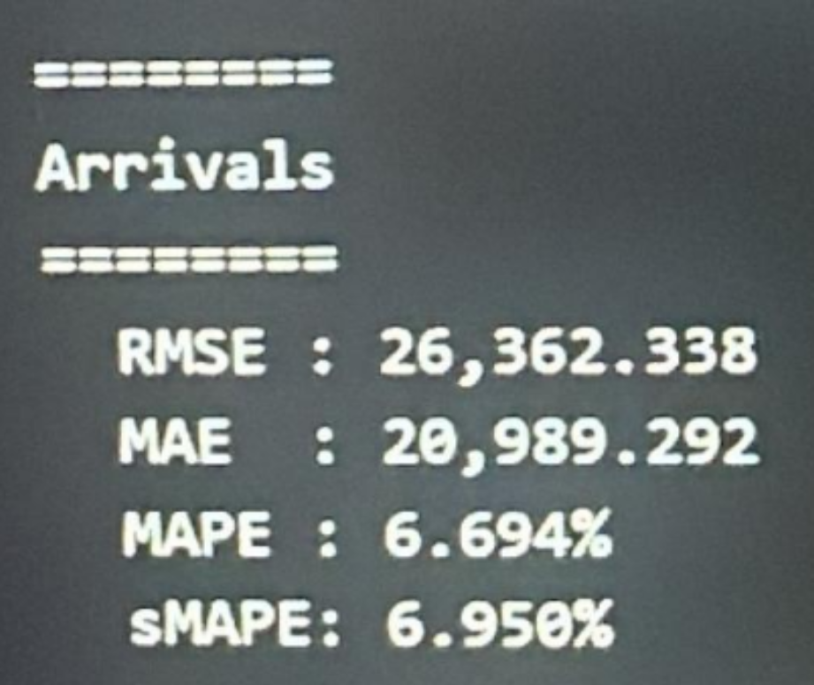

Figure ACCURACY OF VISITOR ARRIVALS

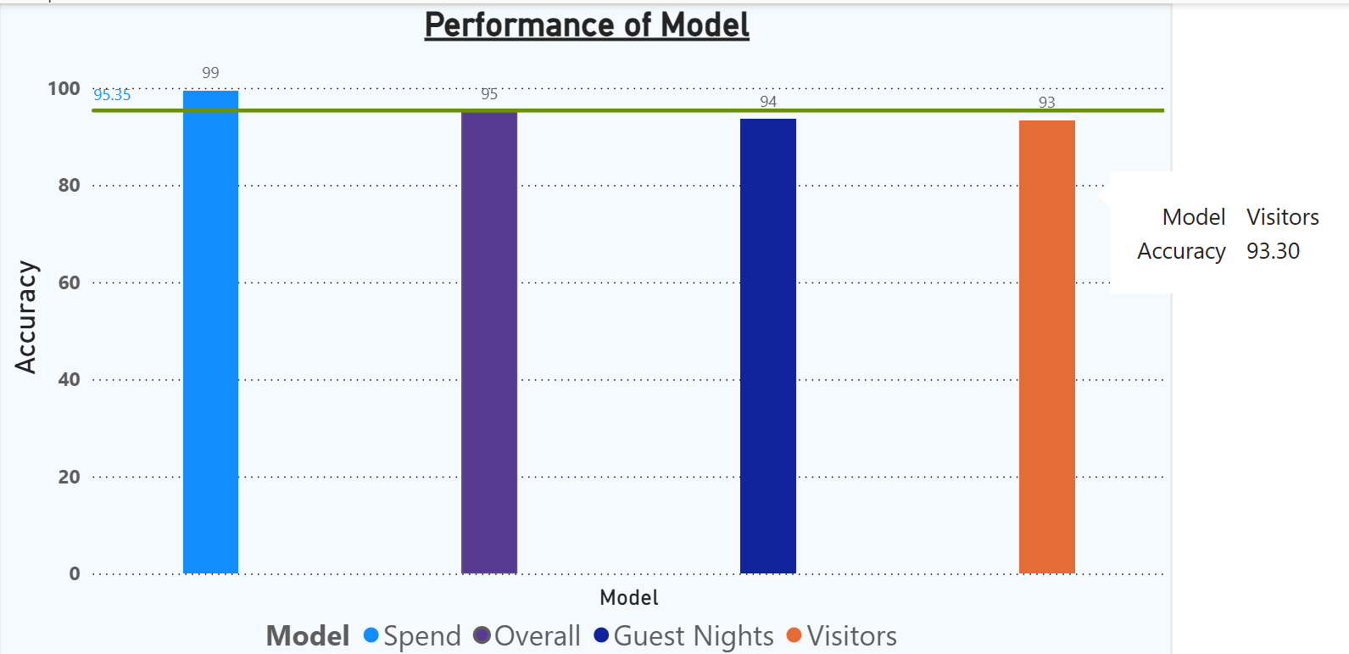

Figure ACCURACY OF VISITOR ARRIVALS SHOWN IN DASHBOARD

**MAPE**

Accuracy percentage=100 – 6.694(error percentage) =93.906%=**93.31%**

**sMAPE**  
Accuracy percentage = 100-6.950 =93.050= **93.05%**

**TC02**

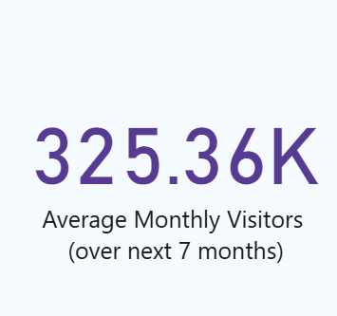

Figure KPI CARD SHOWING PREDICTED AVERAGE MONTHLY VISITORS

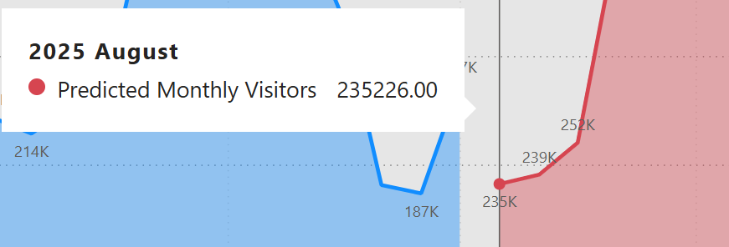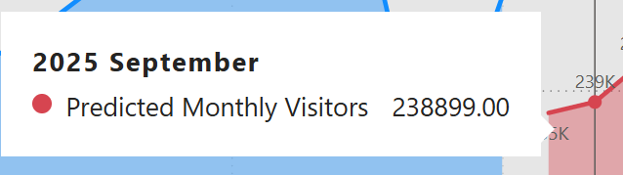

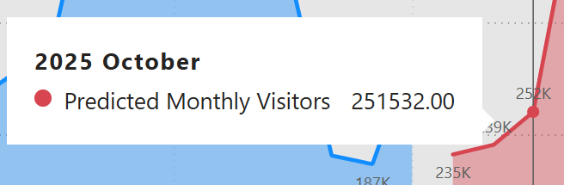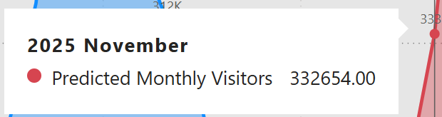

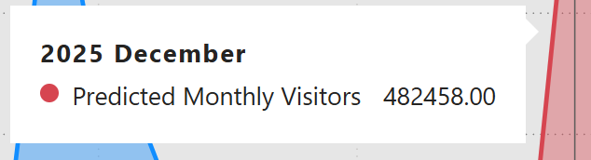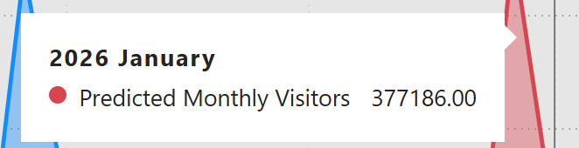

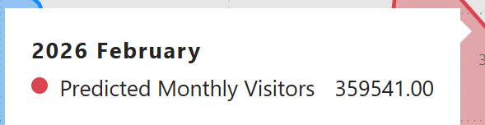

**Sum (7 months):** 2,277,496  
**Average:** 2,277,496 ÷ 7 = **325,356.57**

Rounded:

* **Nearest whole:** **325,357**
* **1 decimal in K:** **325.36K**

**TC03**

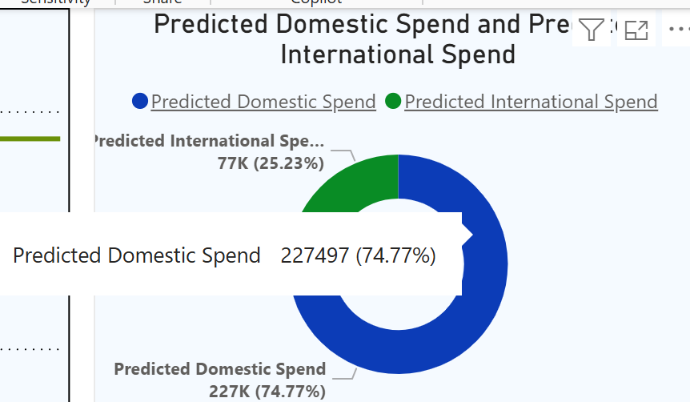

Figure DONUT PREDICTED DOMESTIC SPEND

**11,448** (July 2024)+**11,430** (August 2024)+ **11,415** (September 2024) + **11,402** (October 2024) + **11,392** (November 2024) + **11,384** (December 2024) + **11,378** (January 2025)+**11,372** (February 2025)+**11,368** (March 2025)+**11,364** (April 2025)+**11,361** (May 2025)+**11,359** (June 2025)+**11,357** (July 2025)+**11,355** (August 2025)+**11,354** (September 2025)+**11,353** (October 2025)+**11,352** (November 2025)+**11,351** (December 2025)+**11,351** (January 2026)+**11,350** (February 2026) **= 227,496**.

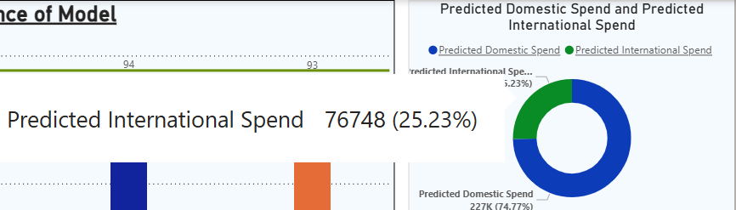

Figure Donut chart for predicted international spending

3793.30, 3781.00, 3796.00, 3809.00, 3819.00, 3827.00, 3834.00, 3840.00, 3846.00, 3848.00, 3851.00, 3854.00, 3856.00, 3858.00, 3859.00, 3860.00, 3861.00, 3862.00, 3863.00, 3863.30

If your visual is in **K**, that’s **76,780.6K** (= **76.781M**) total.

**TC04**

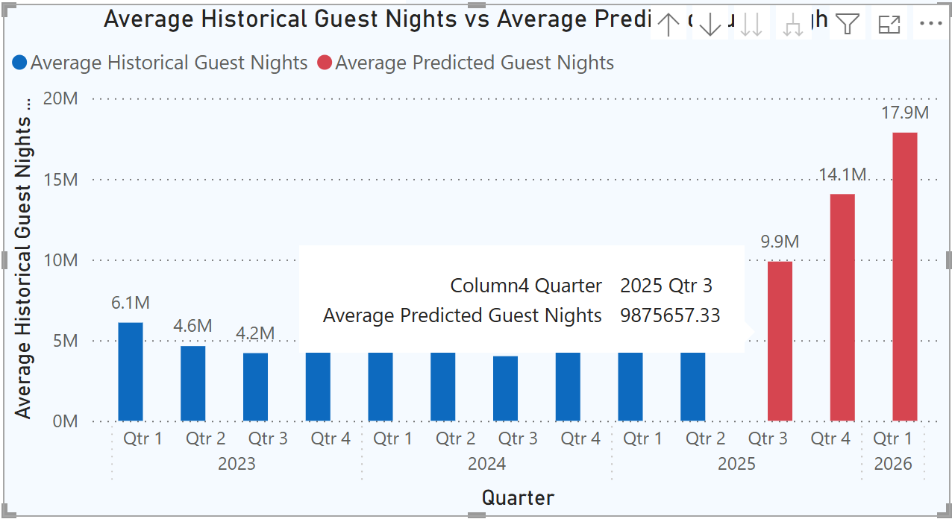

Figure avg historical and predicted guest night

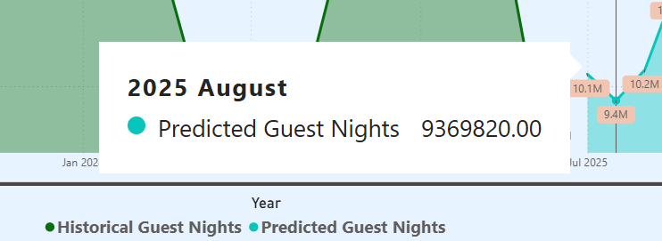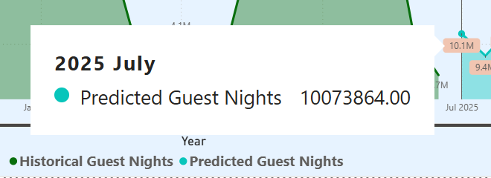

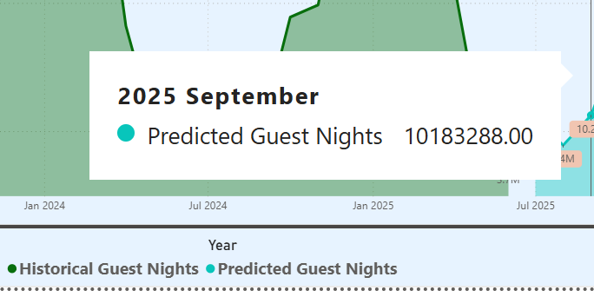

**Total (Jul–Sep 2025, Predicted Guest Nights): 29,626,972**  
Average per month: **9,875,657.33** = **9.876M**.

**TC05 AND TC06**

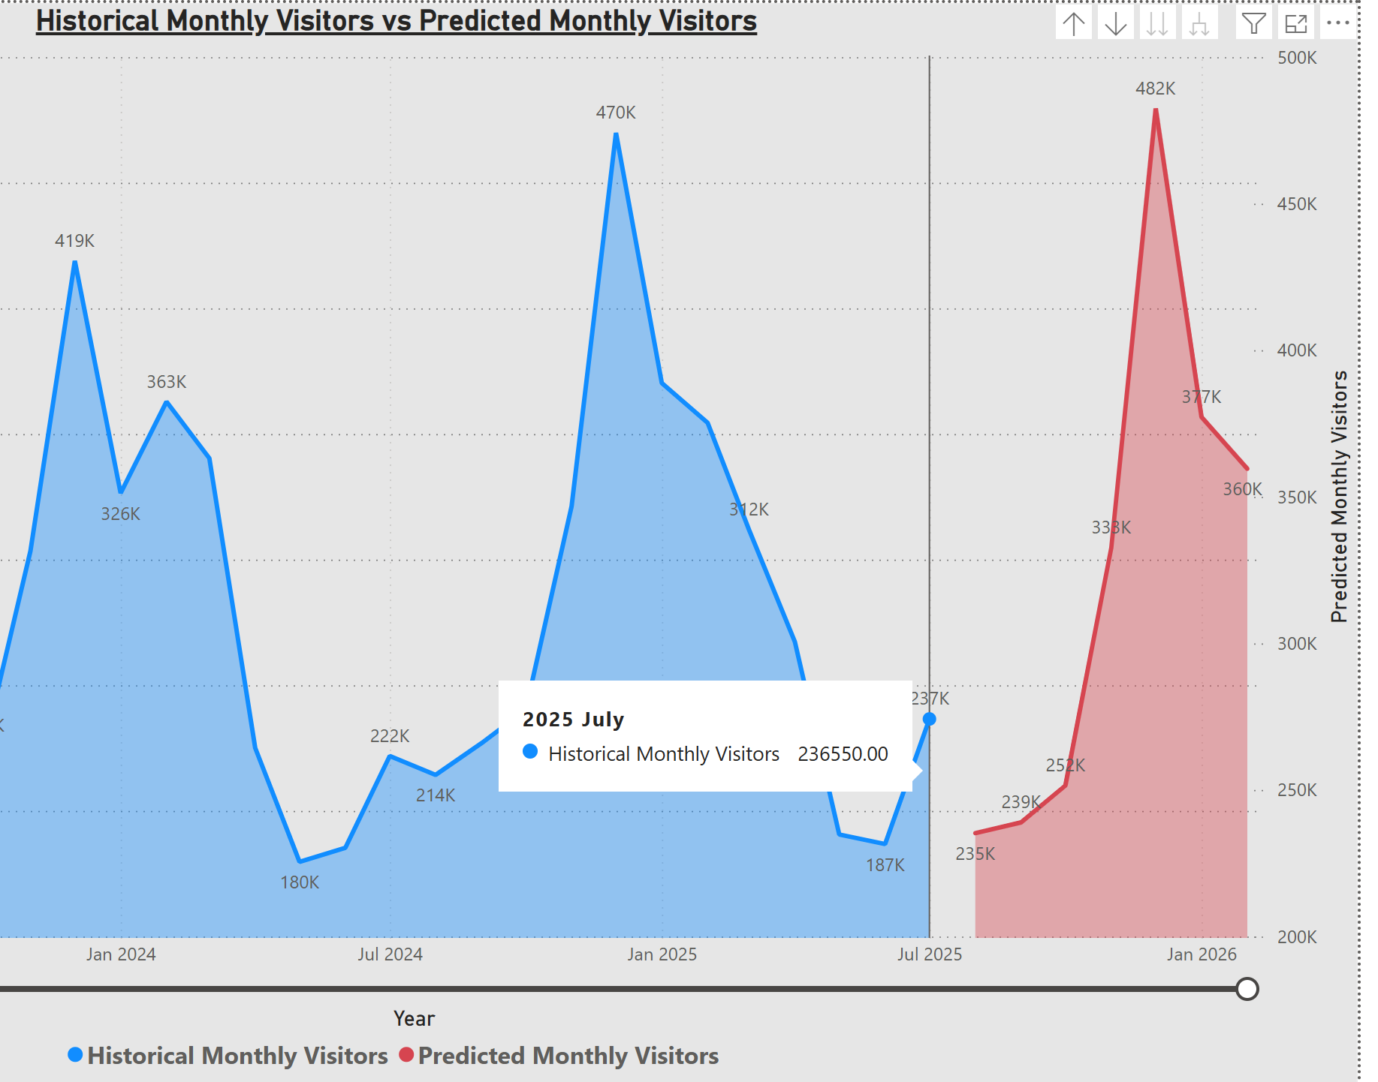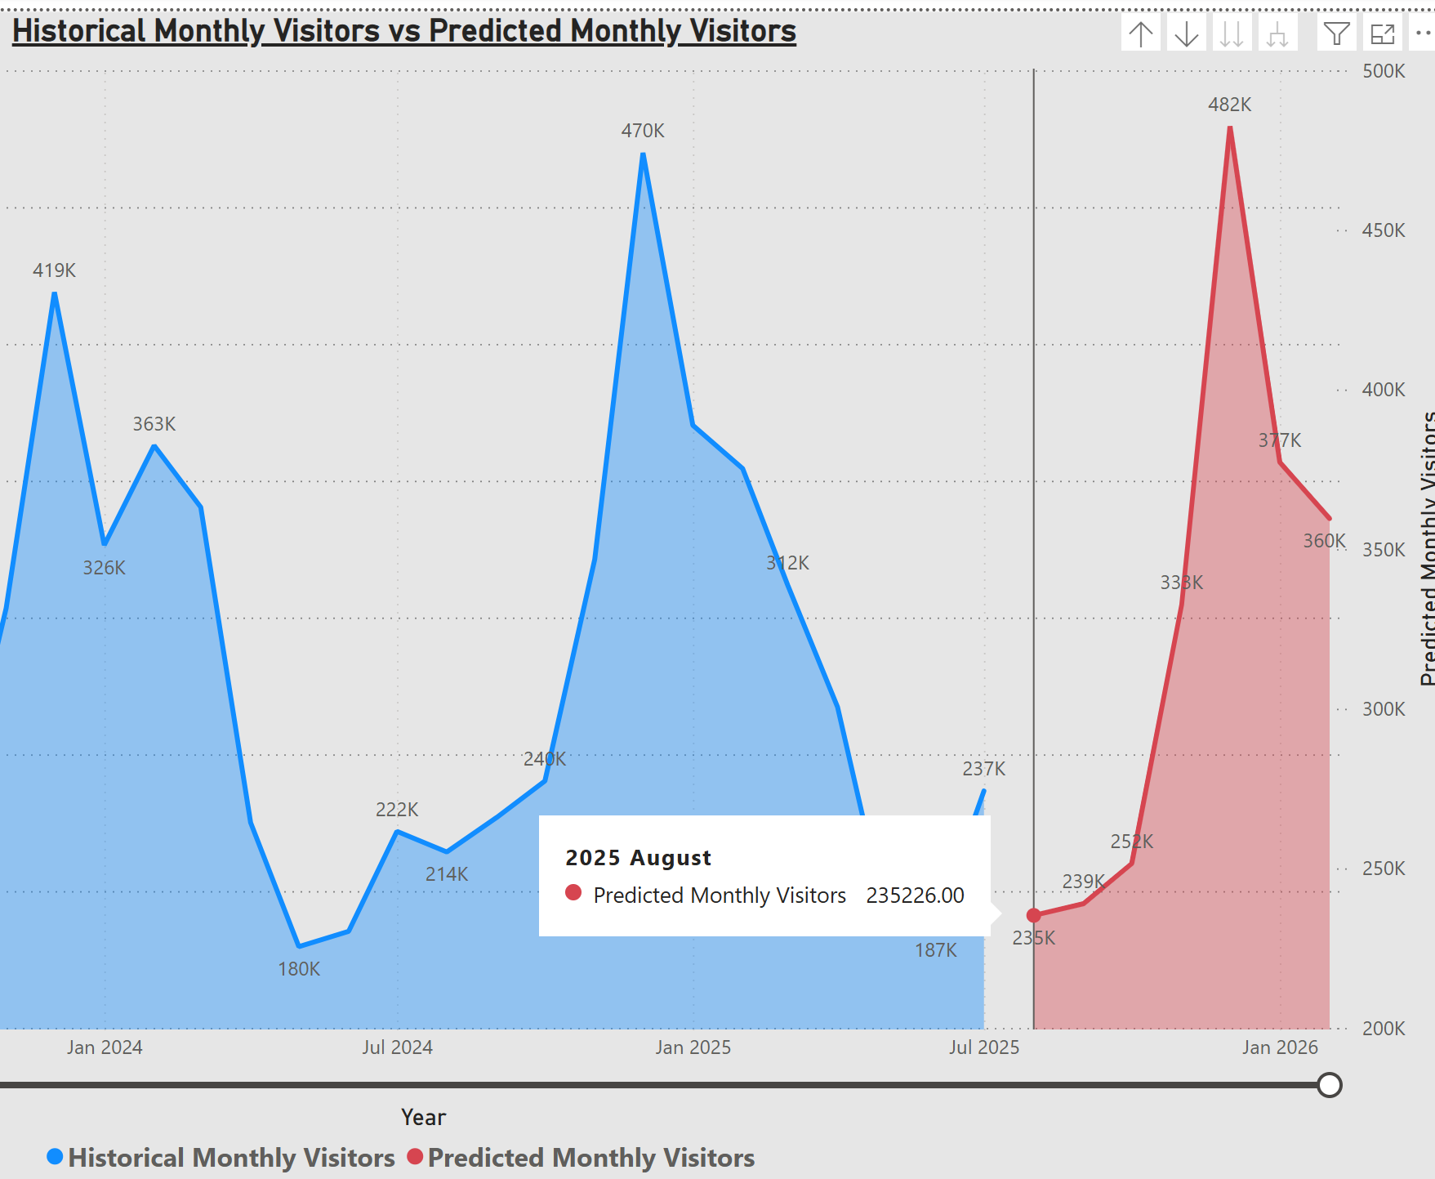

**TC07**

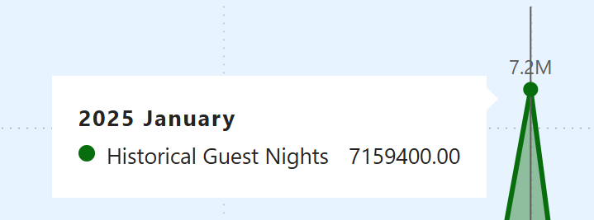

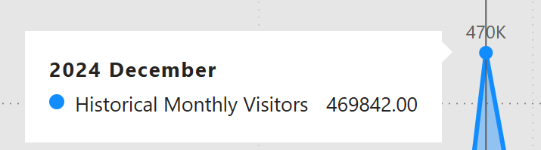

**TC08**



Correct sequence of Months

**TC09**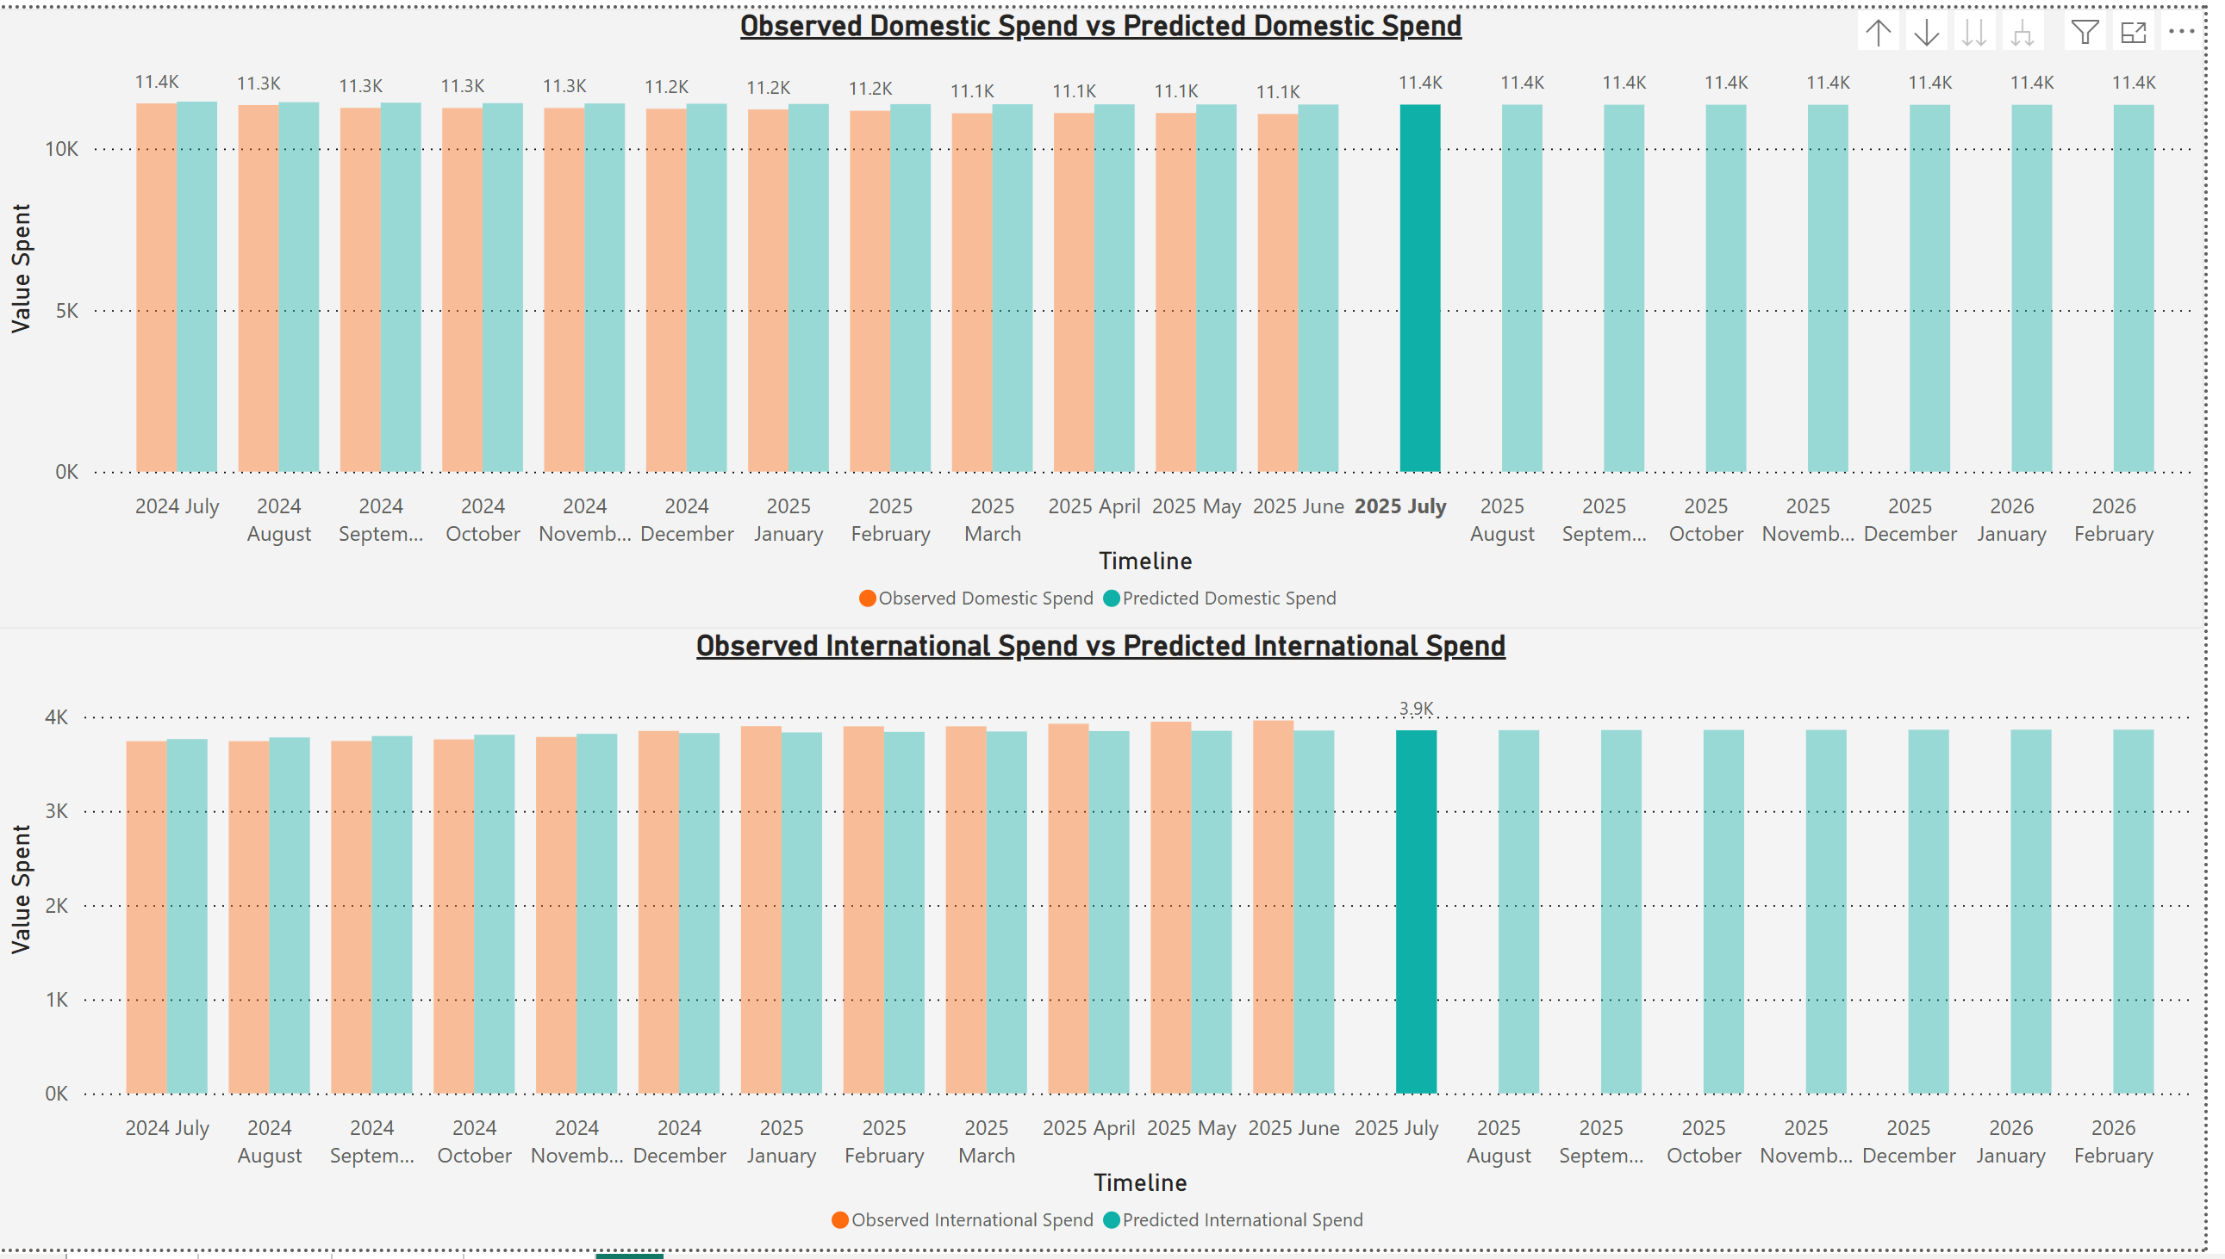

Figure Bar selected

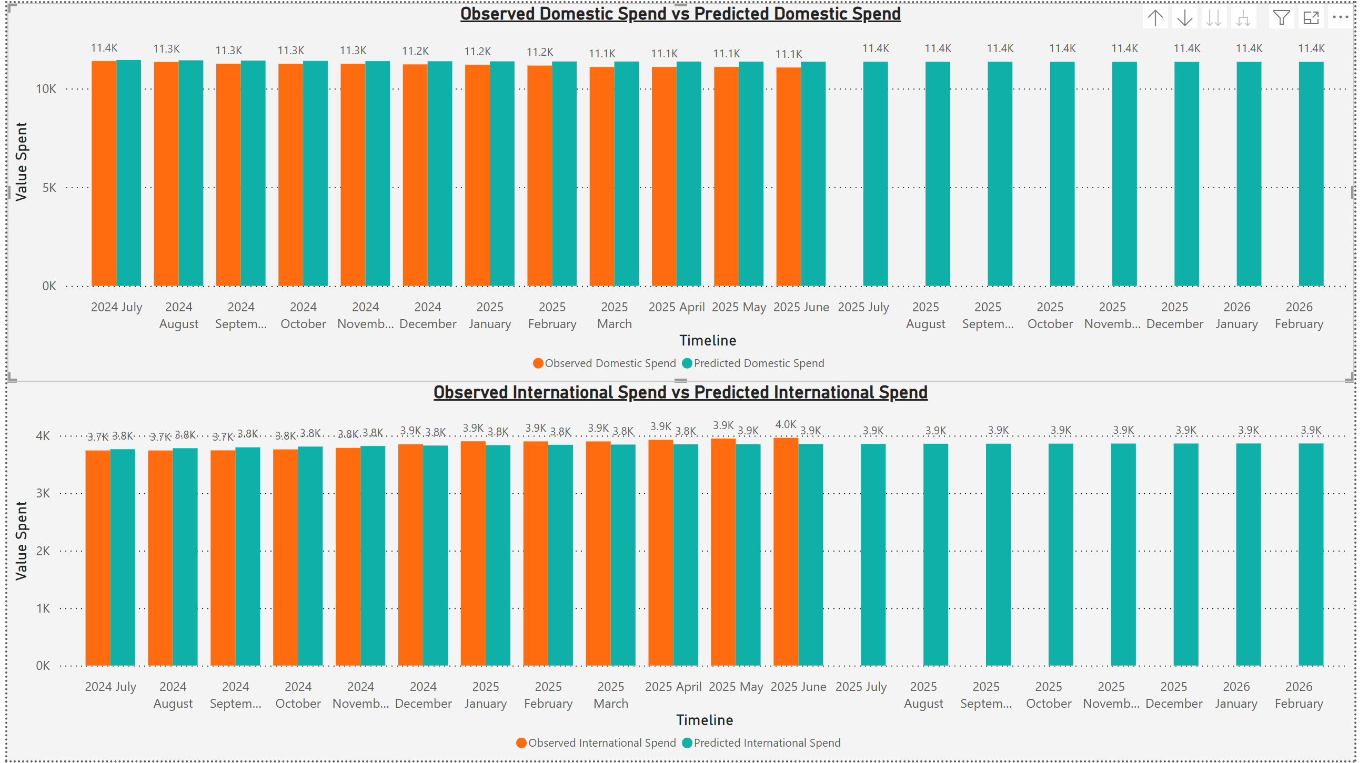

Figure Without selection of bar

## Conclusion

Testing approves that the **FutureTourism.LSG** Power BI dashboard is accurate, consistent and reliable. All the test cases were executed successfully with screenshots attached. The results demonstrate that calculations, visuals, and interactions line up with the documented objectives and test cases. The dashboard meets the acknowledged objectives for data correctness, visual behavior, KPI integrity, formatting, and usability.

# Appendix P



New Zealand Tourism Forecasting

Dashboard Visualization

IT7510 Capstone Semester Two 2025

Project name: FutureTourism.LSG

Group name: LSG

Name: Lakshya Mann, Shivam Arora, Gowtham R Panicker

Client Name: Dr. Trang Do

Contents

Creation of Dashboard 3

Summary Page 5

Accommodation Dataset 7

Domestic and International spend Datasets 8

Visitor Arrival Dataset 9

## Creation of Dashboard

The raw data was sourced from the (MBIE) website and given to us by our client. The former data was used to inform the work behind the analysis and downstream model building. The data had to be cleaned up before we could do any modelling of it. This was a necessary step to prevent and remove discrepancies, omissions or outliers from the dataset that could not be replicated and after all make our data more trustworthy. Upon this data being deemed “clean”, and fit for consumption, we went on to train our predictive model using seven years’ data. We then held out a year of data in order to evaluate the performance and generalizability of our model.

We describe four distinct predictive models that we have compared and thoroughly assessed for their performance using several error metrics in our study. These metrics enabled us to separate the good models from the bad ones and hence see how good they are in predicting based on past patterns. We chose the most accurate model for each dataset after careful consideration, pimping up our final selections based on empirical facts.

Once the most accurate models were chosen, we to obtain the predicted CSV files using each set. This was essential to enable the extension of subsequent analysis and comparison. We also read-in the true data CSV and the predicted CSV for each dataset into our analysis environment to improve speed of work-flow and expedite gaining insights from them.

We performed some data transformations to be able to correspond with POWERBI, a great business analytics tool. This comprised establishing a dedicated date table, which is essential for any time-based analysis, and relationships between data tables to allow seamless integration of data and queries. We wrote queries for each table that would easily pull data or allow us to slice it up.

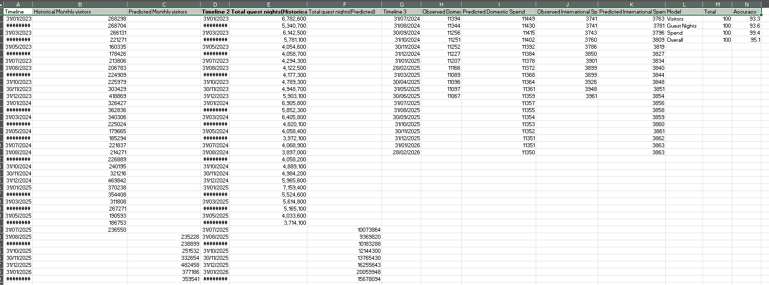

To appropriately interpret the discoveries and learnings, we prepared diverse plotting according to different datasets. These visualizations were clustered bar chart, clustered column chart, donut chart, KPI card and line graph. Each of these graphs was crafted to show historical information alongside forecasts, so stakeholders can quickly understand the implied impact of our analysis.

Finally, a complete summary page was made to store the major learning on each dataset including crucial trends and observations. This is also an evaluation of dimensional predictive model’s performance, which allows stakeholders to have a clear sense of the reliability of our prediction. "Our objective was to provide not only accurate predictions, but the information in a manner that is accessible and useful for decision makers.

## Summary Page

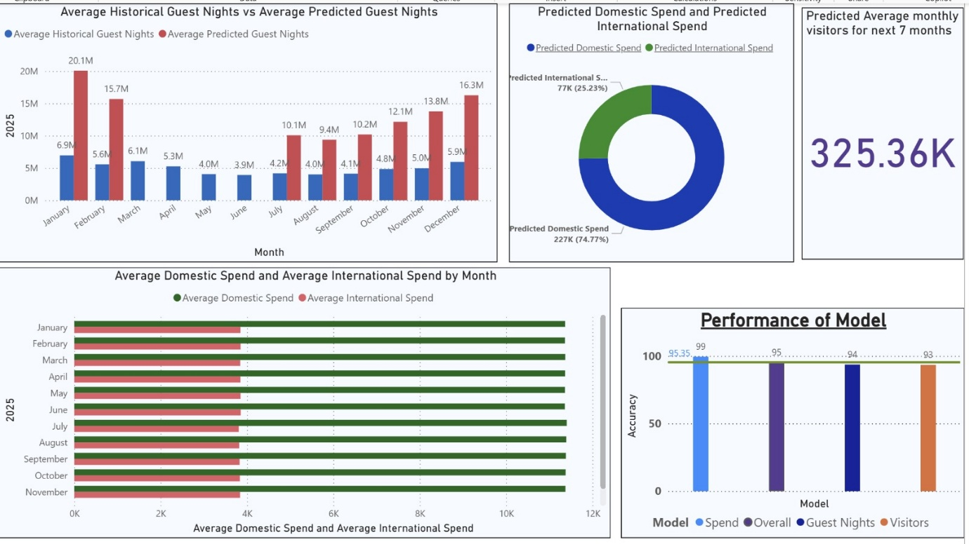

**Top Left – Historical Average Guest Nights vs. Forecasted Guest Nights**

This chart illustrates the comparison between historical and anticipated guest nights for each month in 2025. The blue bars represent past averages, while the red bars indicate forecasted figures. The projections are significantly elevated, particularly for January (20.1 million), February (15.7 million), and December (16.3 million), indicating a sharp increase in tourism during these peak months.

**Top Centre – Projected Domestic and International Spending**

This donut chart depicts the expected distribution of total spending between domestic and international visitors. Domestic spending is substantially higher at 227K (74.8%), compared to international spending at 77K (25.2%). This indicates that local tourists are anticipated to generate the majority of tourism revenue in 2025.

**Top Right – Estimated Monthly Visitors for the Upcoming Seven Months**

This prominent figure presents the average predicted number of visitors per month over the next seven months, calculated at 325.36K. This suggests a stable and robust level of tourism activity, reflecting consistent interest from visitors throughout mid to late 2025.

**Bottom Left – Monthly Average Domestic vs. International Spending**

This horizontal bar chart compares monthly expenditures by domestic and international tourists. The green bars (domestic) exceed the length of the red bars (international), indicating that domestic travellers contribute more to overall spending. Expenditure levels remain relatively stable throughout the year, demonstrating a steady economic impact from both visitor groups.

**Bottom Right – Model Accuracy Assessment**

This chart evaluates the accuracy of prediction models used in this analysis. The overall accuracy stands at an impressive 99%, with specific accuracies for spending, guest nights, and visitor metrics recorded at 95.35%, 95%, and 93%, respectively. These high accuracy rates suggest that the models' forecasts are dependable and reliable for future tourism planning.

## Accommodation Dataset

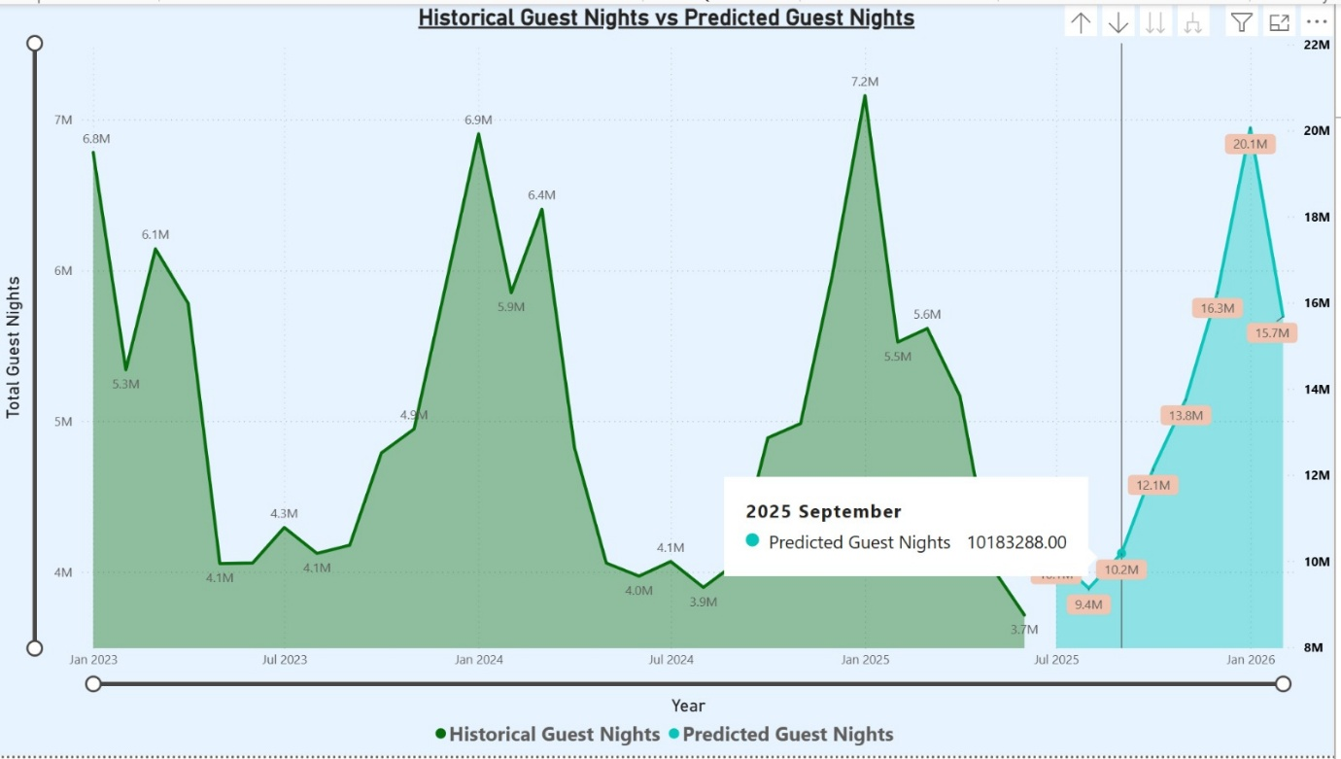

This chart illustrates the comparison between historical guest nights and representing the duration of visitor stays also the future predictions are generated in the model.

* The **green section** depicts actual data from 2023 to 2025, exhibiting fluctuations in response to peak and off-peak seasons.
* In contrast, the **blue section** presents projected figures for late 2025 through 2026, indicating a significant growth trend.

The model thus indicates a substantial rise in tourism activity, characterized by distinct seasonal variations and a robust recovery is anticipated in the upcoming year.

## Domestic and International spend Datasets

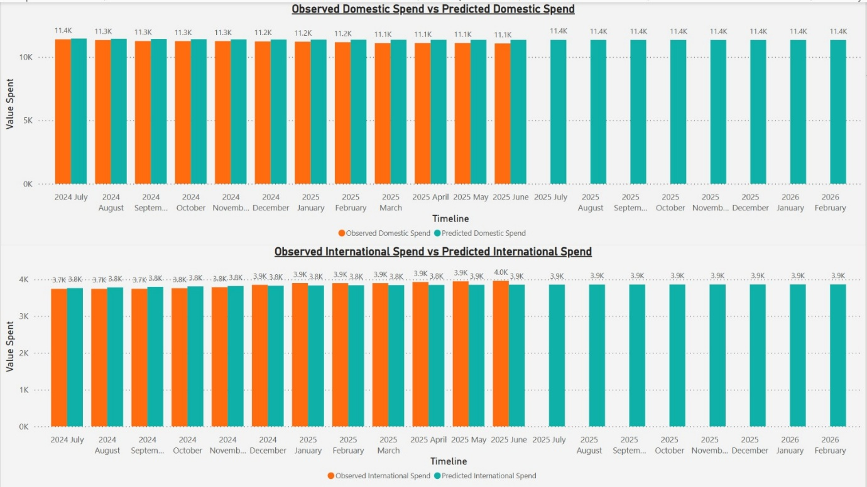

This dashboard evaluates the accuracy of the model's spending forecasts compared to actual data.

In the upper chart, orange bars represent the recorded domestic expenditures, while blue bars depict the anticipated domestic spending. The heights of both sets of bars are nearly identical each month, indicating that the model provides highly precise predictions for local spending, approximately 11K monthly.

The lower chart reflects a similar trend for international expenses. The observed and predicted values align closely, remaining in the range of 3.8K to 4K each month.

## Visitor Arrival Dataset

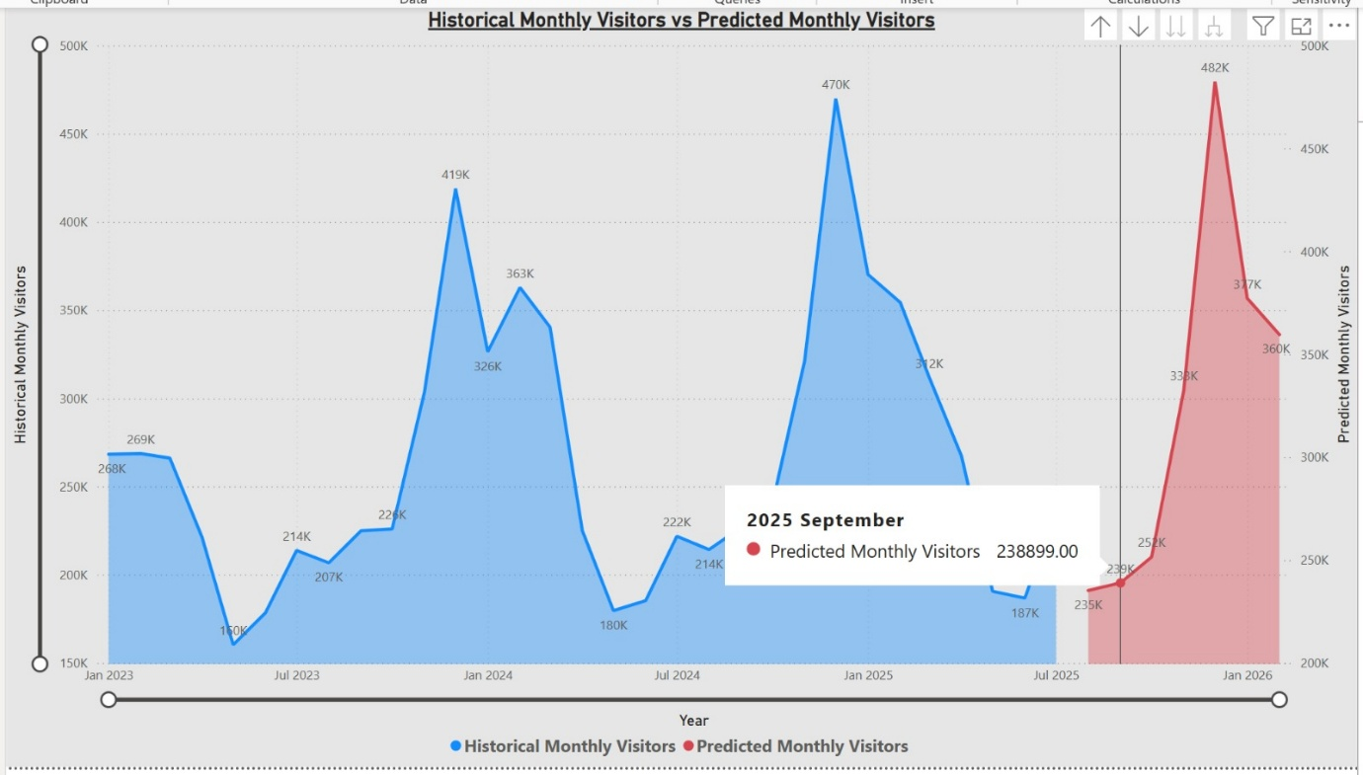

The chart titled “Historical Monthly Visitors vs Predicted Monthly Visitors” contrasts actual monthly visitor figures (depicted in blue) with projected numbers (shown in red) from January 2023 to January 2026.

The blue section illustrates real visitor trends leading up to mid-2025, highlighting distinct seasonal peaks occurring in early 2024 and early 2025, reaching as high as 470,000 visitors.

In contrast, the red section represents forecasted data starting from mid-2025, which maintains a similar seasonal pattern and anticipates a peak of approximately 482,000 visitors in early 2026.

For September 2025, the model forecasts a total of 238,899 visitors, reflecting a gradual increase prior to the subsequent significant seasonal peak.

In summary, the data indicate a robust and repeating seasonal trend, implying regular visitor cycles along with an anticipated growth in future visitor numbers.